

FALCON’s Response to Flipkart for Supply of 80K + 10K Loop CBS system (Kalash) – Option 3
September 13, 2024

Kind Attention –
M/s Flipkart

Offer Ref: F22-403 Option 3 R1 ; Date: 13-09-2024

Subject – Techno -Commercial Offer of Loop Cross Belt Sorter 80K + 10K PPH

We are pleased to submit our Techno-Commercial Offer in response to your RFP.
As you will note, we have done an in-depth data analysis and evaluated various solution options best suited for your requirements, along with the information collected during the meetings and discussions with you, we have put together a detailed technical proposal laid out in various sections and sequenced to enable you to understand our proposed solution and to re-enforce our commitment to being your partner in this strategic initiative.
In subsequent sections, we have highlighted the capabilities and experiences of Falcon Autotech with sections on our Intra-logistics Automation Technologies and references.
To conclude, I would like to add my personal commitment on behalf of Falcon Autotech. As we move through the RFP process, please do not hesitate to contact me and my team. We will be pleased to assist you with any further information or clarifications that you might have.
Best Regards,
Sandeep Bansal
Chief Business Officer

Response to RFP for
Loop Cross Belt Sorter 80K + 10K PPH Throughput
(Kolkata)

Proposal Reference – F22-403 – Option 3 (PH1) – R1

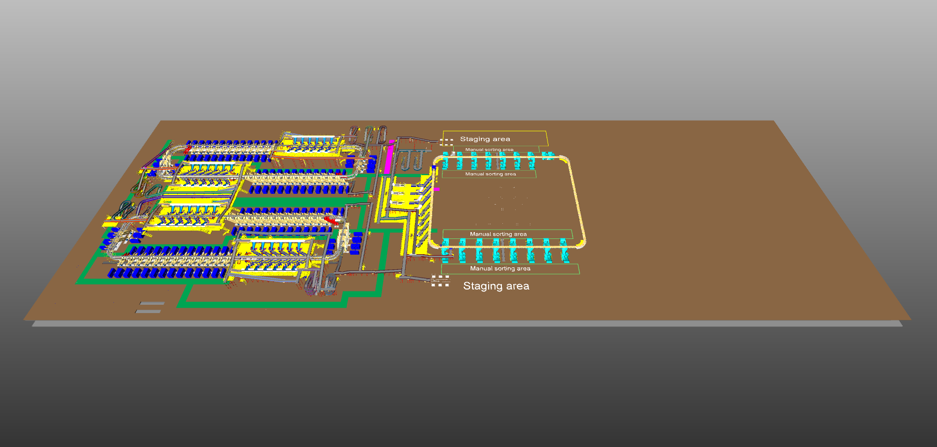
G+1 Level

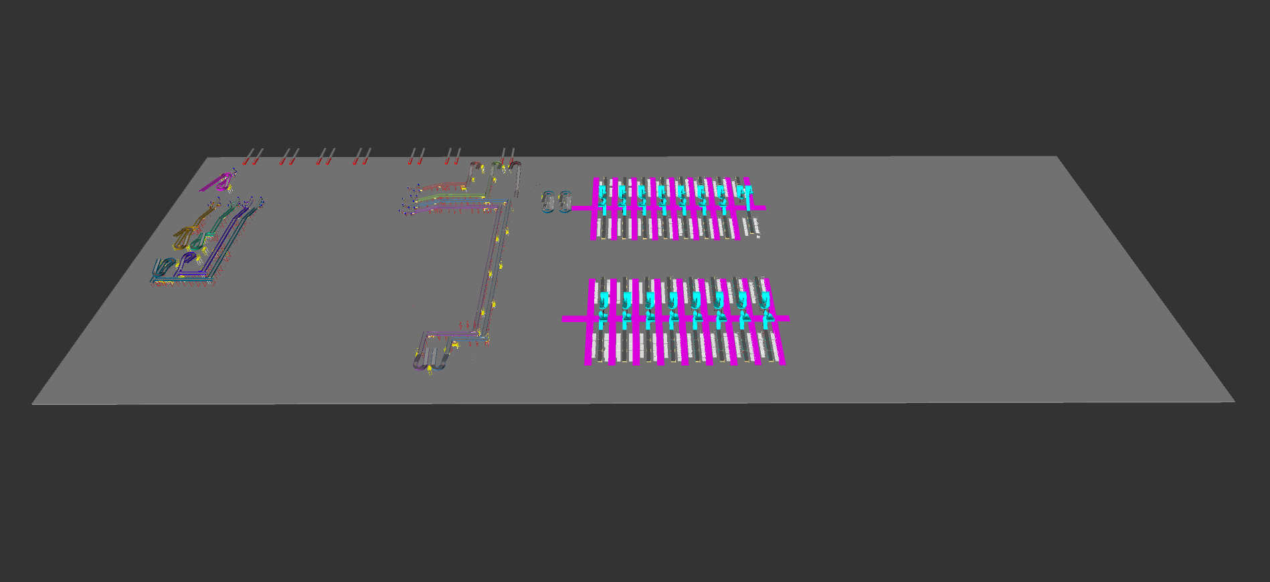

G Level

G Level

Table of Content
1. Glossary 9
2. Executive Summary 10
3. Company Profile 13
4. Falcon’s Experience and Achievements in Sortation Space Globally 17
5. Reference Projects 19
5.1 Project 1- (CEP Client, India) 19
5.2 Project 2- (Client – E-Commerce, India) 20
5.3 Project 3- (Ecommerce Client, India) 21
5.4 Project 4- (CEP Client, UK) 22
5.5 Project 5- (CEP Client, Sydney) 23
6. Handled Shipment Spectrum 24
6.1 Shipment (Non-Large) size loadable on the shipment sorter 24
6.2 Bag size loadable on the Bag & Semi-large sorter 24
6.3 Semi-large shipment size loadable on the Bag & Semi-large sorter 24
6.4 Shipments to be loaded on Sorter shall have the following characteristics: 25
6.5 Shipment not loadable on the sorter 25
6.6 Pictures of Sortable Shipments 26
7. Proposed System Description 27
7.1 Objective 27
7.2 Summary of the System 27
7.3 Main benefits of the proposed solution 28
8. Concept Description 29
8.1 Shipment Sorter 29
8.2 Semi-Large + Bag Sorter 30
9. Layout OverView 31
10. Layout View of Shipment Sorter 32
11. Proposed System Capacity Calculations 33
11.1 Sorter System Capacity 33
12. System description 34
12.1 Infeed System (Non-Large Shipment Sorter) 34
12.1.1 Conveyor BOQ 34
12.2 Infeed System 41
12.2.1 Infeed System Description 42
12.2.1.1 Telescopic Belt Conveyor 42
12.2.1.2 Straight and Inclined Powered Belt Conveyor 43
12.2.1.3 Staircase Conveyor arrangement 45
12.2.1.4 ZTR Curves (Pic for ref.) 45
12.2.1.5 Plastic Modular Belt Conveyor 46
12.2.1.6 Tilted Belt VDS 47
12.2.1.7 VDS Chutes 48
12.3 Induction to Sorter: Feedlines (Bespoke Flipkart Design) 49
12.3.1 Feedlines 49
12.3.1.1 Buffer Conveyors 50
12.3.1.2 Weighing Conveyor 50
12.3.1.3 Orientation Conveyor 51
12.3.1.4 Intelligent Merge Conveyor 51
12.3.1.5 New Bespoke Ergonomic Feedline 52
12.3.1.6 New Induct Fencing 52
12.3.2 Irregular Takeout Conveyor 53
12.3.2.1 Irregular Chute 53
12.3.2.2 Irregular Takeaway Conveyor 53
12.3.2.3 Irregular Collection Bin (In Flipkart’s scope) 54
12.3.3 Conveyor BOQ 54
12.3.4 Main Loop 55
12.3.5 Sorting Output 56
12.3.5.1 Direct Bagging Chute (Bespoke Flipkart design to be used) 56
12.3.5.2 Secondary Chute (L-Type) (Bespoke Flipkart design to be used) 57
12.3.5.3 Rejection Chute (L-Type) (Bespoke Flipkart design to be used) 58
12.3.6 Bag Take away Conveyor 59
12.3.6.1 Conveyor BOQ 59
13. Layout View of Bag & Semi-large Sorter 61
14. Proposed System Capacity Calculations 62
14.1 Sorter System Capacity 62
15. System description 63
15.1 Infeed System 63
15.1.1 Infeed System Description 64
15.1.1.1 Straight and Inclined Powered Belt Conveyor 65
15.1.1.2 Powered Spiral Conveyor 67
15.1.1.3 Roller Aligner conveyor 68
15.1.1.4 ZTR Curves (Pic for ref.) 68
15.1.1.5 Plastic Modular Belt Conveyor 69
15.1.1.6 Swivel Wheel Divert 70
15.1.1.7 Conveyor BOQ 71
15.2 Induction to Bag & Semi-large Sorter 72
15.2.1 Automatic Feedlines for Semi-large Shipment 72
15.2.1.1 Singulator 73
15.2.1.2 Aligning Conveyors 73
15.2.1.3 Buffer Conveyors 74
15.2.1.4 Weighing Conveyor 74
15.2.1.5 Receiving Conveyor 75
15.2.1.6 Intelligent Merge Conveyor 75
15.2.2 Irregular Collection Chute 76
15.2.3 Semi-Automatic Feedlines for Bags 76
15.2.3.1 Buffer Conveyors 77
15.2.3.2 Weighing Conveyor 77
15.2.3.3 Scanning Conveyor 78
15.2.3.4 Intelligent Merge Conveyor 78
15.2.4 79
15.2.5 Sorting Output 80
15.2.5.1 Spiral Chutes 80
15.2.5.2 Rejection Chute 81
15.2.5.3 Conveyor BOQ 82
16. Description of Components of Equipment 84
16.1 Cross Belt Sorter - 84
16.1.1 CBS Carrier 84
16.1.2 Servo Roller 85
16.1.3 Chassis 85
16.1.4 Carrier Wheels 85
16.1.5 Friction Wheel Drive 86
16.1.6 Non-contact based Linear motor drive 86
16.1.7 Power Transmission 86
16.1.8 Data Transmission 87
16.1.8.1 R-Coax Cable 87
16.1.8.2 Microwave Data Transmission (Optional) 87
16.1.9 Carriers positioning System. 87
16.1.10 Technical specifications of Sorter (Shipment Sorter) 88
16.1.11 Technical specifications of Sorter (SL & Bag sorter) 89
16.2 Scanning & Sensing on Main Sorter Loop 90
16.2.1 Automatic Barcode Scanning & Dimensioning System 90
16.2.2 6 Side-Automatic Barcode Scanning & Dimensioning System (SL Shipment) 90
16.2.3 Manual Scanning for Bags 91
16.2.4 Shipment Positioning System. 91
16.2.5 Empty Carrier Detection System 91
16.3 Steel Works – Mezzanine, Maintenance Platforms & Staircases- 92
16.3.1 Mezzanine (Non-large Shipment Sorter) 92
16.3.2 Maintenance Platform & Staircase 92
16.3.3 Mezzanine (SL & Bag Sorter) 93
16.3.4 Maintenance Platform & Staircase 93
17. System layout & Stagging Area Description 94
18. Dock Calculation 95
19. Proposed System Technical Details (Shipment Sorter) 96
19.1 Mechanical equipment 96
19.2 Electrical Equipment 97
19.3 Control System 97
20. Proposed System Technical Details (SL & Bag Sorter) 98
20.1 Mechanical equipment 98
20.2 Electrical Equipment 99
20.3 Control System 99
21. Electrical System 100
21.1 Reference Picture of Power Distribution Panel 100
21.2 Main Control Panel (Reference) 100
21.3 Induct Stations Control Panel (Reference) 101
22. Controls Architecture (Ref.) 102
22.1 Redundant Control Architecture for Double deck System (Optional) 102
23. IT Architecture (Ref.) 103
23.1 HAA Server (In Flipkart Scope) 104
24. Falcon’s WCS CONTROLIT 105
25. Falcon’s Visual Inspection System (SCADA) 106
25.1 FIELD DATA ACQUISITION 106
25.2 ANIMATED SYSTEM VISUALIZATION 107
25.3 ALARM MANAGEMENT 108
26. Key Components Make 109
27. Principle of Safety 109
27.1 E-Stops 109
27.2 Pull Cords Switch- 110
27.3 Fencing 110
28. Additional Scope- 111
29. Program Organisation 111
29.1 Program/ Project Schedule 111
29.2 Program & Account Management 111
30. Flipkart Responsibility 112
30.1 Flipkart Responsibilities During the Assembly and Commissioning Phase 112
30.2 Responsibilities of Flipkart During the Tests 112
30.3 Flipkart Responsibilities During the Training 112
31. Testing, Training, and Support 113
31.1 Acceptance Testing 113
31.1.1 Acceptance Test Plan 113
31.1.2 Minor / Major Faults 114
31.1.2.1 Specific Procedure 114
31.1.3 Included Acceptance Tests 114
31.1.4 Physical Acceptance Testing 114
31.1.4.1 Test Definition 114
31.1.4.2 Specific Practice 114
31.1.5 Functional Acceptance Testing 115
31.1.5.1 Test Definition 115
31.1.5.2 Specific Practice 115
31.1.6 Throughput Testing 115
31.1.6.1 Test Definition 115
31.1.6.2 Measurement 115
31.1.6.3 Specific Practice 115
31.1.7 Final Acceptance Criteria 115
31.1.7.1 Acceptance Test Letter 116
31.2 Training 116
31.2.1 Operations Training 116
31.2.2 Maintenance Training 116
31.2.3 Information System Training 116
32. Life Cycle Services 117
32.1 Preventive Maintenance 117
32.2 Corrective Maintenance 117
32.3 Hotline Support 117
32.4 On Site Support 118
32.5 Supply and Management of Spare Parts 118
33. Commercial Terms 119
33.1 Price Sheet 119
33.2 Payment Terms 121
34. Warranty Period 121
35. Exclusions 122

Glossary

S. No. | Term | Description
1 | RFP | Request For Proposal
2 | PPH | Shipments Per Hour
3 | ICR | Intelligent Character Recognition
4 | MEZZ | Mezzanine
5 | FWD | Friction Wheel Drive
6 | ECDS | Empty Carrier Detection System
7 | AC | Alternating Current
8 | DC | Direct Current
9 | PLC | Programmable Logic Controller
10 | IT | Information Technology
11 | BOQ | Bill Of Quantity
12 | I/O | Input/ Output
13 | PDP | Power Distribution Panel
14 | PC | Personal Computer
15 | UPS | Uninterrupted Power Supply
16 | CBS | Cross Belt Sorter
17 | MDR | Motor Driven Roller
18 | DAP | Design Approval Phase

Executive Summary
Falcon Autotech is pleased to confirm its great interest in responding to this Flipkart RFQ of Loop CBS for Kalash North. Our team has been working closely with the relevant stakeholders, with a clear commitment to listening, understanding your needs, and ensuring this project's success.
Following the same objective for the Kalash CBS system, we are happy to offer a compliant solution meeting all technical and operational requirements at competitive price, delivering key results.

Our solution is based on the following key characteristics:

Shipment Sorter 80K PPH:-

• Two double deck loops of shipment sorter, employing our cross-belt technology, have been designed to handle a throughput of approximately 20K packages per hour on each loop, making the total capacity of the system 80K sorts per hour.

• Each loop is equipped with its own infeed conveyor system, comprising of:

- Infeed Conveyor Line – Conveyor based infeed lines are provided to transport the Marketplace load to the VDS loop.
- Staircase Conveyor Line – Combination of Inclined conveyor & Modular Turns are present to transport the Marketplace load from G level to G+1 level into the VDS loop.

Furthermore, to cater the priority line/load an additional Staircase conveyor is incorporated in the system.

• For each loop there are two induction zones featuring six induct lines and provision for irregular shipment takeout in each zone.
• Every double deck system has 60 secondary chutes (L-Type), 60 Direct bagging chute (L-Type) and four rejection chutes (L-Type).
• Bagging conveyors are planned below the loop to transport the bags to the Bag & Semi-Large Sorter.
- Provision of irregular shipments take out & segregation via PTL setup is provided near each induction zone.

Bag & Semi-Large Sorter 10K PPH:-

• One loop of XL sorter, employing our cross-belt technology, have been designed to handle a throughput of approx. 10K packages per hour.
• Loop is equipped with its own infeed conveyor system, comprising of:
- Bag Infeed Conveyor – Staircase conveyor arrangement is provided to transport the Cross dock volume to the dump VDS loop & separate Spiral conveyors are present to transport bags from shipments sorters for further sortation in Bag sorter. Additionally Bidirectional conveyors are provided to host the contingency situation.
- Semi-Large Infeed conveyor – Two Staircase conveyors set are present to transport the Cross dock load into SWEDI based VDS loop. Additionally Bidirectional conveyors are provided to host the contingency situation.

• Within loop one induction zone featuring seven induct lines. Where three automatic inducts are dedicated for Semi-large shipments & four semi-auto inducts are dedicated for Bags.
• In loop, there are 36 Spiral chutes, and two rejection spiral chutes.
• The system layout has been meticulously planned to facilitate smooth operational flow, ensuring efficient and safe man movement
• Spiral chutes are present to transport bags & SL Shipments to Ground (G) level, which are further connected to small sections of conveyors delivering the bags into the Trolley.
- In case the bag sorter is down, Contingency is planned to transport volume to manual sorting area.

This solution has been crafted especially keeping Flipkart’s technical and operational requirements, as listed in the RFP document, making it a tailor-made system delivering a faster TAT and an efficient material flow.

The Falcon Autotech Cross Belt Sorter, proudly MADE IN INDIA, incorporates in-house designed and developed system components and associated peripherals.

- Falcon's reliable Shipment sortation systems

Falcon Autotech has over 50+ Cross belt sorter loops installed globally which are used by most innovative brands such as Flipkart, Amazon, Delhivery, Asendia, Fastway and many more. The main and critical components of the Falcon Autotech sorter building blocks, like wheels, motors, belts, bearings, Bus Bars, Communication platforms, PLCs etc., are sourced from industry leading suppliers in the world, such as SEW, Siemens, SICK, Vahle, Forbo etc. This strategic baseline of sourcing policy allows Falcon's customers to be fully confident in the systems' robustness and reliability.

- Commitment to quality systems

Demonstrating Falcon's clear commitment to the Flipkart satisfaction, the shipment sortation system, parts and services will be under warranty for 12 months from installation go-live.

- A strong and already successful partnership between Flipkart & Falcon

Flipkart has been Falcon's customer since long and using multiple Falcon Systems and now four new shipment sortation system of 20,000 PPH is being installed at the Ulluberia, Jaipur & Surat location along with four conveyor automation & VDS system at four strategic location of the Flipkart network. For each of these projects, several advanced tools to improve the service's quality and efficiency are provided: Service Desk, Hotline support, remote access, regular governance meetings and monthly reports.

Company Profile

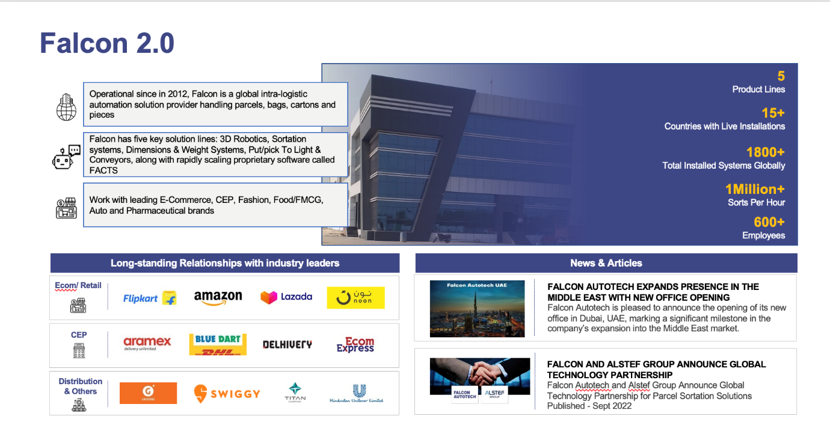
Falcon Autotech (Falcon) is a global intralogistics automation solutions company. With over 10 years of experience, Falcon has worked with some of the most innovative brands in E-Commerce, CEP, Fashion, Food/FMCG, Auto and Pharmaceutical Industries. With our proprietary software and robust hardware integration capabilities, Falcon designs, manufactures, supplies, implements, and maintains world-class warehouse automation systems globally. Falcon’s strong research and development team and the continuous focus on innovation reflect our strong solution line around Sortation, Robotics, Conveying, Vision Systems and IOT. Falcon has done over 1,800 installations across 15 countries on four continents.
Falcon Autotech is currently among the top 15 intralogistics automation company, our vision is to become top 10 intralogistics automation company in our focused product lines.
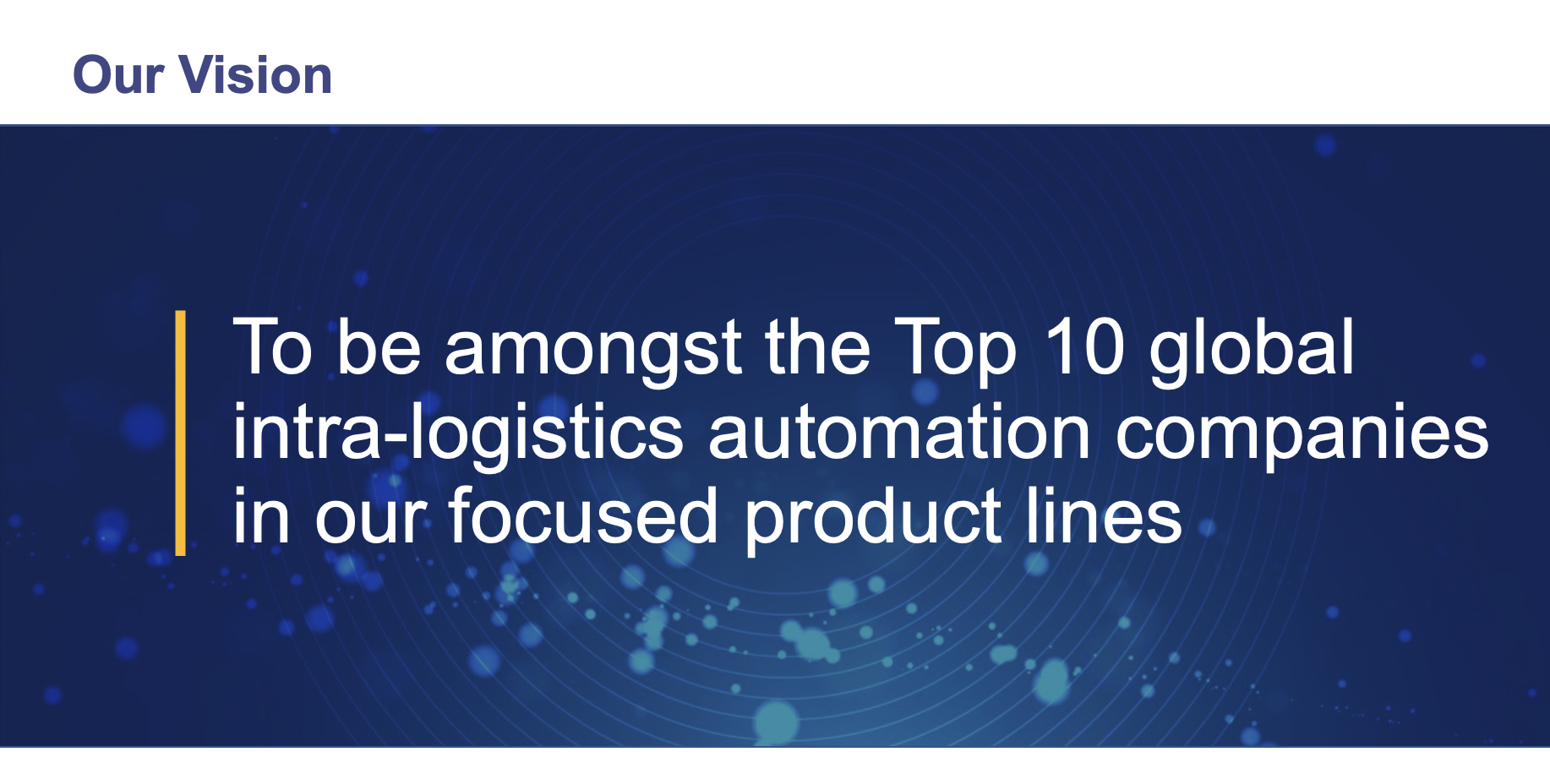

The team started out in 2004 solving special purpose automation problems for clients and later established Falcon Autotech in 2012 with strong focus on building standard technology stack spanning across Hardware, Firmware and Software to tackle bigger Supply Chain problems around warehouse automation and material handling. Over the decade, Falcon has made rapid strides and has carved out a niche in some of the world's most cutting-edge technologies: Sortation, Robotics, Conveying, Vision Systems and IOT.

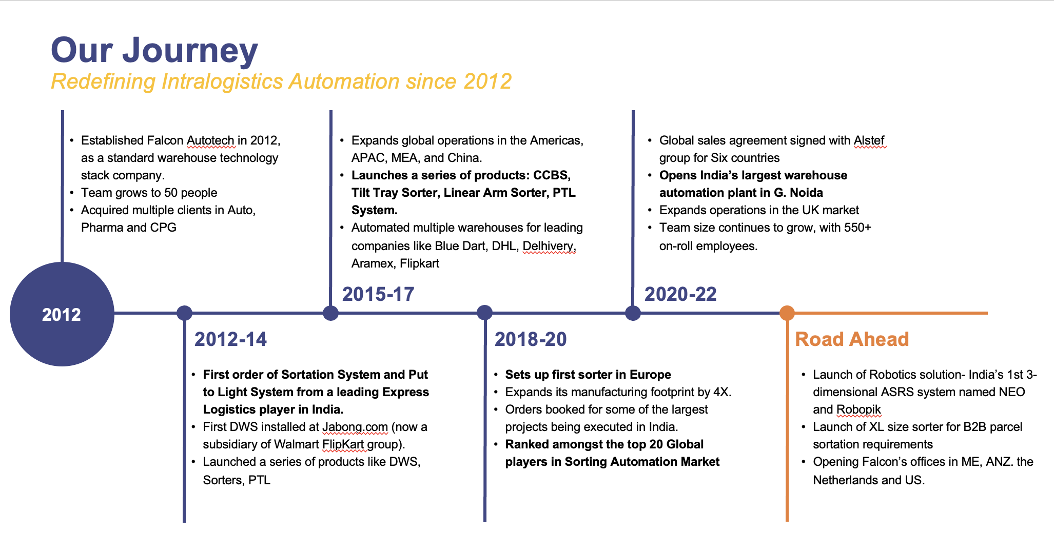

As a leading player in the intra-logistics automation space, Falcon continuously strives to improve the operational efficiencies and accuracies for its clients through its domain knowledge and experience in addition to its wide range of products and solutions. In order to be able to live up to the high expectations set forth by our clients, the team at Falcon realizes the importance of taking up selective applications in focused Industries and deliver world class projects in return.
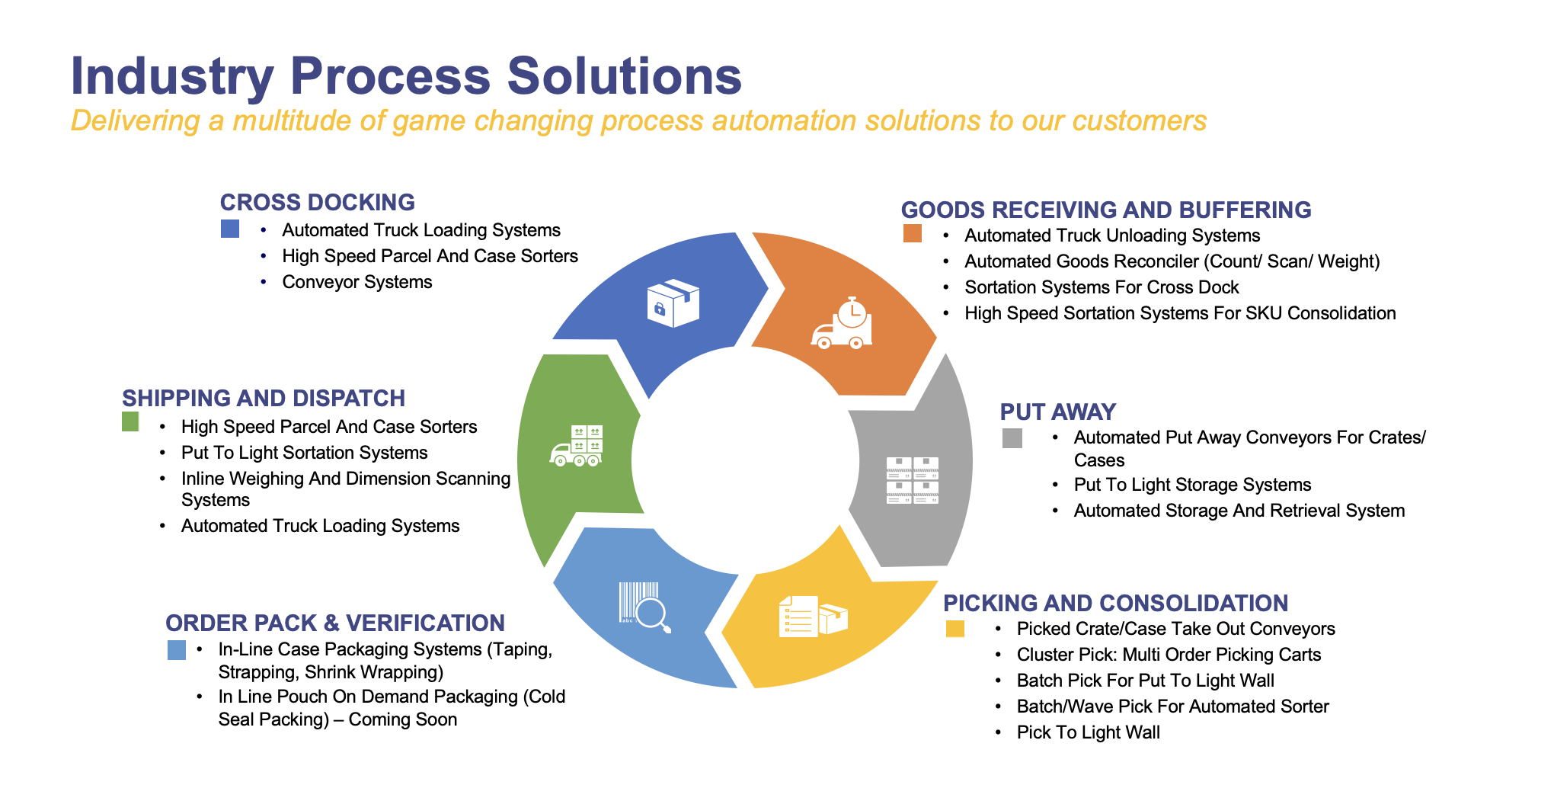

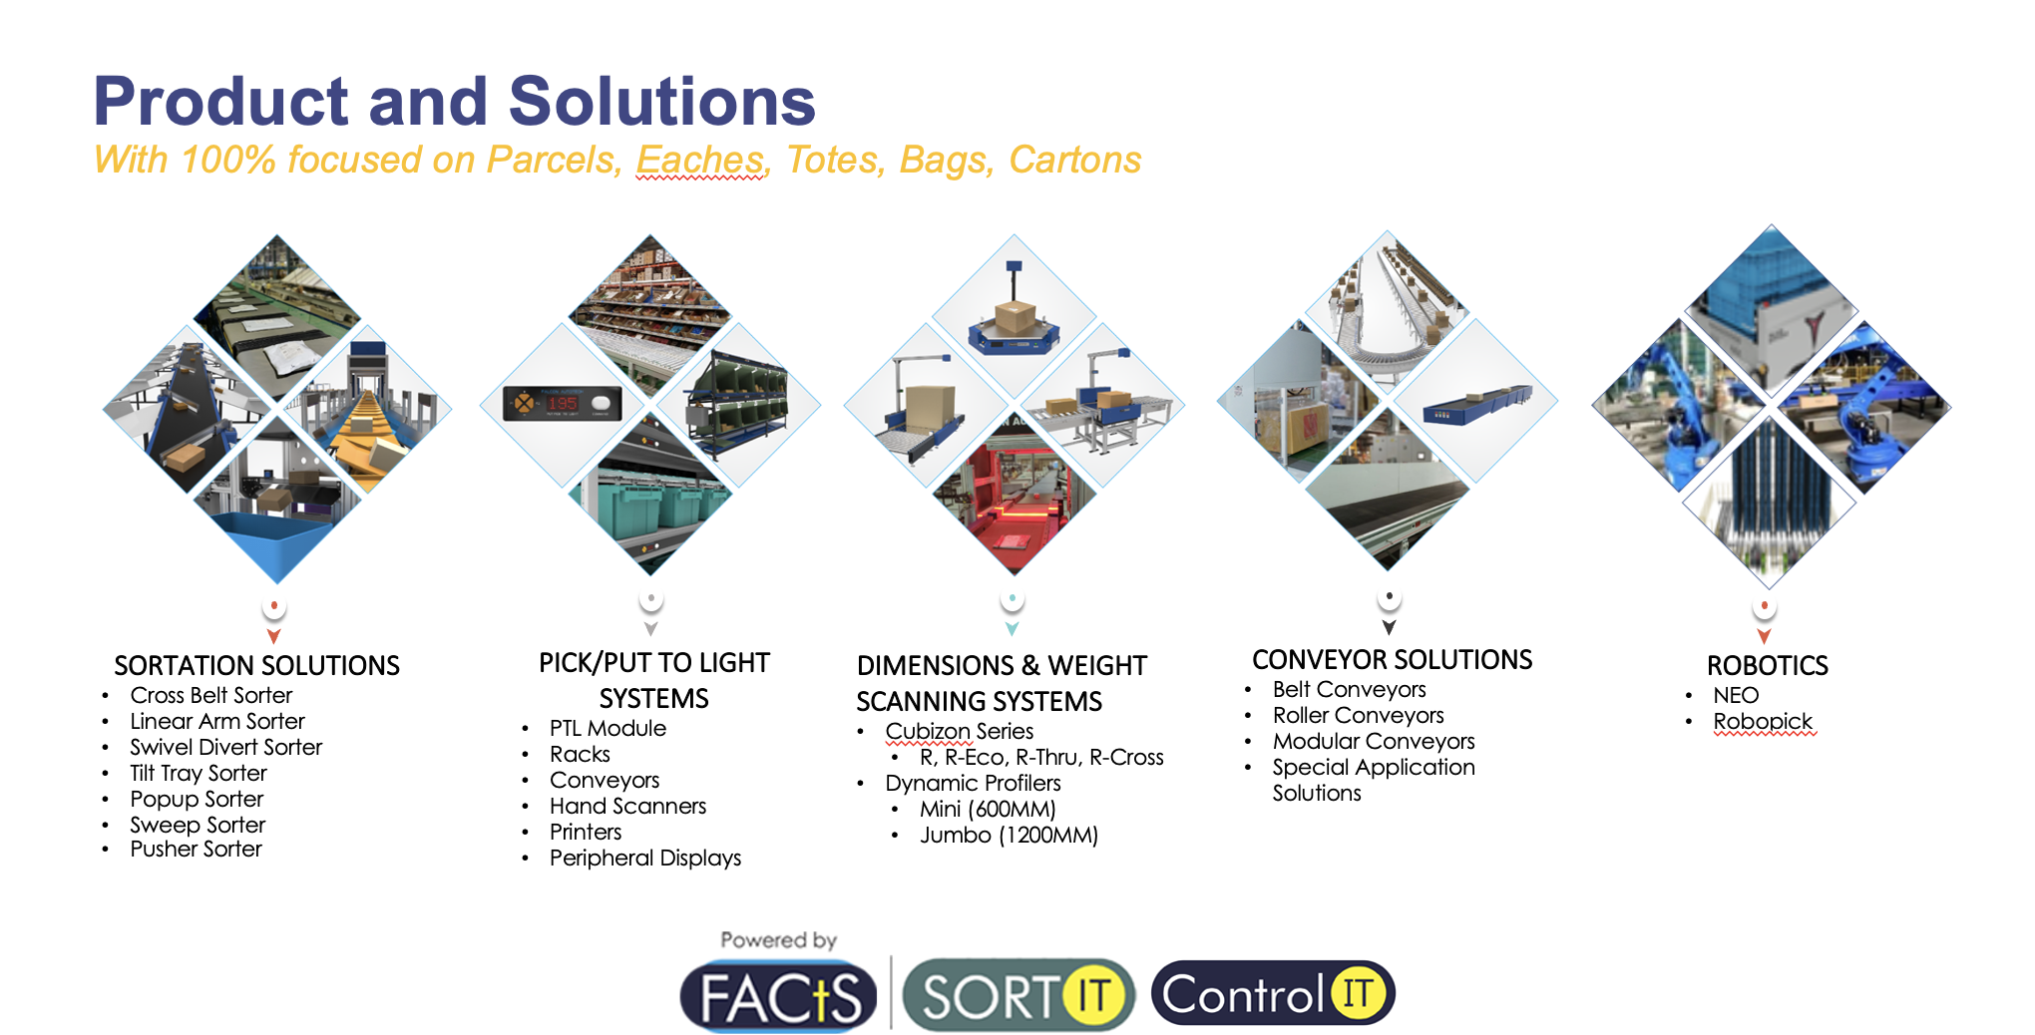

Falcon Autotech has successfully delivered warehouse automation solutions based on smart and innovative combinations of above product lines for effective materials handling, sortation and movement. The process is controlled in real-time by our in house WCS applications. These solutions considerably cut the need for manual operations, improve working conditions and ensure the highest accuracy of the entire process up to final delivery to the recipient.

Over the last 10 years, Falcon has worked with some of the most innovative brands worldwide and has established long standing partnerships. These brands are testimony of our strong focus on delivering superior customer satisfaction and offering end-to-end intralogistics solutions.

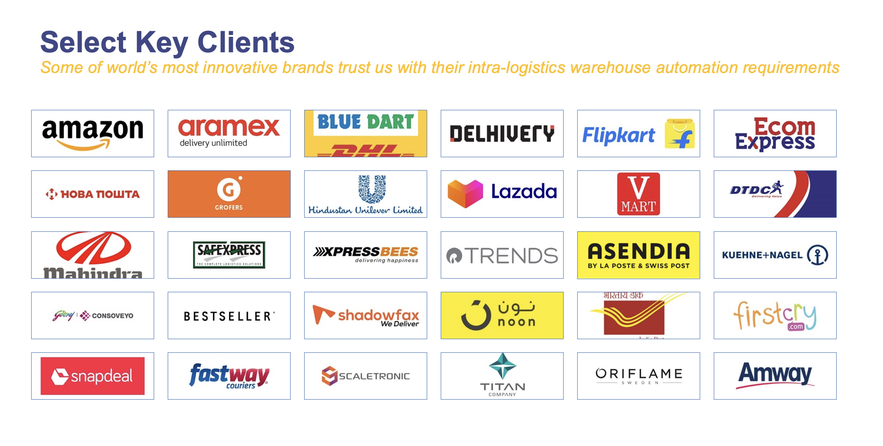

With over 1,800 installations, today Falcon’s systems are used all over the globe. Falcon has highly motivated team of 600+ employees supported by over 15 global partners who help us design, manufacture, deliver and maintain automation solutions globally.

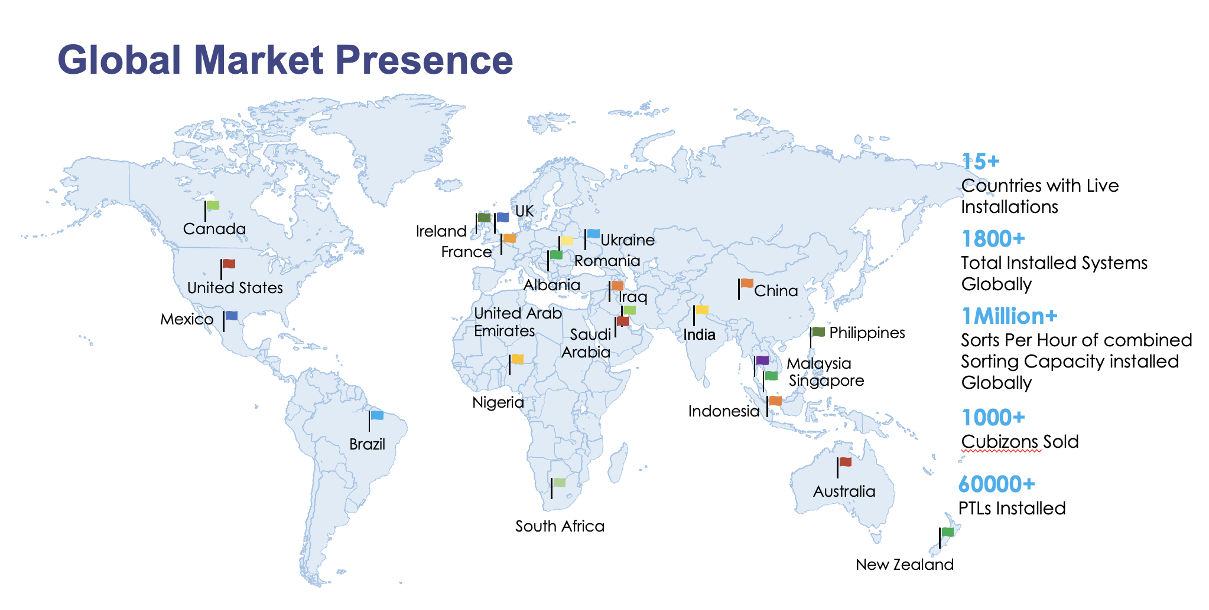

Falcon’s Experience and Achievements in Sortation Space Globally

- Ranked among Top 20 Sortation System Suppliers globally. Only company from APAC/EMEA Region.
- Currently possess one of the World’s largest portfolios in Sortation Technologies: 7 In-house technologies.
- Total installed capacity of 10 million Shipments per day worldwide.
- Only company to be able to offer a Fully Integrated AMS.

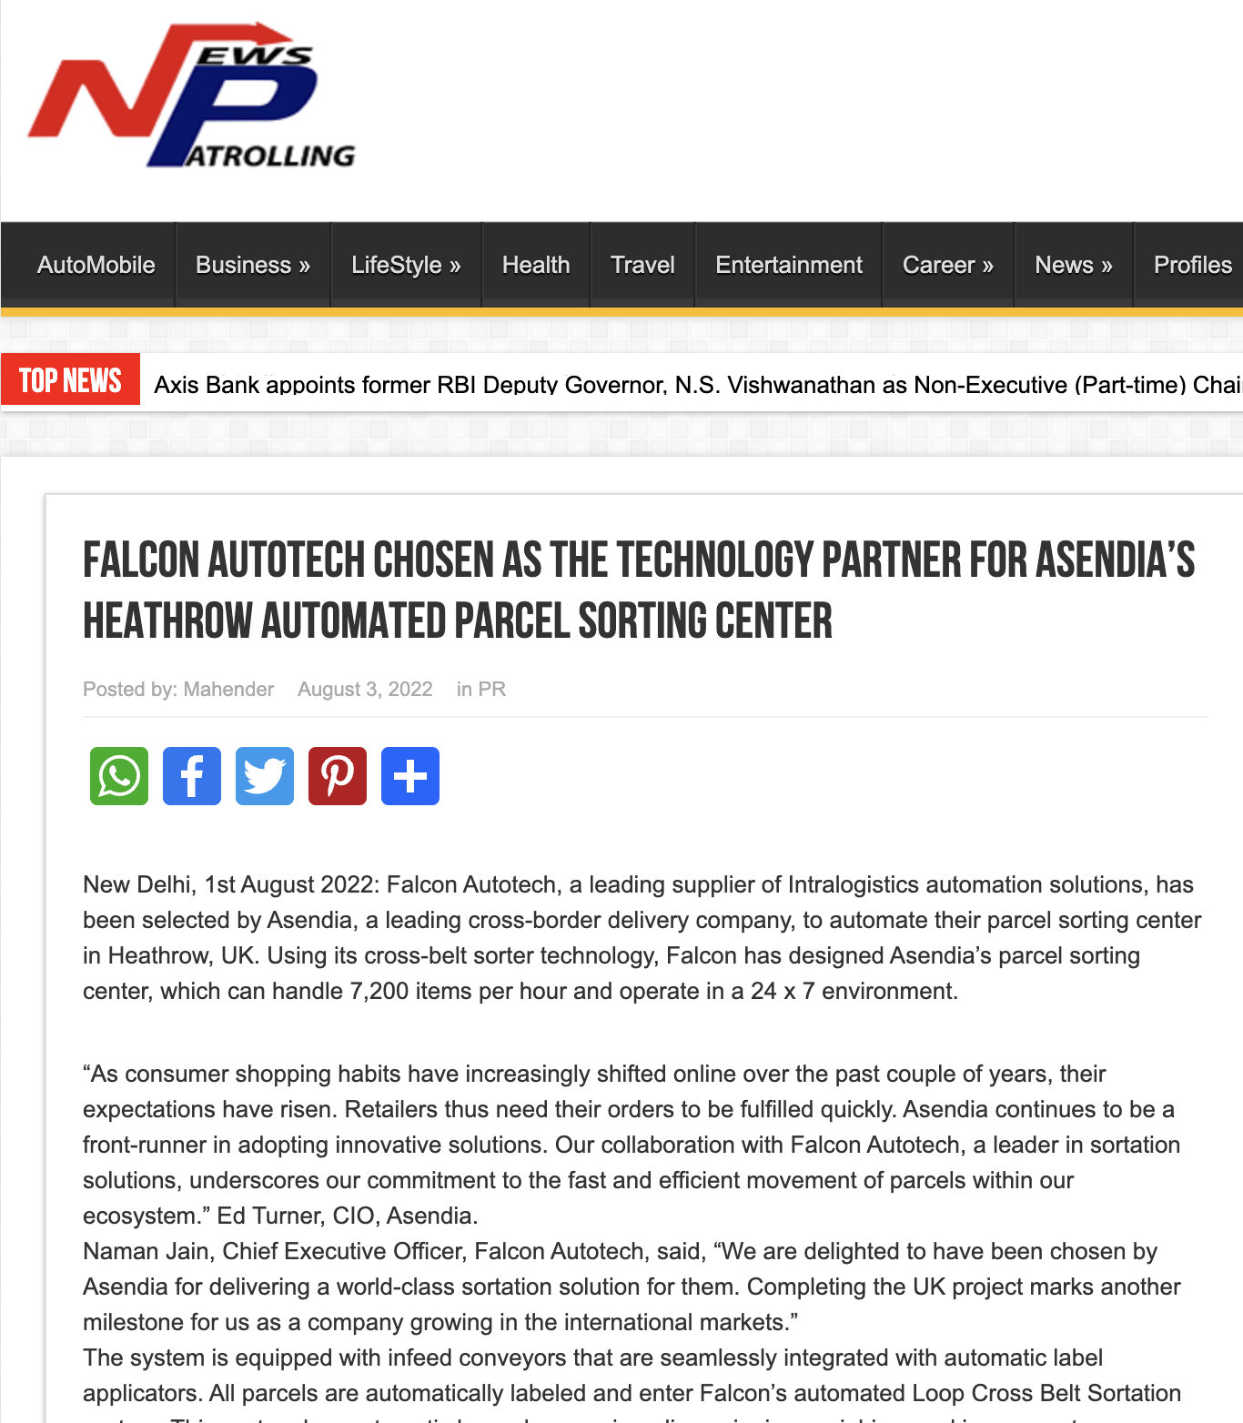





Reference Projects
Falcon has a strong legacy in Warehousing Automation solutions and references-

- Expertise in Shipment Sortation, Piece Picking and Handling, Case Picking and Handling.
- Lifecycle services (maintenance, spares supply chain, support).
- Full in-house expertise (Hardware/Software).
- Turn-key tailored solutions.
The references list presented below focuses on Sortation Solution –

Project 1- (CEP Client, India)
The System is equipped with two fully automated and interconnected Sub-systems. Sub-System 1 is designed for handling large B2B boxes and E-commerce shipment bags while the Sub-System 2 is designed to handle Small E-commerce packages.
Solution Specifications –
  - 48,000 PPH (Double Deck CBS- Shipment Sorter)
  - 17,000 PPH (Double Deck CBS- Bag Sorter)
- Building Size: 700,000 Sq. Ft
Key Technology Modules –

- 2 Sets of Double Decker CBS Sorters
- Mezzanine Structures (one large mezz on to install a double decker Sorter).
- Automated Singulators
- Fully Automatic Inductions
- Semi-Automatic Inductions
- Telescopic belt conveyors
- PVC Belt Conveyors
- Modular Belt Conveyors
- Spiral Chutes with Braking rollers
- 5-Sided Scanning Tunnels
- High speed weighing conveyors
- Direct Bagging Chutes
- Put to Light Chutes
- Volume Distribution systems
- High Availability Server Systems
- WCS

Site Pictures -
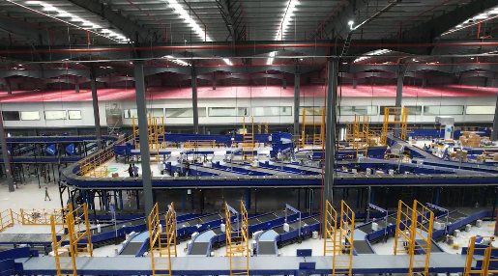
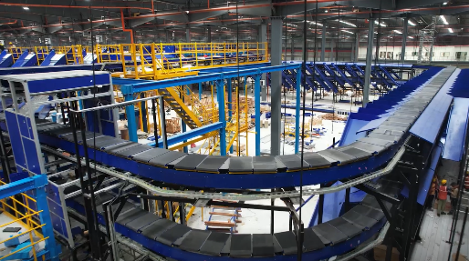
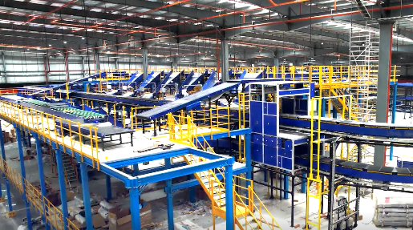

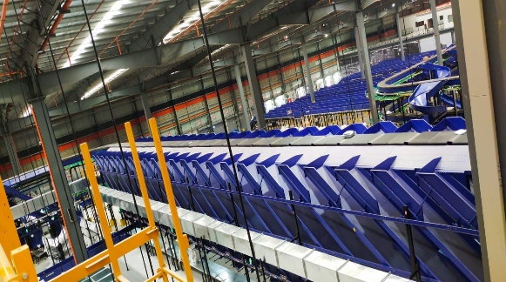
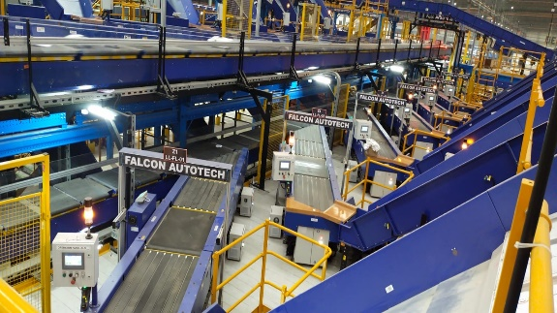

Project 2- (Client – E-Commerce, India)
Use Case – Destination Sorting of Packed Shipments.
In 2019, Client was looking for a potential automation partner for design and development of a new automated sortation system for B2C shipments. The system should be able to provide maximum uptime with reduced dependency on skilled manpower, and space optimization.
The customer chose Falcon Autotech based on its unique design which could cater to all their pain points, capability of seamless integration with WMS and life cycle support services.
Solution Specifications –
- Throughput: 27,600 PPH
- End Destinations: 410 Direct Outputs
- Building Size: 200,000 Sq Ft
Key Technology Modules –
- Bulk Infeed Conveyors.
- ARB based Volume Distribution System
- Integrated Presort System.
- Irregular Ejection System.
- Automatic Induct Lines.
- Automatic Barcode Scanner with Image Capture.
- Automatic Weight & Volume Measurement System.
- Loop Cross Belt Sorter.
- Smart Sliding Chutes for Direct bagging and Cage Sorting.
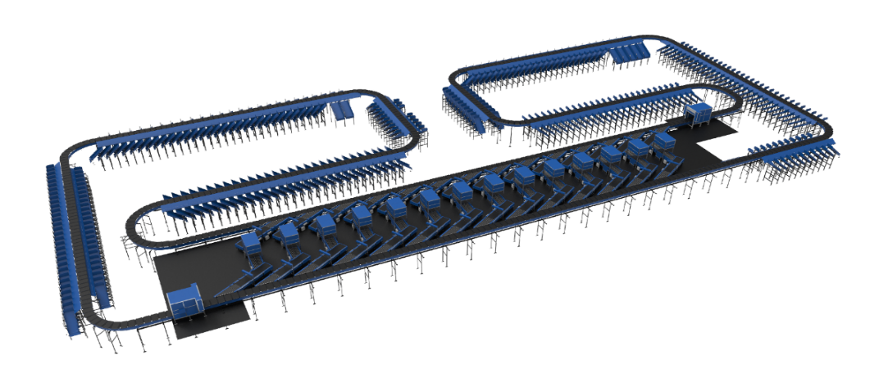
- Bag take out system
- WCS Software System.

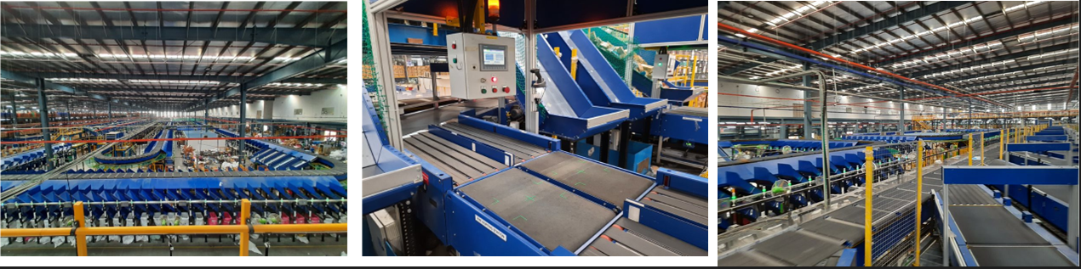

Project 3- (Ecommerce Client, India)
Use Case - Destination Sorting of Packed Shipments
Solution Specifications –
- Throughput: 24,000 PPH
- End Destinations: 110
- Building Size: 200,000 Sq. Ft
Key Technology Modules - Loop Cross Belt Sorter with a cell size of 900 x 500 mm
Layout and Site Pictures -
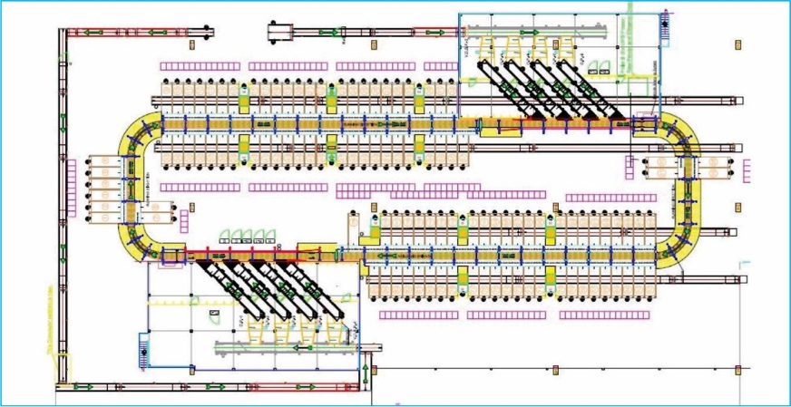

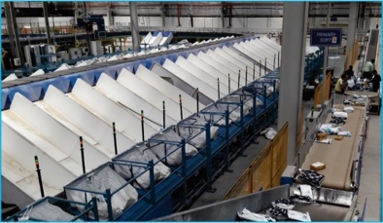
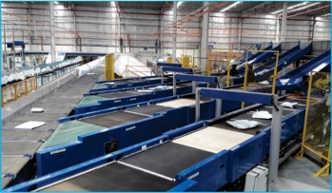

Project 4- (CEP Client, UK)
This Solution is designed to handle a volume of 7200 shipments per hour. The system is equipped with three infeed conveyors integrated with an automatic label applicator before shipments enter the sortation system. The shipments are sorted using Falcon's Loop Cross Belt Sorter equipped with automatic barcode scanning, dimensioning, weighing and image capture capabilities. The sorter is installed on the mezzanine floor and sorts directly to 58 end destinations.
Solution Specifications –
- Throughput: 7200 PPH
- End Destinations: 58 Nos
Key Technology Modules –
- Powered Belt Conveyors.
- Automatic Induct Lines.
- Automatic Barcode Scanner with Image Capture.
- Automatic Weight & Volume Measurement System.
- Loop Cross Belt Sorter.
- WCS Software System.
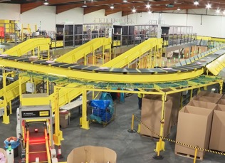
Site Picture –

Project 5- (CEP Client, Sydney)
Solution is designed for handling a throughput of 16,000 shipments per hour with the help of Falcon’s Loop Cross Belt Sorter. The system consists of 2 feeding zones with a total of 10 feedlines. Sorter design enables the van drivers to directly drop the shipments at the dock doors. It has a total of 369 end destinations that are achieved with a combination of direct drops and PTLs. System is integrated with 5 side automatic barcode scanning, weight and volume measurement and automatic detection of oversize and overweight shipments.
Solution Specifications –
- Throughput: 16000 PPH
- End Destinations: 369 Nos
Key Technology Modules –
- Powered Belt Conveyors.
- 2 Induct zone.
- 5 side Automatic Barcode Scanner.
- Automatic Weight & Volume Measurement System.
- Automatic detection of oversize shipment.
- Loop Cross Belt Sorter.
- WCS Software System.
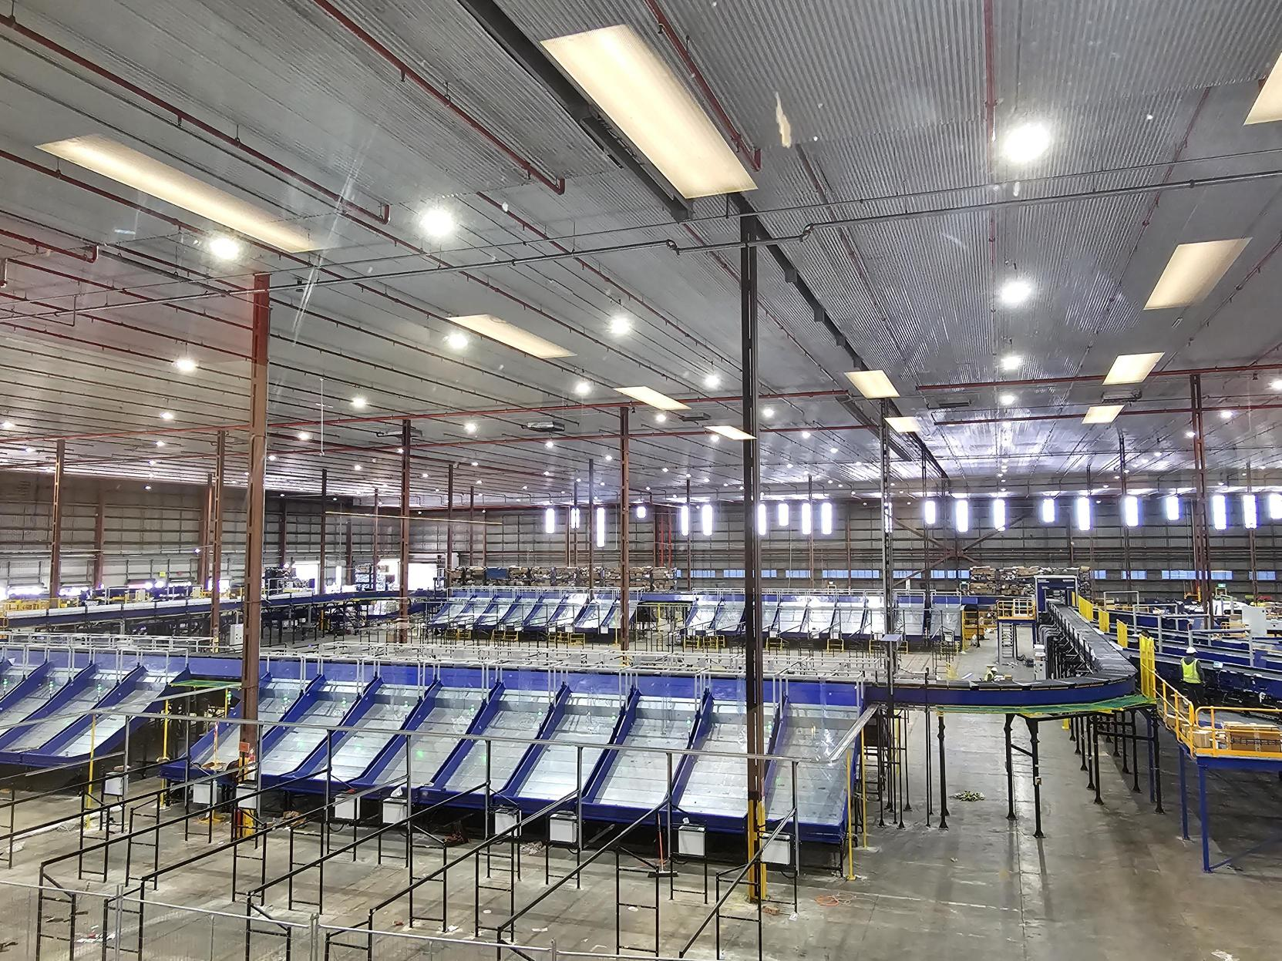
Site Picture –

Add uluberia as well

Handled Shipment Spectrum
As per the shipment spectrum data provided in the RFP documents, Falcon has studied and analysed the shipment spectrum in detail.
Falcon purposes to use its “Dual Belt Regular Configuration” for shipment sorter & “Single Belt XL Configuration” for bag & Semi-large sorter to provide the maximum benefits to Flipkart in-terms of handling various sizes and weight.

Shipment (Non-Large) size loadable on the shipment sorter
Falcon’s Dual belt regular Cross belt sorter has a capability to handle the below mentioned shipment sizes and weight.
Specification | Unit | Value
Max Length | mm | 600
Max Width | mm | 400
Max Height | mm | 300
Max Weight | Kg | 10
Min length | mm | 100
Min Width | mm | 100
Min Height | mm | 3
Min Weight | gm | 100

Bag size loadable on the Bag & Semi-large sorter
Falcon’s Single belt XL Cross belt sorter has a capability to handle the below mentioned shipment sizes and weight.
Specification | Unit | Value
Max Length | mm | 1000
Max Width | mm | 600
Max Height | mm | 600
Max Weight | Kg | 40
Min length | mm | 200
Min Width | mm | 200
Min Height | mm | 10
Min Weight | gm | 1000

Semi-large shipment size loadable on the Bag & Semi-large sorter
Falcon’s Single belt XL Cross belt sorter has a capability to handle the below mentioned shipment sizes and weight.
Specification | Unit | Value
Max Length | mm | 800
Max Width | mm | 800
Max Height | mm | 500
Max Weight | Kg | 25

Shipments to be loaded on Sorter shall have the following characteristics:

- Centre of Gravity of item must not move during conveyance or sorting.
- Item must not have magnetic content, otherwise behavior of shipment cannot be guaranteed.
- Liquid or fragile material, to avoid breaking, spillage or leakage, such as wine bottles, metal cans of paint are designated as non- conveyable items.
- Shipments shall be perfectly and safely packaged: protrusion or open surfaces are not allowed.
- Plastic ropes shall be perfectly adherent to the surface of the package.
- All items with the risk of being damaged during the transport on an automatic sorting system or
damaging the sorting system. They must be robust enough to avoid disintegration of container material and loose of contents in the sorting process.
- Item packaging shall have enough grip to be handled on the belts during the acceleration and
referencing phases.
- Items shall not have slippery surfaces and must be able to withstand acceleration of the items on the belt during the start-stop phases (accelerations up to 0.5 g shall be assured without any sliding or tumbling of the items on the belt conveyor).
- The shipments must have at least one flat and regular surface providing enough stability during conveyance.
- All shapes are permitted except spherical, cylindrical, or alike unstable items & shapes.
- All usual packaging materials are permitted (including paper, carton, plastics, plastic foil, rope, tape, textile, and wood)

Shipment not loadable on the sorter

All products that are not within the range as described here, are considered non- conveyable products, and must be taken out of the main sorter flow by the operators.

- Unstable items with a risk to roll or tumble on the sorting system, such as spherical or cylindrical items.
- Items that have a spherical or cylindrical shape.
- Items that are packed in material that can damage the conveyors or the sorter.
- Items that have sharp points (e.g., Nails) or sharp edges, that can damage the conveyors or the sorter.
- Fragile shipments with contents not sufficiently secured.
- Items that have been classified as dangerous are designated.
- Wet items are designated.
- Items with anti-slip treatment.
- Items with protruding parts.
- Items with sharp edges.
- Inadequately packed items that could be damaged during automatic transportation.
- Electrostatically loaded items.
- Loose parts on loads and load carriers, such as adhesive tape, stickers, slips of paper, straps, wrap foil etc. are designated as non- conveyable items.

Pictures of Sortable Shipments
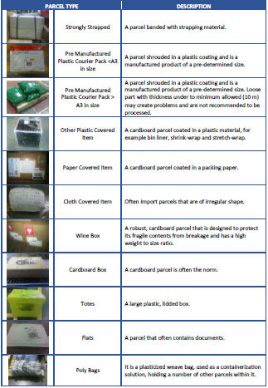

Proposed System Description

Objective
The purpose of this proposal is to present the design, manufacturing, installation, commissioning, testing, and acceptance testing of the Loop CBS for sorting shipment, Bags & Semi-Large Shipments as per Flipkart’s requirements.
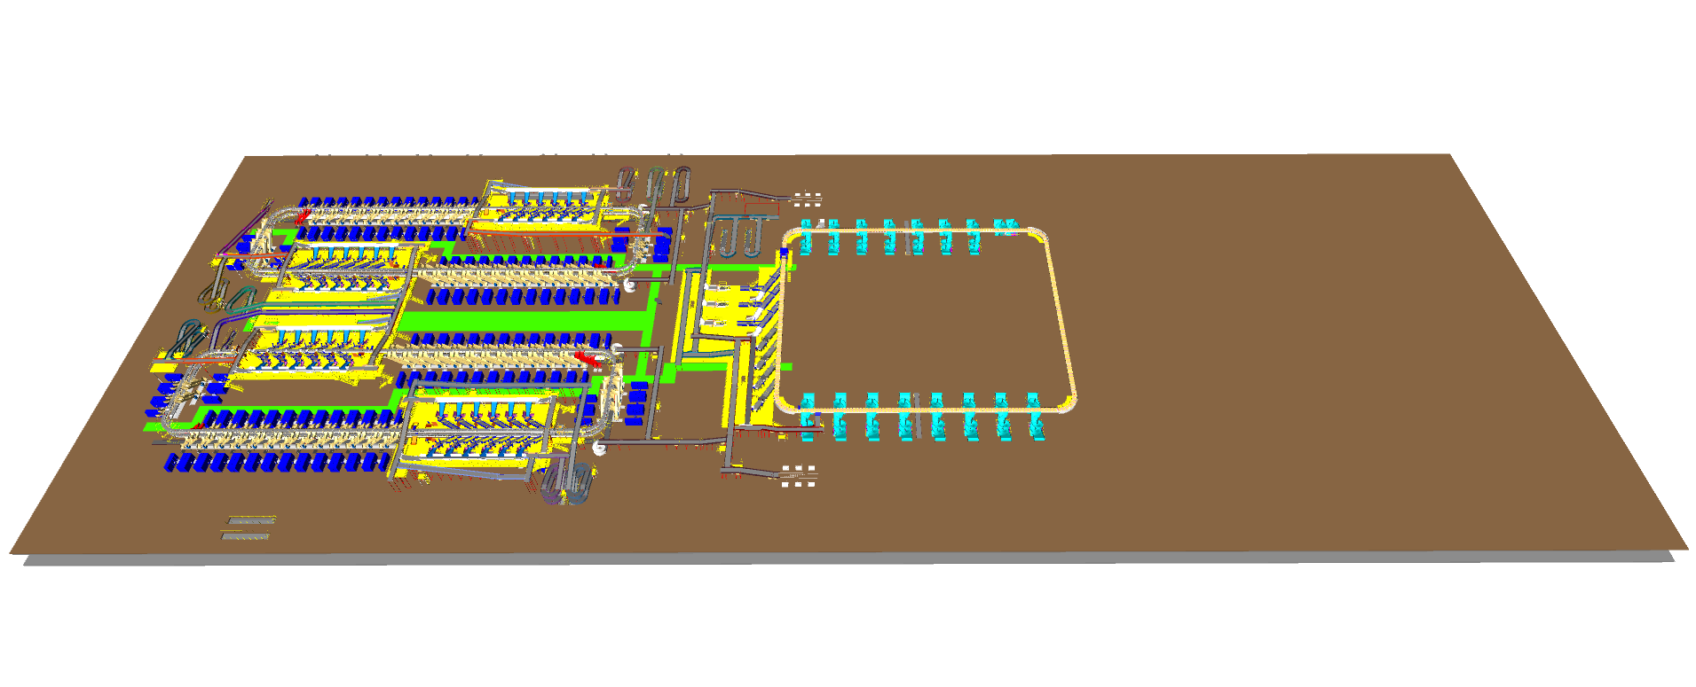

Summary of the System

Process flow of the Non-Large Shipment Loop CBS System-
- Infeed System: - Shipments Bags are unsealed and dumped in bulk onto the infeed lines of the Cross belt sorter. The shipments ascend to a higher level and arrive at the VDS system. Once the shipments are within the VDS loop, they are evenly distributed among all inducts using Tilted Gate VDS technology.
A separate priority line is provided, that directly transport high priority shipments to VDS zone of North shipment sorter.
- Inducts: - After the shipments are collected in the VDS chute, an operator picks and positions each shipment on the induct line, ensuring that the shipment is properly aligned and that its barcode is facing upwards. The feedlines then automatically induct the shipments onto the Cross-Belt Sorter Loop.
- Loop CBS: - Once the shipments have entered the main loop, the Cross-Belt Sorter (CBS) efficiently sorts the shipments into their respective output chutes by utilizing the data provided by Flipkart's sorting logic.
- Output Chutes: - The shipments are discharged into two types of chutes.
  - Direct Bagging Chutes (L-type) - Within a double decker loop CBS system, there are a total of 60 L-Type direct bagging chutes. Shipments collected within these direct bagging chutes are bagged.
  - Secondary Chutes (L-type) - Within a double decker loop CBS system, there are a total of 60 L-Type Secondary chutes. Shipments collected within these secondary chutes Further undergo sortation via PTL setup (In FK Scope).

  - Rejection Chute- Four rejection chutes are present to handle rejected Shipments.
- Bag Takeaway Conveyor: - Following the direct bagging process & secondary sorting process, the shipments are placed into bags and then manually loaded onto a bag takeaway conveyor located beneath the CBS loop. This conveyor transports the bags out of shipment sorter to bag & Semi-large sorter located in the centre of the facility.
Process flow of the Bag & Semi-large Loop CBS System-
- Infeed System: - Bags from Shipment sorter & Cross dock Bags are dumped onto the infeed lines of the Bag & Semi-large CBS sorter.
Semi-large shipments from Fulfilment centre & Cross dock are also loaded on the conveyors, the Semi-large Shipments ascend to a higher level and arrive at the VDS system of the Bag & Semi-large sorter.
Once the Bags & semi-large Shipments are within the VDS loop, they are evenly distributed among all inducts of the loop CBS.
- Inducts: - After the bags reaches the VDS loops, bags are collected from the VDS loop manually, an operator picks, positions & scan each Bag on the induct line of the sorter whereas Semi-large shipments are diverted with the help of SWEDI diverters & then these shipment are automatically inducted via fully auto inducts onto the Cross-Belt Sorter Loop.
- Loop CBS: - Once the Bags & Semi-large shipments have entered the main XL loop, the Cross-Belt Sorter (CBS) efficiently sorts the bags & Semi-large shipment into their respective output spiral chutes by utilizing the data provided by Flipkart.
- Output Chutes: - The shipments are discharged into two types of chutes.
  - Spiral Chutes - Within a single-loop CBS system, there are a total of 32 spiral chutes. Bags & Semi-large shipments are sorted into these spiral chutes and descend down to mezzanine level, where it further gets sorted via PTL setup (In FK scope).
  - Rejection Chute- Two rejection chute is present to handle rejected Shipments.
Refeed line: - Bags & shipments collected in these spirals further follow the refeed conveyor & reaches induction zone of the Loop CBS for refeeding.
Two Powered conveyor is provided beneath Bags & shipments loop CBS at two sides to transport the bags within the Manual sortation area.
- Contingency line: - Bidirectional conveyor are present on both sides of Bag & Semilarge VDS, In case of contingency situation, provision of Diverting Bags & Shipments towards manual sorting area is provided.

Main benefits of the proposed solution
The proposed solution has the following advantages:

- High operational throughput
- Ability to serve entire range of conveyable Shipments with a sorter’s speed of up to 2.1 m/s for NL Shipment sorter & 2.3 m/s for SL & Bag sorter.
- Low occupancy of floor space in the building.
- Narrow discharge centers for the increased number of splits in limited space.
- FALCON’s CBS can adapt to changing business requirements by adjusting its speed.
to match the operational throughput requirement, thereby leading to Power Savings
and reduced system Wear & Tear.

Concept Description

Shipment Sorter
- Non-Large Shipments
- Bags

Fulfillment Center (Future scope)
Priority Line
Marketplace




Infeed System


Volume distribution system


Irregular Takeout conveyor

Induct Lines

Shipment Loop CBS






Rejection Chutes
Secondary Chutes
Direct Bagging



Secondary sortation station
In FK scope)
Manual processing (In FK scope)




Bag takeaway conveyor

Semi-Large + Bag Sorter
- Semi-Large Shipment
- Bags

Fulfillment Center (Future Scope)
Marketplace

Bag takeaway conveyor
Cross Dock Bag






Contingency Line
Volume distribution system(Bag & SL sorter)



Contingency Line




Induct Lines





Bag & Semi-large Loop CBS
Refeed Line






Rejection chute
Output chute - Spiral

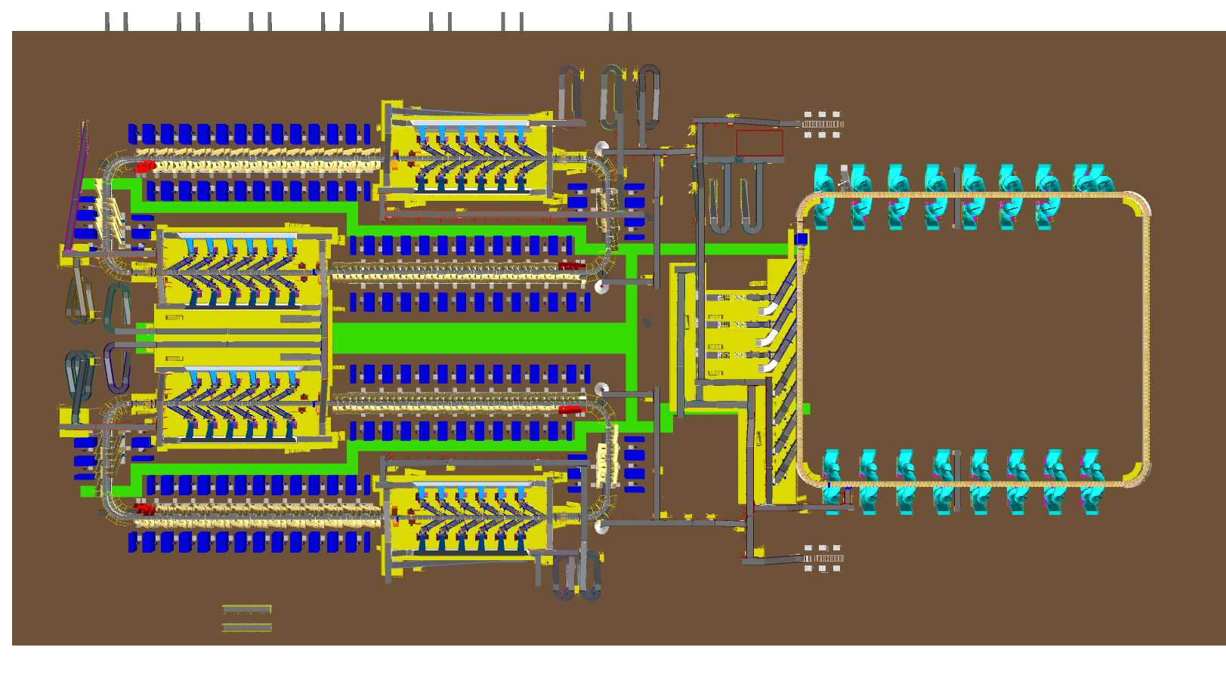
Layout Overview

2
4
3

2
1

5
4

1

4

Legend
1 – Shipment Sorter
2 – Cross Dock Lines
3 – Priority Line
4 – Market Place Lines
5 – Bags & Semi-Large Sorter

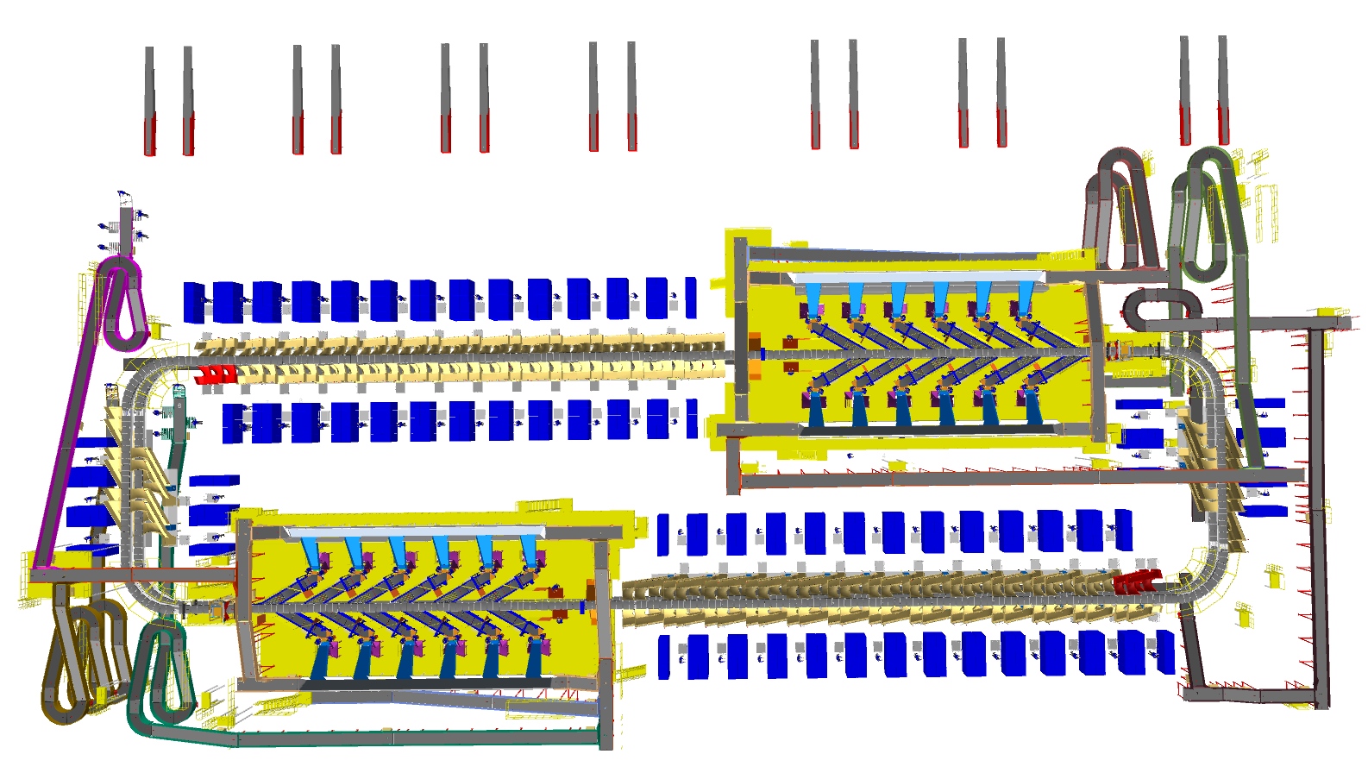
Layout View of Shipment Sorter
1

3
2
6
5

6
4
8
5
7
6
4

3

Legend
- Telescopic Belt Conveyor
- Priority Line
- Staircase Powered Conveyors
- VDS System & Inducts
- Main Loop CBS
- Output Chutes (Direct bagging & Secondary Chutes)
- Bag Takeout Conveyor
- Contingency Line

Proposed System Capacity Calculations

Sorter System Capacity
The following table shows the throughput calculation for the sortation system designed based on Flipkart RFP requirements.

SPECIFICATION | VALUE
Sorter Type | Loop CBS
Speed | 2.1 m/s
Pitch | 1175 mm
Carrier per hour | 6,434 CPH
Belts per hour | 12,868 BPH
Effective Designed Throughput of 1 loop CBS (A) | 25,736 Shipments per hour
Per Feedline Capacity | 2,000 Shipments per hour
No of Feedlines (Both Zones) | 12 Nos.
Total Feedline designed capacity (B) | 24,000 Shipments per hour
System designed throughput (Min of A&B) | 24,000 Shipments per hour
System designed throughput from 1 Double deck | 48,000 Shipments per hour
Designed throughput from 2 Double Decks | 96,000 Shipments per hour

System description

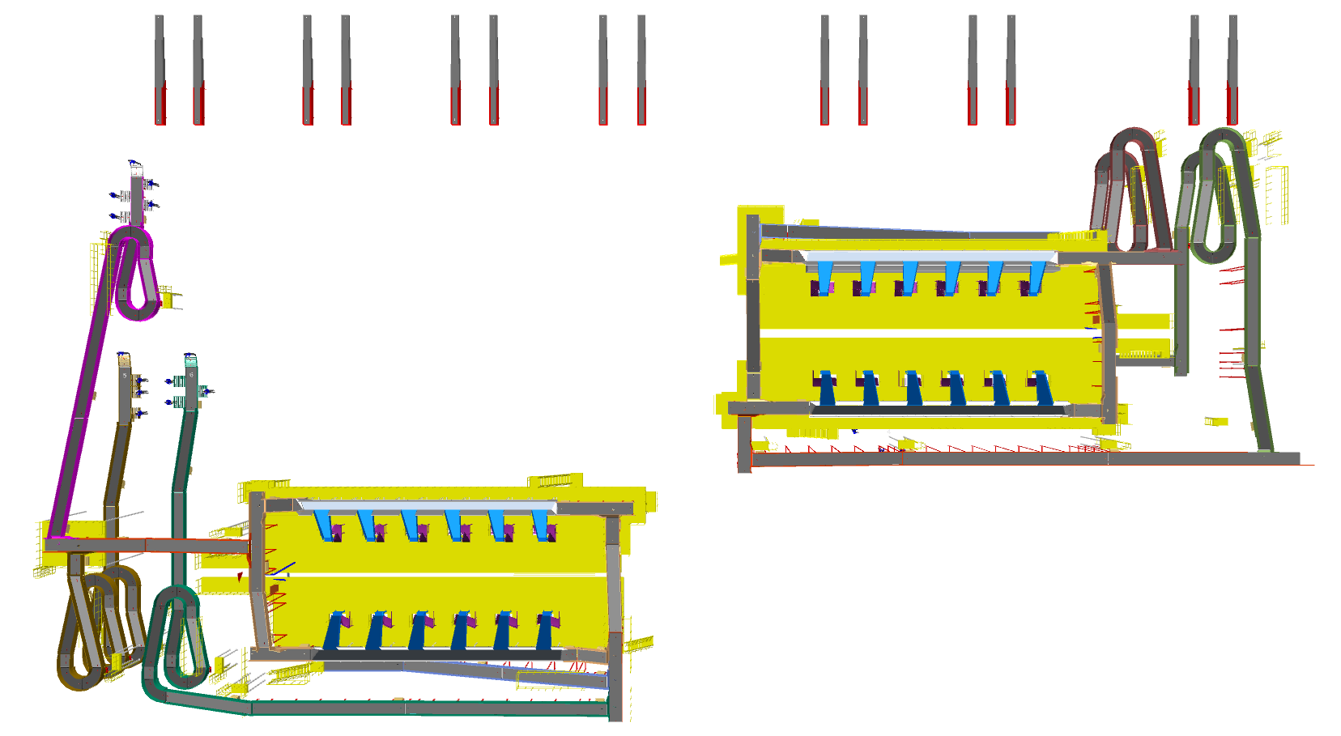
Infeed System (Non-Large Shipment Sorter)

The layout presents entire conveyors used as infeed conveyors of the non-large shipment sorters.
Each Zone is connected with conveyor network to receive shipment volume from Market place, Additionally a priority line is provide to transport high priority shipments, Prob

Conveyor BOQ

S.No | Name | EL_1 | EL_2 | Length (m) | Width (mm) | Set
1 | PVC Belt Conveyor | 11001 | 11001 | 6 | 1210 | 1
2 | PVC Belt Conveyor | 12751 | 12751 | 10 | 1210 | 1
3 | PVC Belt Conveyor | 11001 | 11001 | 6 | 1210 | 1
4 | PVC Belt Conveyor | 13251 | 13251 | 5 | 1210 | 1
5 | PVC Belt Conveyor | 13251 | 13251 | 5 | 1210 | 1
6 | PVC Belt Conveyor | 12751 | 12751 | 10 | 1210 | 1
7 | PVC Belt Conveyor | 11001 | 11250 | 20 | 1210 | 1
8 | PVC Belt Conveyor | 11001 | 11001 | 9 | 1210 | 1
9 | PVC Belt Conveyor | 11001 | 11250 | 20 | 1210 | 1
10 | PVC Belt Conveyor | 12751 | 12751 | 8 | 1210 | 1
11 | PVC Belt Conveyor | 12750 | 12750 | 13 | 1210 | 1
12 | PVC Belt Conveyor | 11001 | 11001 | 10 | 1210 | 1
13 | PVC Belt Conveyor | 13001 | 13001 | 8 | 1210 | 1
14 | PVC Belt Conveyor | 13251 | 13251 | 2 | 1210 | 1
15 | PVC Belt Conveyor | 13001 | 13001 | 7 | 1210 | 1
16 | PVC Belt Conveyor | 11001 | 11001 | 9 | 1210 | 1
17 | PVC Belt Conveyor | 12218 | 12218 | 20 | 1210 | 1
18 | PVC Belt Conveyor | 12320 | 12320 | 1 | 1210 | 1
19 | PVC Belt Conveyor | 12320 | 12320 | 1 | 1210 | 1
20 | PVC Belt Conveyor | 12320 | 12320 | 1 | 1210 | 1
21 | PVC Belt Conveyor | 12320 | 12320 | 1 | 1210 | 1
22 | PVC Belt Conveyor | 10901 | 13350 | 9 | 1210 | 1
23 | PVC Belt Conveyor | 10901 | 13350 | 9 | 1210 | 1
24 | PVC Belt Conveyor | 12652 | 11370 | 6 | 1210 | 1
25 | PVC Belt Conveyor | 10221 | 11202 | 3 | 1210 | 1
26 | PVC Belt Conveyor | 12221 | 12957 | 2 | 1210 | 1
27 | PVC Belt Conveyor | 12140 | 13075 | 10 | 1210 | 1
28 | PVC Belt Conveyor | 12637 | 13057 | 13 | 1210 | 1
29 | PVC Belt Conveyor | 12221 | 12957 | 2 | 1210 | 1
30 | PVC Belt Conveyor | 12652 | 11370 | 6 | 1210 | 1
31 | PVC Belt Conveyor | 10221 | 11202 | 3 | 1210 | 1
32 | PVC Belt Conveyor | 11000 | 11000 | 15 | 1210 | 1
33 | PVC Belt Conveyor | 9822 | 9822 | 6 | 1210 | 1
34 | PVC Belt Conveyor | 9572 | 9572 | 3 | 1210 | 1
35 | PVC Belt Conveyor | 9470 | 12832 | 13 | 1210 | 1
36 | PVC Belt Conveyor | 10150 | 12464 | 8 | 1210 | 1
37 | PVC Belt Conveyor | 12221 | 12957 | 2 | 1210 | 1
38 | PVC Belt Conveyor | 10221 | 11202 | 3 | 1210 | 1
39 | PVC Belt Conveyor | 12652 | 11370 | 6 | 1210 | 1
40 | PVC Belt Conveyor | 12390 | 13536 | 13 | 1210 | 1
41 | PVC Belt Conveyor | 10221 | 11202 | 3 | 1210 | 1
42 | PVC Belt Conveyor | 12652 | 11370 | 6 | 1210 | 1
43 | PVC Belt Conveyor | 12108 | 13544 | 15 | 1210 | 1
44 | PVC Belt Conveyor | 12221 | 12957 | 2 | 1210 | 1
45 | PVC Belt Conveyor | 10901 | 13350 | 9 | 1210 | 1
46 | PVC Belt Conveyor | 10901 | 13350 | 9 | 1210 | 1
47 | PVC Belt Conveyor | 10320 | 10320 | 1 | 1210 | 1
48 | PVC Belt Conveyor | 10320 | 10320 | 1 | 1210 | 1
49 | PVC Belt Conveyor | 10320 | 10320 | 1 | 1210 | 1
50 | PVC Belt Conveyor | 10320 | 10320 | 1 | 1210 | 1
51 | PVC Belt Conveyor | 10251 | 10251 | 12 | 1210 | 1
52 | PVC Belt Conveyor | 11001 | 11001 | 12 | 1210 | 1
53 | PVC Belt Conveyor | 12751 | 12751 | 10 | 1210 | 1
54 | PVC Belt Conveyor | 11001 | 11001 | 6 | 1210 | 1
55 | PVC Belt Conveyor | 12751 | 12751 | 10 | 1210 | 1
56 | PVC Belt Conveyor | 13251 | 13251 | 2 | 1210 | 1
57 | PVC Belt Conveyor | 12501 | 12501 | 12 | 1210 | 1
58 | PVC Belt Conveyor | 12501 | 12501 | 18 | 1210 | 1
59 | PVC Belt Conveyor | 12250 | 12250 | 10 | 1210 | 1
60 | PVC Belt Conveyor | 11000 | 11000 | 15 | 1210 | 1
61 | PVC Belt Conveyor | 13001 | 13001 | 7 | 1210 | 1
62 | PVC Belt Conveyor | 13251 | 13251 | 2 | 1210 | 1
63 | PVC Belt Conveyor | 12218 | 12218 | 20 | 1210 | 1
64 | PVC Belt Conveyor | 11001 | 11001 | 9 | 1210 | 1
65 | PVC Belt Conveyor | 13001 | 13001 | 8 | 1210 | 1
66 | PVC Belt Conveyor | 13251 | 13251 | 2 | 1210 | 1
67 | PVC Belt Conveyor | 600 | 600 | 5 | 1210 | 1
68 | PVC Belt Conveyor | 2950 | 2950 | 9 | 1210 | 1
69 | PVC Belt Conveyor | 498 | 3030 | 10 | 1210 | 1
70 | PVC Belt Conveyor | 2700 | 2700 | 15 | 1210 | 1
71 | PVC Belt Conveyor | 498 | 3030 | 10 | 1210 | 1
72 | PVC Belt Conveyor | 2700 | 2700 | 19 | 1210 | 1
73 | PVC Belt Conveyor | 2700 | 2700 | 20 | 1210 | 1
74 | PVC Belt Conveyor | 498 | 3030 | 10 | 1210 | 1
75 | PVC Belt Conveyor | 2700 | 2700 | 18 | 1210 | 1
76 | PVC Belt Conveyor | 2700 | 2700 | 20 | 1210 | 1
77 | PVC Belt Conveyor | 2702 | 3095 | 10 | 1210 | 1
78 | PVC Belt Conveyor | 2950 | 2950 | 10 | 1210 | 1
79 | PVC Belt Conveyor | 2950 | 2950 | 4 | 1210 | 1
80 | PVC Belt Conveyor | 2700 | 2700 | 8 | 1210 | 1
81 | S3 (MDR PVC Belt Conveyor) | 4051 | 4051 | 1 | 1210 | 1
82 | S3 (MDR PVC Belt Conveyor) | 5900 | 5900 | 2 | 1210 | 1
83 | S3 (MDR PVC Belt Conveyor) | 4051 | 4051 | 1 | 1210 | 1
84 | S3 (MDR PVC Belt Conveyor) | 5899 | 5899 | 1 | 1210 | 1
85 | S3 (MDR PVC Belt Conveyor) | 7298 | 7298 | 1 | 1210 | 1
86 | S3 (MDR PVC Belt Conveyor) | 8673 | 8673 | 1 | 1210 | 1
87 | S3 (MDR PVC Belt Conveyor) | 10072 | 10072 | 1 | 1210 | 1
88 | PVC Belt Conveyor | 450 | 450 | 4 | 1210 | 1
89 | S3 (MDR PVC Belt Conveyor) | 2666 | 2666 | 1 | 1210 | 1
90 | S3 (MDR PVC Belt Conveyor) | 3976 | 3976 | 1 | 1210 | 1
91 | S3 (MDR PVC Belt Conveyor) | 5916 | 7844 | 6 | 1210 | 1
92 | S3 (MDR PVC Belt Conveyor) | 2601 | 4040 | 5 | 1210 | 1
93 | S3 (MDR PVC Belt Conveyor) | 4043 | 5970 | 6 | 1210 | 1
94 | S3 (MDR PVC Belt Conveyor) | 5916 | 7844 | 6 | 1210 | 1
95 | PVC Belt Conveyor | 600 | 600 | 6 | 1210 | 1
96 | PVC Belt Conveyor | 2700 | 2700 | 15 | 1210 | 1
97 | S3 (MDR PVC Belt Conveyor) | 2692 | 4064 | 4 | 1210 | 1
98 | S3 (MDR PVC Belt Conveyor) | 4091 | 5858 | 6 | 1210 | 1
99 | PVC Belt Conveyor | 9487 | 12577 | 10 | 1210 | 1
100 | PVC Belt Conveyor | 12500 | 12500 | 2 | 1210 | 1
101 | S3 (MDR PVC Belt Conveyor) | 5885 | 7653 | 6 | 1210 | 1
102 | S3 (MDR PVC Belt Conveyor) | 9471 | 9471 | 1 | 1210 | 1
103 | PVC Belt Conveyor | 3200 | 3200 | 13 | 1210 | 1
104 | PVC Belt Conveyor | 498 | 3280 | 11 | 1210 | 1
105 | PVC Belt Conveyor | 2950 | 2950 | 3 | 1210 | 1
106 | S3 (MDR PVC Belt Conveyor) | 2692 | 4064 | 4 | 1210 | 1
107 | S3 (MDR PVC Belt Conveyor) | 4091 | 5858 | 6 | 1210 | 1
108 | PVC Belt Conveyor | 9487 | 13037 | 12 | 1210 | 1
109 | S3 (MDR PVC Belt Conveyor) | 7663 | 7663 | 1 | 1210 | 1
110 | S3 (MDR PVC Belt Conveyor) | 7693 | 9460 | 6 | 1210 | 1
111 | PVC Belt Conveyor | 498 | 2780 | 9 | 1210 | 1
112 | S3 (MDR PVC Belt Conveyor) | 4051 | 4051 | 1 | 1210 | 1
113 | S3 (MDR PVC Belt Conveyor) | 5889 | 5889 | 1 | 1210 | 1
114 | S3 (MDR PVC Belt Conveyor) | 7749 | 7749 | 1 | 1210 | 1
115 | PVC Belt Conveyor | 498 | 3280 | 11 | 1210 | 1
116 | PVC Belt Conveyor | 3200 | 3200 | 10 | 1210 | 1
117 | S3 (MDR PVC Belt Conveyor) | 2601 | 4040 | 5 | 1210 | 1
118 | S3 (MDR PVC Belt Conveyor) | 4043 | 5879 | 6 | 1210 | 1
119 | S3 (MDR PVC Belt Conveyor) | 5906 | 7741 | 6 | 1210 | 1
120 | PVC Belt Conveyor | 9214 | 12465 | 12 | 1210 | 1
121 | PVC Belt Conveyor | 2700 | 2700 | 8 | 1210 | 1
122 | S3 (MDR PVC Belt Conveyor) | 4051 | 4051 | 1 | 1210 | 1
123 | S3 (MDR PVC Belt Conveyor) | 5899 | 5899 | 1 | 1210 | 1
124 | S3 (MDR PVC Belt Conveyor) | 7298 | 7298 | 1 | 1210 | 1
125 | S3 (MDR PVC Belt Conveyor) | 8673 | 8673 | 1 | 1210 | 1
126 | S3 (MDR PVC Belt Conveyor) | 10072 | 10072 | 1 | 1210 | 1
127 | S3 (MDR PVC Belt Conveyor) | 8689 | 10061 | 4 | 1210 | 1
128 | S3 (MDR PVC Belt Conveyor) | 7290 | 8662 | 4 | 1210 | 1
129 | S3 (MDR PVC Belt Conveyor) | 5915 | 7287 | 4 | 1210 | 1
130 | S3 (MDR PVC Belt Conveyor) | 4043 | 5891 | 6 | 1210 | 1
131 | S3 (MDR PVC Belt Conveyor) | 2601 | 4040 | 5 | 1210 | 1
132 | PVC Belt Conveyor | 3991 | 9184 | 18 | 1210 | 1
133 | PVC Belt Conveyor | 2700 | 2700 | 4 | 1210 | 1
134 | S3 (MDR PVC Belt Conveyor) | 7749 | 7749 | 1 | 1210 | 1
135 | S3 (MDR PVC Belt Conveyor) | 5889 | 5889 | 1 | 1210 | 1
136 | S3 (MDR PVC Belt Conveyor) | 4051 | 4051 | 1 | 1210 | 1
137 | PVC Belt Conveyor | 7754 | 11078 | 11 | 1210 | 1
138 | PVC Belt Conveyor | 2950 | 2950 | 6 | 1210 | 1
139 | PVC Belt Conveyor | 3200 | 3200 | 20 | 1210 | 1
140 | PVC Belt Conveyor | 600 | 600 | 5 | 1210 | 1
141 | S3 (MDR PVC Belt Conveyor) | 5906 | 7741 | 6 | 1210 | 1
142 | S3 (MDR PVC Belt Conveyor) | 4043 | 5879 | 6 | 1210 | 1
143 | S3 (MDR PVC Belt Conveyor) | 2601 | 4040 | 5 | 1210 | 1
144 | PVC Belt Conveyor | 7754 | 11078 | 11 | 1210 | 1
145 | PVC Belt Conveyor | 2700 | 2700 | 12 | 1210 | 1
146 | PVC Belt Conveyor | 600 | 600 | 5 | 1210 | 1
147 | S3 (MDR PVC Belt Conveyor) | 9471 | 9471 | 1 | 1210 | 1
148 | S3 (MDR PVC Belt Conveyor) | 5885 | 7653 | 6 | 1210 | 1
149 | PVC Belt Conveyor | 12961 | 12961 | 2 | 1210 | 1
150 | S3 (MDR PVC Belt Conveyor) | 5869 | 5869 | 1 | 1210 | 1
151 | S3 (MDR PVC Belt Conveyor) | 4074 | 4074 | 3 | 1210 | 1
152 | PVC Belt Conveyor | 2700 | 2700 | 11 | 1210 | 1
153 | PVC Belt Conveyor | 2950 | 2950 | 18 | 1210 | 1
154 | PVC Belt Conveyor | 3200 | 3200 | 20 | 1210 | 1
155 | PVC Belt Conveyor | 600 | 600 | 5 | 1210 | 1
156 | S3 (MDR PVC Belt Conveyor) | 7693 | 9460 | 6 | 1210 | 1
157 | S3 (MDR PVC Belt Conveyor) | 7663 | 7663 | 1 | 1210 | 1
158 | S3 (MDR PVC Belt Conveyor) | 5869 | 5869 | 1 | 1210 | 1
159 | S3 (MDR PVC Belt Conveyor) | 4074 | 4074 | 3 | 1210 | 1
160 | PVC Belt Conveyor | 498 | 2780 | 9 | 1210 | 1
161 | S3 (MDR PVC Belt Conveyor) | 7788 | 10326 | 9 | 1210 | 1
162 | S3 (MDR PVC Belt Conveyor) | 7773 | 7773 | 3 | 1210 | 1
163 | S3 (MDR PVC Belt Conveyor) | 5900 | 5900 | 2 | 1210 | 1
164 | S3 (MDR PVC Belt Conveyor) | 4051 | 4051 | 1 | 1210 | 1
165 | S3 (MDR PVC Belt Conveyor) | 7790 | 11146 | 11 | 1210 | 1
166 | S3 (MDR PVC Belt Conveyor) | 7773 | 7773 | 3 | 1210 | 1
167 | S3 (MDR PVC Belt Conveyor) | 2659 | 4046 | 4 | 1210 | 1
168 | S3 (MDR PVC Belt Conveyor) | 351 | 2656 | 7 | 1210 | 1
169 | PVC Belt Conveyor | 10080 | 11273 | 8 | 1210 | 1
170 | S3 (MDR PVC Belt Conveyor) | 8689 | 10061 | 4 | 1210 | 1
171 | S3 (MDR PVC Belt Conveyor) | 7290 | 8662 | 4 | 1210 | 1
172 | S3 (MDR PVC Belt Conveyor) | 5915 | 7287 | 4 | 1210 | 1
173 | S3 (MDR PVC Belt Conveyor) | 4043 | 5891 | 6 | 1210 | 1
174 | S3 (MDR PVC Belt Conveyor) | 2601 | 4040 | 5 | 1210 | 1
175 | S3 (MDR PVC Belt Conveyor) | 4043 | 5970 | 6 | 1210 | 1
176 | S3 (MDR PVC Belt Conveyor) | 2601 | 4040 | 5 | 1210 | 1
177 | PVC Belt Conveyor | 2950 | 2950 | 8 | 1210 | 1
178 | PVC Belt Conveyor | 2700 | 2700 | 10 | 1210 | 1
179 | PVC Belt Conveyor | 2790 | 2790 | 17 | 1210 | 1
180 | PVC Belt Conveyor | 2702 | 3257 | 16 | 1210 | 1
181 | PVC Belt Conveyor | 2700 | 2700 | 20 | 1210 | 1
182 | PVC Belt Conveyor | 2950 | 2950 | 20 | 1210 | 1
183 | PVC Belt Conveyor | 600 | 600 | 5 | 1210 | 1
184 | PVC Belt Conveyor | 2700 | 2700 | 20 | 1210 | 1
185 | PVC Belt Conveyor | 2950 | 2950 | 19 | 1210 | 1
186 | PVC Belt Conveyor | 600 | 600 | 5 | 1210 | 1
187 | PVC Belt Conveyor | 2950 | 2950 | 18 | 1210 | 1
188 | PVC Belt Conveyor | 600 | 600 | 5 | 1210 | 1
189 | PVC Belt Conveyor | 498 | 3030 | 10 | 1210 | 1
190 | Boom Conveyor | 850 | 850 | NA | NA | 1
191 | Boom Conveyor | 850 | 850 | NA | NA | 1
192 | Boom Conveyor | 850 | 850 | NA | NA | 1
193 | Boom Conveyor | 850 | 850 | NA | NA | 1
194 | Boom Conveyor | 850 | 850 | NA | NA | 1
195 | Boom Conveyor | 850 | 850 | NA | NA | 1
196 | Boom Conveyor | 850 | 850 | NA | NA | 1
197 | Gravity Roller Conveyor | 750 | 650 | 1 | 1200 | 1
198 | Gravity Roller Conveyor | 750 | 650 | 1 | 1200 | 1
199 | Gravity Roller Conveyor | 750 | 650 | 1 | 1200 | 1
200 | Gravity Roller Conveyor | 750 | 650 | 1 | 1200 | 1
201 | Gravity Roller Conveyor | 750 | 650 | 1 | 1200 | 1
202 | Gravity Roller Conveyor | 750 | 650 | 1 | 1200 | 1
203 | Gravity Roller Conveyor | 750 | 650 | 1 | 1200 | 1
204 | Gravity Roller Conveyor | 750 | 650 | 1 | 1200 | 1
205 | Belt Turn (1200mm_180_deg) | 5900 | 5900 | NA | NA | 1
206 | Belt Turn (1200mm_180_deg) | 5899 | 5899 | NA | NA | 1
207 | Belt Turn (1200mm_180_deg) | 8673 | 8673 | NA | NA | 1
208 | Belt Turn (1200mm_180_deg) | 3976 | 3976 | NA | NA | 1
209 | Gravity Roller Conveyor | 550 | 450 | 1 | 1200 | 1
210 | Gravity Roller Conveyor | 550 | 450 | 1 | 1200 | 1
211 | Belt Turn (1200mm_180_deg) | 7773 | 7773 | NA | NA | 1
212 | Belt Turn (1200mm_180_deg) | 4051 | 4051 | NA | NA | 1
213 | Belt Turn (1200mm_180_deg) | 7773 | 7773 | NA | NA | 1
214 | Gravity Roller Conveyor | 750 | 650 | 1 | 1200 | 1
215 | Belt Turn (1200mm_180_deg) | 4074 | 4074 | NA | NA | 1
216 | Belt Turn (1200mm_180_deg) | 7676 | 7676 | NA | NA | 1
217 | Gravity Roller Conveyor | 750 | 650 | 1 | 1200 | 1
218 | Belt Turn (1200mm_180_deg) | 2699 | 2699 | NA | NA | 1
219 | Belt Turn (1200mm_180_deg) | 5869 | 5869 | NA | NA | 1
220 | Belt Turn (1200mm_180_deg) | 9471 | 9471 | NA | NA | 1
221 | Gravity Roller Conveyor | 750 | 650 | 1 | 1200 | 1
222 | Gravity Roller Conveyor | 750 | 650 | 1 | 1200 | 1
223 | Gravity Roller Conveyor | 750 | 650 | 1 | 1200 | 1
224 | Belt Turn (1200mm_180_deg) | 5889 | 5889 | NA | NA | 1
225 | Gravity Roller Conveyor | 750 | 650 | 1 | 1200 | 1
226 | Belt Turn (1200mm_180_deg) | 4051 | 4051 | NA | NA | 1
227 | Belt Turn (1200mm_90_deg) | 7748 | 7748 | NA | NA | 1
228 | Gravity Roller Conveyor | 750 | 650 | 1 | 1200 | 1
229 | Gravity Roller Conveyor | 750 | 650 | 1 | 1200 | 1
230 | Gravity Roller Conveyor | 750 | 650 | 1 | 1200 | 1
231 | Gravity Roller Conveyor | 750 | 650 | 1 | 1200 | 1
232 | Belt Turn (1200mm_180_deg) | 7298 | 7298 | NA | NA | 1
233 | Belt Turn (1200mm_180_deg) | 8673 | 8673 | NA | NA | 1
234 | Belt Turn (1200mm_180_deg) | 5899 | 5899 | NA | NA | 1
235 | Belt Turn (1200mm_180_deg) | 4051 | 4051 | NA | NA | 1
236 | Gravity Roller Conveyor | 750 | 650 | 1 | 1200 | 1
237 | Gravity Roller Conveyor | 750 | 650 | 1 | 1200 | 1
238 | Belt Turn (1200mm_180_deg) | 5889 | 5889 | NA | NA | 1
239 | Gravity Roller Conveyor | 750 | 650 | 1 | 1200 | 1
240 | Gravity Roller Conveyor | 750 | 650 | 1 | 1200 | 1
241 | Belt Turn (1200mm_90_deg) | 7748 | 7748 | NA | NA | 1
242 | Belt Turn (1200mm_180_deg) | 4051 | 4051 | NA | NA | 1
243 | Gravity Roller Conveyor | 750 | 650 | 1 | 1200 | 1
244 | Belt Turn (1200mm_180_deg) | 7676 | 7676 | NA | NA | 1
245 | Belt Turn (1200mm_180_deg) | 4074 | 4074 | NA | NA | 1
246 | Gravity Roller Conveyor | 750 | 650 | 1 | 1200 | 1
247 | Gravity Roller Conveyor | 750 | 650 | 1 | 1200 | 1
248 | Belt Turn (1200mm_180_deg) | 9471 | 9471 | NA | NA | 1
249 | Belt Turn (1200mm_180_deg) | 5869 | 5869 | NA | NA | 1
250 | Belt Turn (1200mm_180_deg) | 2699 | 2699 | NA | NA | 1
251 | Gravity Roller Conveyor | 750 | 650 | 1 | 1200 | 1
252 | Belt Turn (1200mm_180_deg) | 5900 | 5900 | NA | NA | 1
253 | Gravity Roller Conveyor | 550 | 450 | 1 | 1200 | 1
254 | Gravity Roller Conveyor | 550 | 450 | 1 | 1200 | 1
255 | Belt Turn (1200mm_180_deg) | 2666 | 2666 | NA | NA | 1
256 | Belt Turn (1200mm_180_deg) | 10072 | 10072 | NA | NA | 1
257 | Belt Turn (1200mm_180_deg) | 7298 | 7298 | NA | NA | 1
258 | Belt Turn (1200mm_180_deg) | 4051 | 4051 | NA | NA | 1
259 | Belt Turn (1200mm_180_deg) | 4051 | 4051 | NA | NA | 1
260 | Gravity Roller Conveyor | 750 | 650 | 1 | 1200 | 1
261 | Gravity Roller Conveyor | 750 | 650 | 1 | 1200 | 1
262 | Gravity Roller Conveyor | 750 | 650 | 1 | 1200 | 1
263 | Gravity Roller Conveyor | 750 | 650 | 1 | 1200 | 1
264 | Gravity Roller Conveyor | 750 | 650 | 1 | 1200 | 1
265 | Gravity Roller Conveyor | 750 | 650 | 1 | 1200 | 1
266 | Boom Conveyor | 850 | 850 | NA | NA | 1
267 | Boom Conveyor | 850 | 850 | NA | NA | 1
268 | Boom Conveyor | 850 | 850 | NA | NA | 1
269 | Boom Conveyor | 850 | 850 | NA | NA | 1
270 | Boom Conveyor | 850 | 850 | NA | NA | 1
271 | Boom Conveyor | 850 | 850 | NA | NA | 1
272 | Boom Conveyor | 850 | 850 | NA | NA | 1
273 | Tilted Gate VDS | 13000 | 13000 | 25 | 1200 | 1
274 | Tilted Gate VDS | 13000 | 13000 | 25 | 1200 | 1
275 | Tilted Gate VDS | 13000 | 13000 | 25 | 1200 | 1
276 | Tilted Gate VDS | 13000 | 13000 | 25 | 1200 | 1
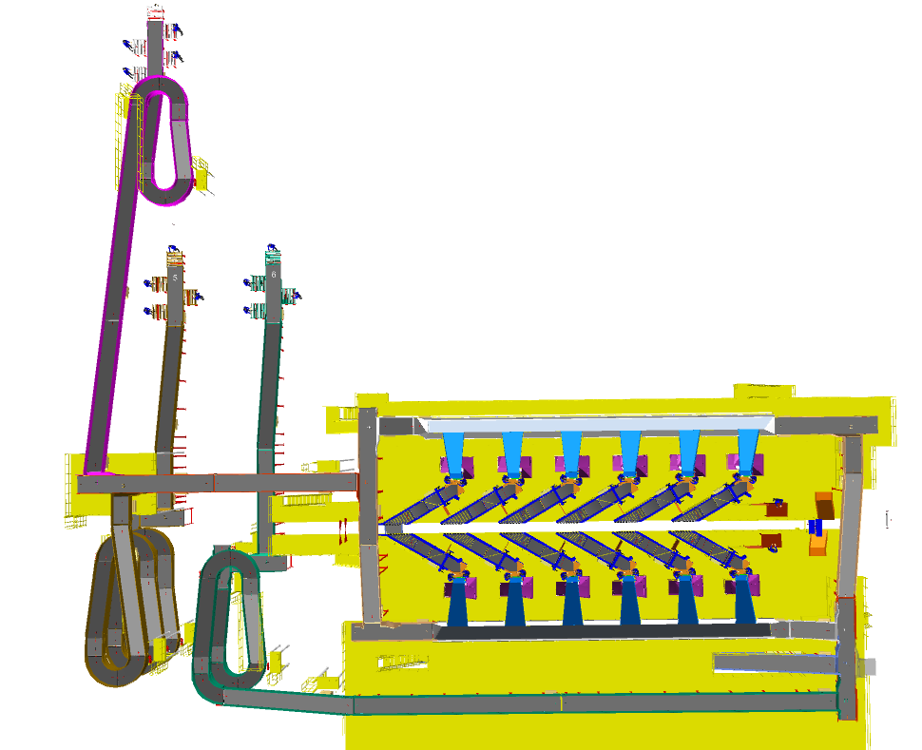
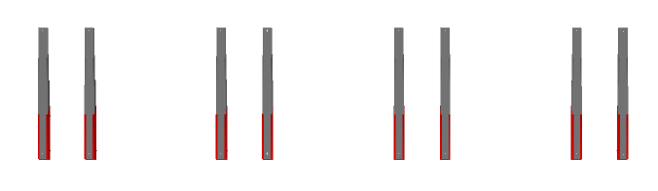

Infeed System
1

2

4
5

5
4
6
3
3

Legend
- Telescopic belt conveyor
- Infeed Conveyor (Priority Line)
- Infeed Staircase Conveyor (Market Place Volume)
- VDS Loop
- VDS Chutes
- Refeed line

Every CBS loop is equipped with two set of Staircase conveyors for facilitating the movement of Marketplace shipment volume to VDS loop. Additionally, each loop features two Rejection/DBO refeed lines for transporting processed shipments back to Inducts.

Infeed System Description
Infeed conveyor system consists of below components:
- Telescopic Belt Conveyors
- Straight PVC Conveyor
- Inclined PVC Conveyor
- Turns
- VDS System (Tilted Belt)
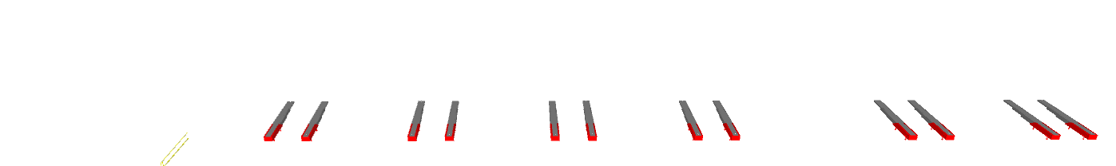
- VDS Chute
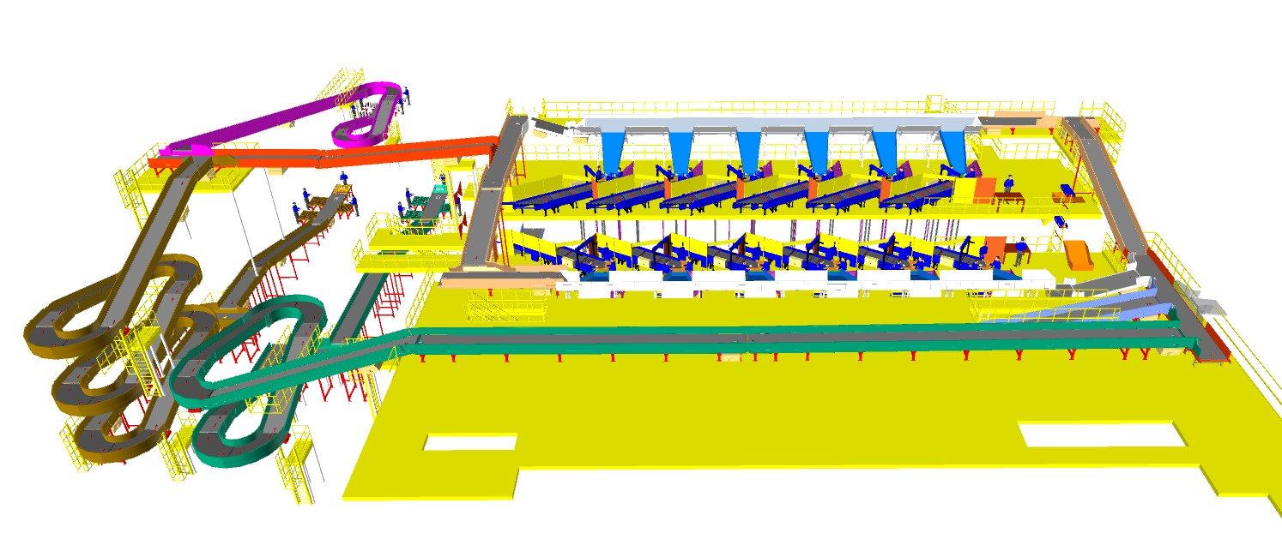
1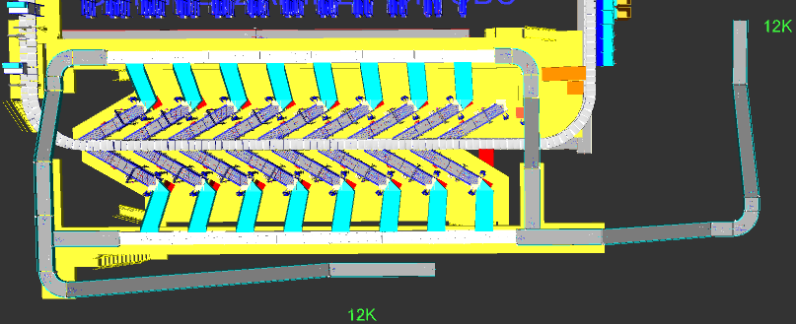

5
3
6
2
3

2

4
2

Telescopic Belt Conveyor
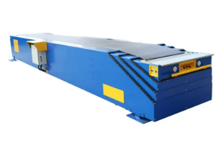

Specification | UOM | Remark
Manufacturer Name | Name | Falcon Autotech
Base Length | Mm | 6000
Extended Length (Total Length) | Mm | 18000
Motor Rating | Type | 0.75 Kw, 415V AC, 50 Hz

Straight and Inclined Powered Belt Conveyor

Falcon’s Belt Conveyors are modular & robust in design, used for smooth conveying of products over Straight, inclined and declined paths. MS profile is used to build conveyor frame.

The conveyors are supplied with the necessary supports and bolts to fix them to the supporting plane, as well as with the junction elements allowing easy and jam-free passage from one conveyor to the other.
Some Silent Features of Falcon’s Belt conveyor:
- Low Noise
- Maximum uptime.
- Minimal maintenance
- High safety standards.
- Fastest ROI.
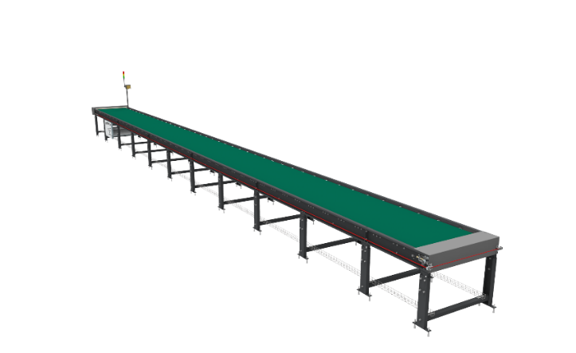

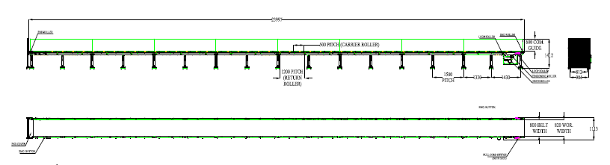

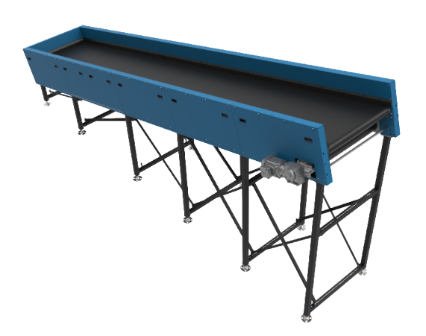
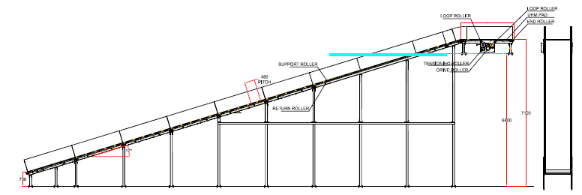

Specification | UOM | Remark
Manufacturer Name | Name | Falcon Autotech
Material of Roller | Type | MS Rollers with Zinc Plating
MOC of Belt | Type | PVC
Belt Thickness | mm | 3
Belt Finish | Type | Matt Finish
Belt width | mm | 1200
Belt Joint Type | Type | Vulcanized, Endless Belts
Belt Make/Model No. | Make | FORBO/DERCO
Chassis | mm | MS, 3mm Thick, Powder Coated-75 Microns
Idler Roller Pitch on running side (Top) | mm | 480
Idler Roller Specs | Spec | Dia.50.8, shaft-12 mm, bearing-6301
End Rollers | Spec | Dia 81.2 x 2.85 Thick, 30mm Shaft Dia, & Bearing Size-UCFH206D1, MOC-EN9, Zinc Plated -25 microns
Drive Rollers | Spec | OUTER Dia 178 PIPE Dia 168x5 Thick, 40mm Shaft Dia, & Bearing Size-UCF208D1, MOC(SHAFT)-EN9, NEOPRENE RUBBER COATING
Motor Shaft | MOC | EN9 Shaft material
Conveyor Under guarding | Spec | MOC-MS, 0.8 to 1mm thickness, Steel Stiffeners at every 600mm to avoid the sagging due to self-weight
Load capacity per unit length of Conveyor | kg/m | 50
Type of Guides | Type | Steel guides at 50mm/400mm height basis the position of conveyor on both sides from Conveyor Belt Surface.
Drive Power Rating | kW | Motor Rating depends on Length of the Conveyor
Type of Motor | Type | AC Geared Motor
Ingress Protection | Type | IP 55
Type of Drive System | Type | Direct Shaft Mounted Motor/ Flange Mounted
Type of Drive | Type | Chain drive/Torque Arm type
Gear Motor | make | Sew/Nord
Drive | make | Lenze/Siemens/Omron/Allen Bradly
Insulation Class | Type | Yes
Conveyor Speed | m/s | Variable speed to meet TPH requirements
Type of Mounts | Type | Fixed Heights Legs with Grouting Provisions

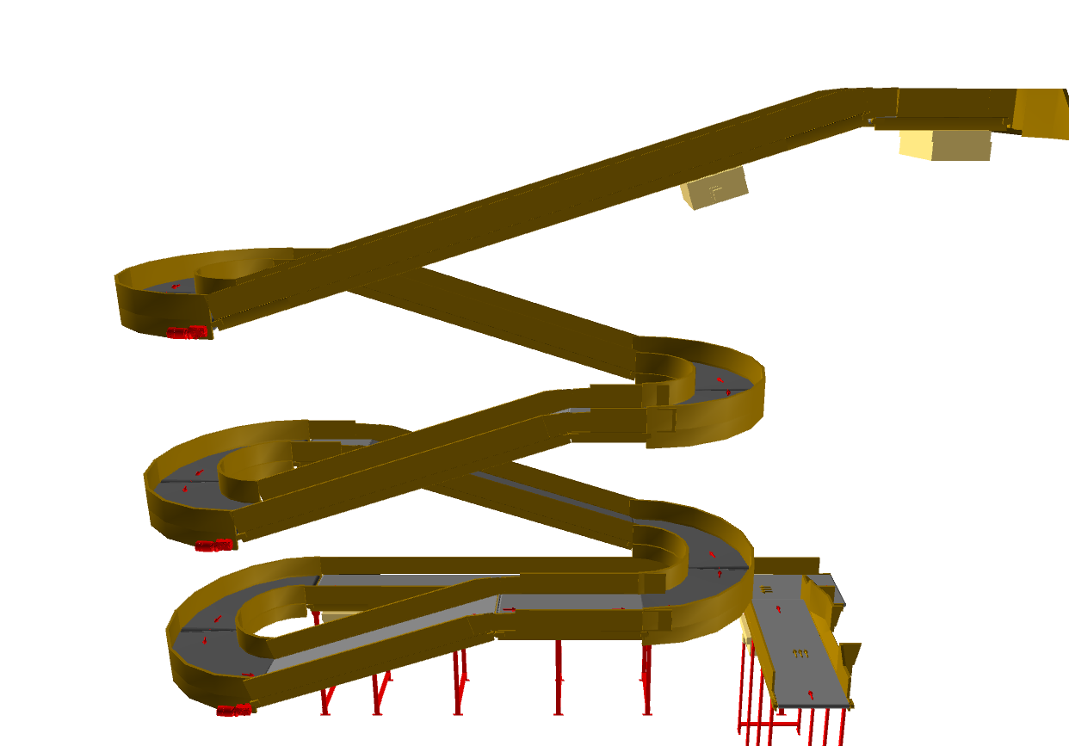
Staircase Conveyor arrangement

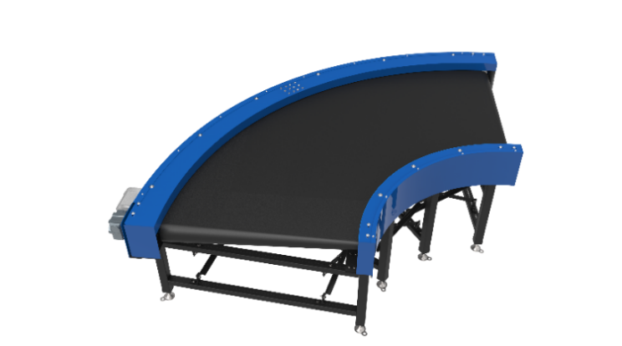
ZTR Curves (Pic for ref.)

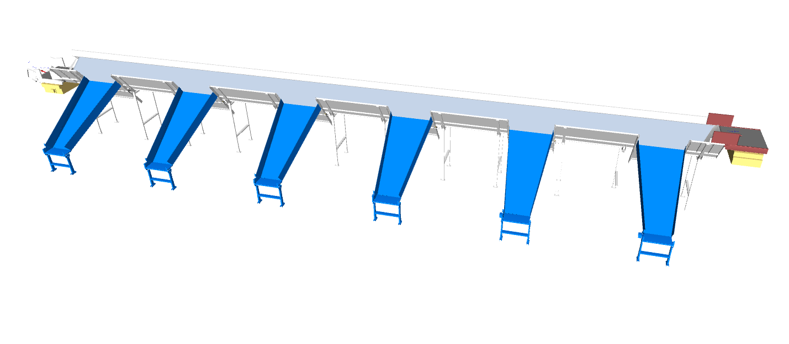
Tilted Belt VDS

Specification | Tilted belt
Actuation method | Electric induction motor
Belt type | Tilted PVC Top
Belt width (mm) | 1200
Max. product weight (kg) | 40

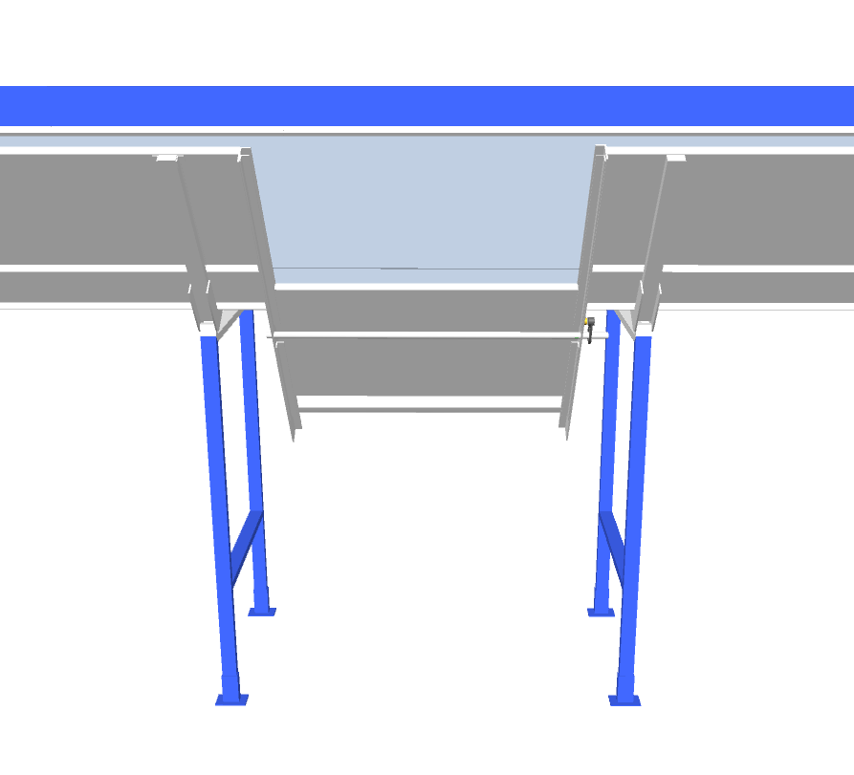
Side Guards
Tilted belt

Reciprocating gate
Rack & Pinion Setup

Titled Belt VDS is a newly developed volume distribution technology where falcon has used its tilted PVC belt integrated with metallic door that move back & forth with the help of rack & pinion gear arrangement. This mechanism designed to efficiently distribute items or packages across different sections with minimum stuckage & can handle almost all parcel spectrum.

VDS Chutes

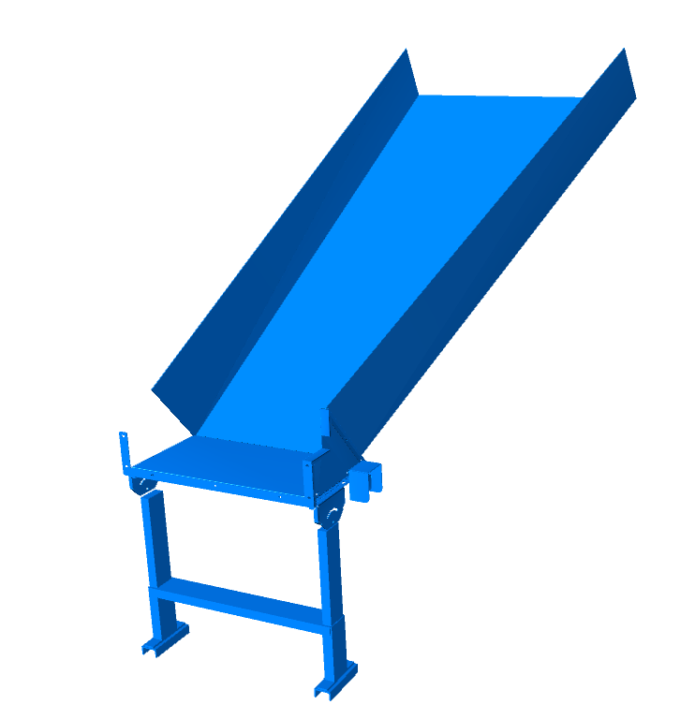
A VDS chute is a type of chute used for the smooth descent of materials or objects from an elevated position to a lower level (at an operator level). It utilizes base metal to guide and support the flow of items along the chute & collect the shipments within its area.

Calculation for Design: We have considered an average parcel size of 300 X 300 X 300 mm while designing the capacity of chutes.
Average parcel size considered for chute volume calculation | L(m) | B(m) | H(m) | Volume (m3)
 | 0.3 | 0.3 | 0.3 | 0.027
Collection type Chute | 3.5 | 1.5 | 0.4 | 2.1

Assuming a 60% occupancy rate, about 46 parcels will readily fit into these chutes.
Each Chute is equipped with below components to ease the operations:
- Chute Full Sensor
- Tower Light
- Push Button
Chute I/Os | Description
Chute Full Sensor | To alert the system that the chute is full and mark that chute unavailable for further sortation
Tower Lamp | To indicate the chute status
Push Button | To Start/Stop Sorting Operations

Induction to Sorter: Feedlines (Bespoke Flipkart Design)

The main purpose of the feedlines is to transport the shipments from the VDS chutes to the sorter by means Loading conveyors, Weighing, Buffer/Spacing Conveyor and Angle Merge conveyors. The flow of shipments on the Inducts are controlled by sensors in such a way that the required gap is ensured between the shipments.
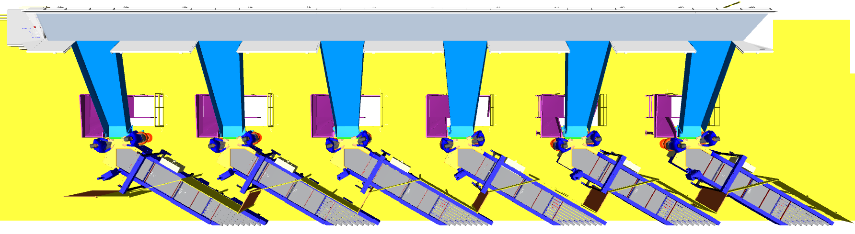
These Feedlines are designed especially for Flipkart Group considering Operator Ease and ergonmics. Where the operator ensures proper placement of the shipments on the Induct.

Induction Zone

Feedlines

Each Loop CBS has a total 12 Automatic Feedlines with Designed IPP of 2000 PPH.

- Each Feedline has Four Conveyor Modules-

  - Orientation/Loading Conveyor- 1 Nos.
  - Weighing Conveyor- 1 Nos.
  - Buffer Conveyor- 1 Nos.
  - Intelligent Merge- 1 Nos.

- Sensors are placed on the Induct Lines to determine the exact position and dimensions (Length and Width) of the Shipment on the conveyor and prepare the Cross-Belt Cell for receiving the shipment with high precision.

- Over the feedline, the shipments are evenly spaced and smoothly transferred to the main Loop.

Buffer Conveyors
A buffer conveyor, also known as a buffering conveyor or accumulation conveyor, is a type of conveyor system used to temporarily store or hold items in a controlled manner. Its primary purpose is to manage the flow of items between different stages of a production or handling process when there is a mismatch in the speeds or capacities of the upstream and downstream equipment.
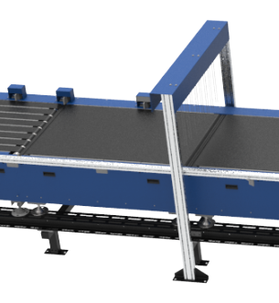
This Conveyors required to maintain the Throughput of Line.
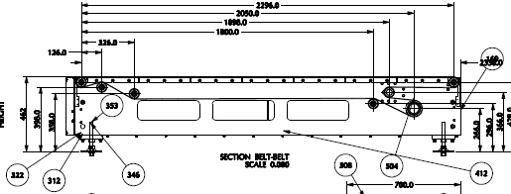

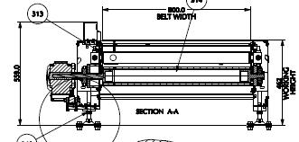

Weighing Conveyor
A weighing conveyor, also known as a weigh belt conveyor, is a type of conveyor system specifically designed to measure the weight of materials as they move along the conveyor belt. It combines the functions of conveying and weighing into a single integrated process.
Weighing Conveyors equipped with high precision Load Cells to capture the weight of Shipments.
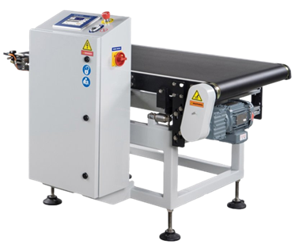
Make- Bizerba/ Mettler Toledo

Orientation Conveyor
An Orientation conveyor is a type of conveyor system used to align & Release the products for induction onto CBS. It serves as the initial point of entry where products are collected and conveyed to subsequent stages of the process.
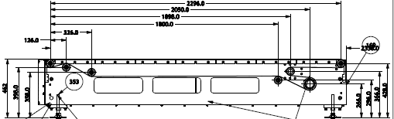

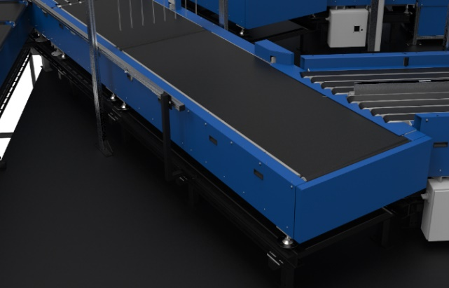

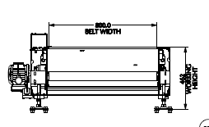

Intelligent Merge Conveyor
An intelligent merge conveyor is a type of conveyor system that incorporates advanced automation and control technologies to intelligently merge multiple conveyor lines or streams of materials into a single unified flow. It optimizes the merging process by dynamically adjusting the speed and position of items to ensure a smooth and efficient merge.
In the proposed solution this is 30° triangular high-speed conveyor used for inducting shipment/boxes directly on to the sorter. The Belts are Strip Belts for smooth shipment movement.
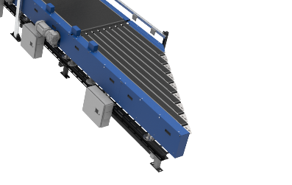
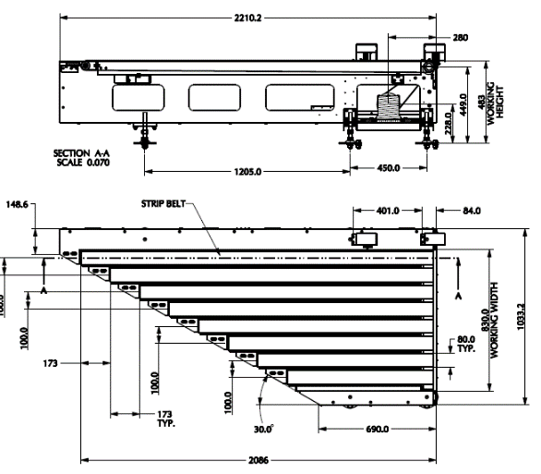

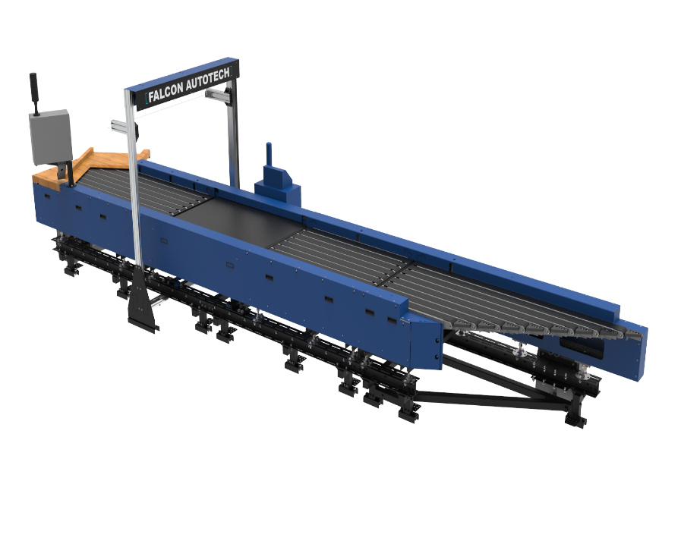
New Bespoke Ergonomic Feedline

- Ergonomic Operator & Remote Panel
- Strip type belt conveyors
- One touch bidirectional conveyors
- Lean design
- MLG sensor
- Two Roller conveyor design

Ergonomic Operator & Remote Panel: Easily reachable operator panel allowing quick & convenient access from operator position. Relocation of remote panel below feedline.
Lean Design: Under conveyor motor placement make the feedline leaner & increase possibility of free man movement.
Bidirectional Conveyor: Thanks to bidirectional conveyors that move in reverse direction when overweight and/or over sized parcel needs to be brought back, hence the operator movement close to CBS loop is eliminated increasing operator safety.
MLG: Now with MLG we have light grids at 5 mm pitch, therefore more precise position of parcel can be determined.

New Induct Fencing

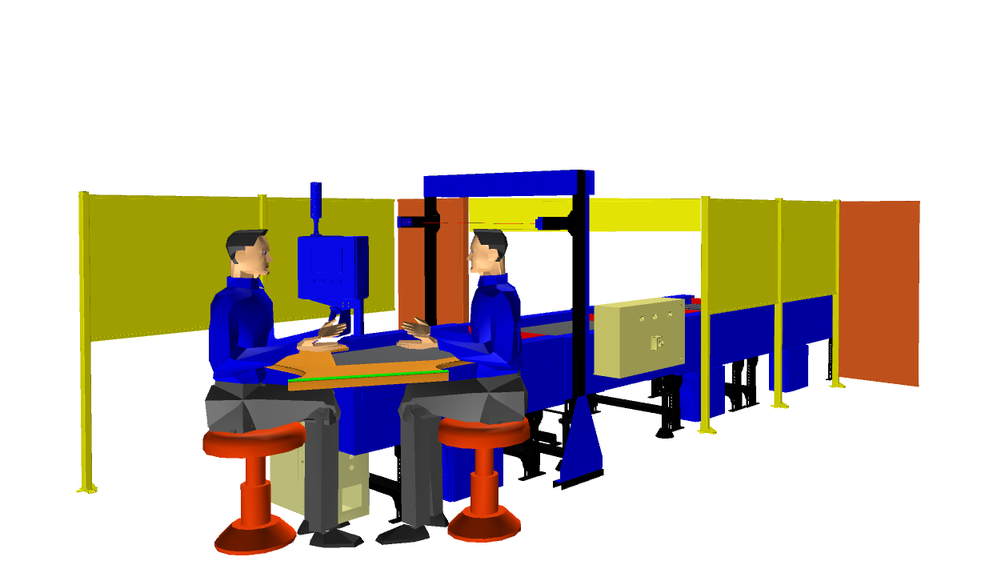
Setting a new Safety paramount. The new Induct Fencing helps prevent unauthorized operators from entering the induction zone, eliminating the risk of accidents and injuries.

Irregular Takeout Conveyor
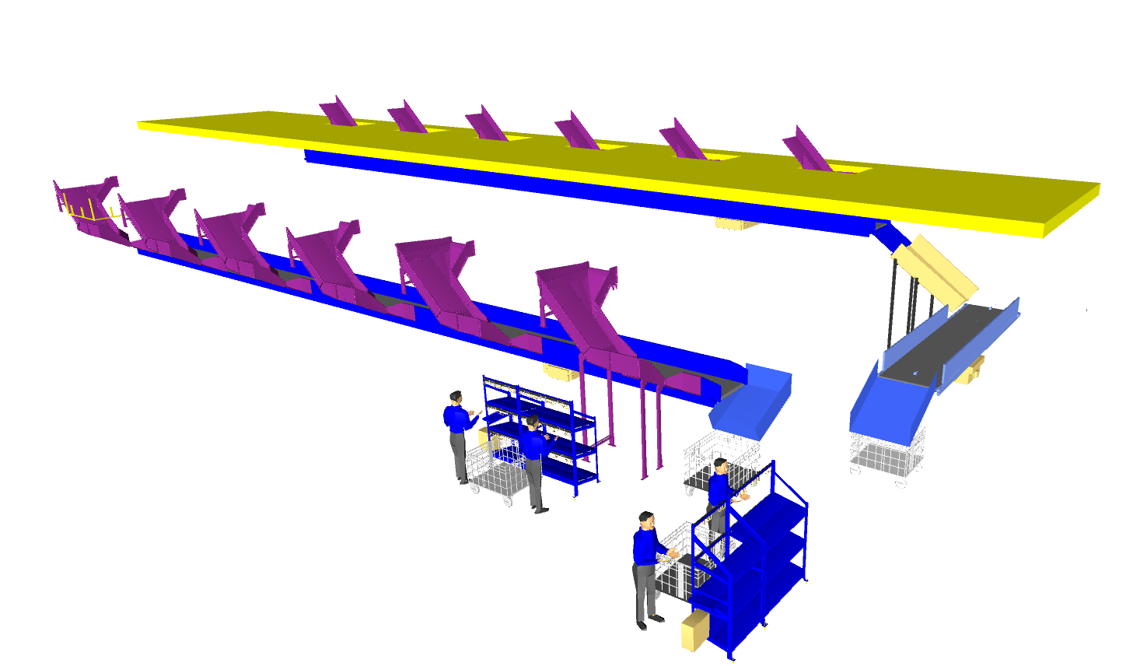
Explain Irregular setup in detail

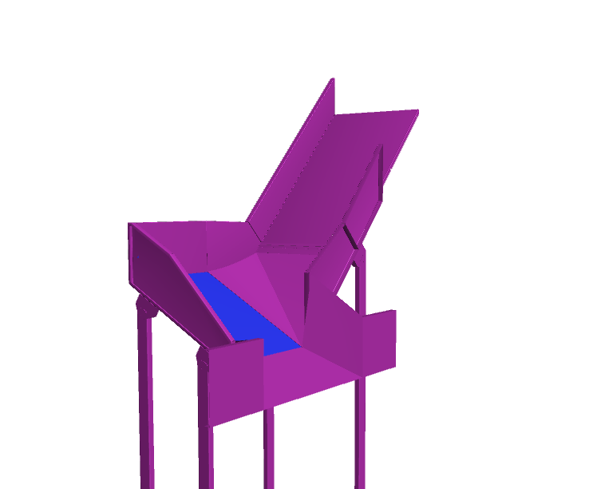
Irregular Chute

Irregular Takeaway Conveyor

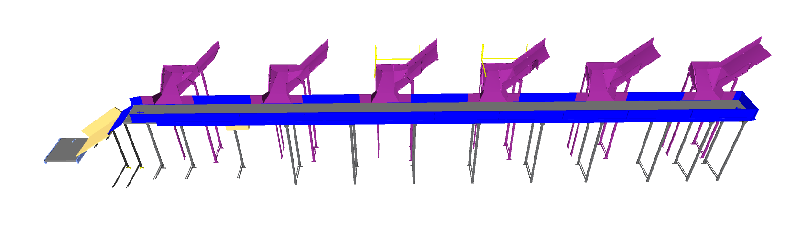

Irregular Collection Bin (In Flipkart’s scope)

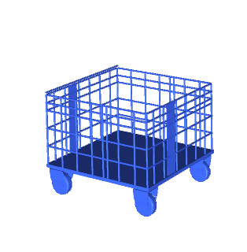
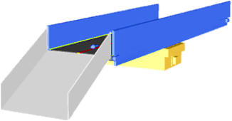

Conveyor BOQ

S.No | Name | EL_1 | EL_2 | Length (m) | Width (mm) | Set
1 | PVC Belt Conveyor | 7180 | 7180 | 6 | 1210 | 1
2 | PVC Belt Conveyor | 6000 | 6000 | 9 | 1210 | 1
3 | PVC Belt Conveyor | 6000 | 6000 | 7 | 1210 | 1
4 | PVC Belt Conveyor | 10681 | 11296 | 3 | 1210 | 1
5 | PVC Belt Conveyor | 5898 | 8565 | 11 | 1210 | 1
6 | PVC Belt Conveyor | 5898 | 10656 | 20 | 1210 | 1
7 | PVC Belt Conveyor | 5898 | 8565 | 11 | 1210 | 1
8 | PVC Belt Conveyor | 8591 | 11257 | 11 | 1210 | 1
9 | PVC Belt Conveyor | 6000 | 6000 | 9 | 1210 | 1
10 | PVC Belt Conveyor | 10681 | 11296 | 3 | 1210 | 1
11 | PVC Belt Conveyor | 8591 | 11257 | 11 | 1210 | 1
12 | PVC Belt Conveyor | 5898 | 10656 | 20 | 1210 | 1
13 | PVC Belt Conveyor | 7180 | 7180 | 6 | 1210 | 1
14 | PVC Belt Conveyor | 7180 | 7180 | 6 | 1210 | 1
15 | PVC Belt Conveyor | 11251 | 11251 | 6 | 1210 | 1
16 | PVC Belt Conveyor | 7180 | 7180 | 6 | 1210 | 1
17 | PVC Belt Conveyor | 6000 | 6000 | 9 | 1210 | 1
18 | PVC Belt Conveyor | 9002 | 9002 | 24 | 1010 | 1
19 | PVC Belt Conveyor | 7002 | 7002 | 24 | 1010 | 1
20 | PVC Belt Conveyor | 7002 | 7002 | 24 | 1010 | 1
21 | PVC Belt Conveyor | 9002 | 9002 | 24 | 1010 | 1
22 | PVC Belt Conveyor | 7002 | 7002 | 24 | 1010 | 1
23 | PVC Belt Conveyor | 9002 | 9002 | 24 | 1010 | 1
24 | PVC Belt Conveyor | 9002 | 9002 | 24 | 1010 | 1
25 | PVC Belt Conveyor | 7002 | 7002 | 24 | 1010 | 1

Main Loop

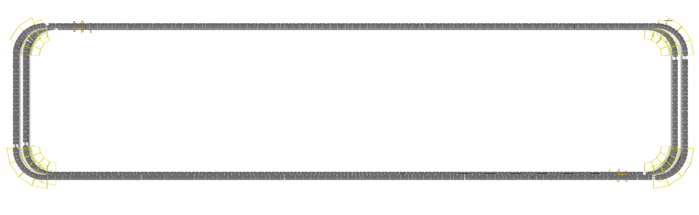
Induct Zone
Induct Zone

Induct Zone

Induct Zone

- The proposed Double Deck CBS Sorter will be installed on Mezzanine level. The Sorter runs at 3500 mm (Lower Loop) & 5500 mm (Upper Loop) from Mezzanine level.

- We have provided loop with Dual Belt Carriers with 1175 mm pitch and Belt Size of 495 x 800mm.

- One single deck loop CBS has a total length of 254 m & 217 number of carriers.

- As Shipments pass through the Barcode Scanning Tunnel on the Loop, their barcodes are scanned, and chutes are assigned. Once the shipment reaches the respective chute, the carrier carrying the shipment for the chute will actuate and drop the shipment in the assigned chute.

Sorting Output

Direct Bagging Chute (Bespoke Flipkart design to be used)
A Direct bagging chute is a type of chute used for the smooth descent of materials or objects from an elevated position to a lower level. It utilizes base metal to guide and support the flow of items along the chute & collect the shipments into bags placed at the end of each chute.
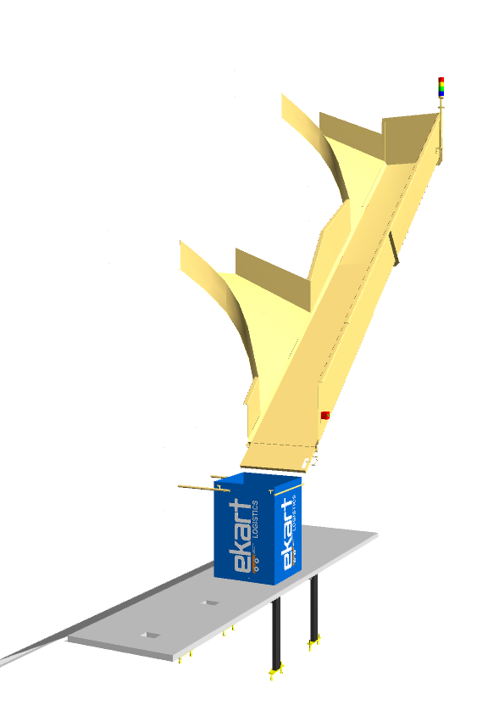
Each Direct bagging chute has capacity to accumulate 40 shipments, The sorted shipments will travel along these collection chutes and get accumulated at the bottom of the chute.

Image for representation purpose only

Calculation for Design: We have considered an average shipment size of 300 X 300 X 300 mm while designing the capacity of chutes.
Average shipment size considered for chute volume calculation | L(m) | B(m) | H(m) | Volume (m3)
 | 0.3 | 0.3 | 0.3 | 0.027
Collection type Chute | 5.8 | 0.7 | 0.5 | 2.03

Assuming a 60% occupancy rate, about 45 shipments will readily fit into these chutes. 67
Each Chute is equipped with below components to ease the operations:
- Chute Full Sensor
- Four Color Tower Light
- Push Button
Chute I/Os | Description
Chute Full Sensor | To alert the system that the chute is full and mark that chute unavailable for further sortation
Four Colour Tower Lamp | To indicate the chute status
Push Button | To Start/Stop Sorting Operations

Secondary Chute (L-Type) (Bespoke Flipkart design to be used)

Secondary Chute is a type of chute used for the smooth descent of materials or objects from an elevated position to a lower level. It utilizes base metal to guide and support the flow of items along the chute & end gate can be closed to collect the shipments within its area.
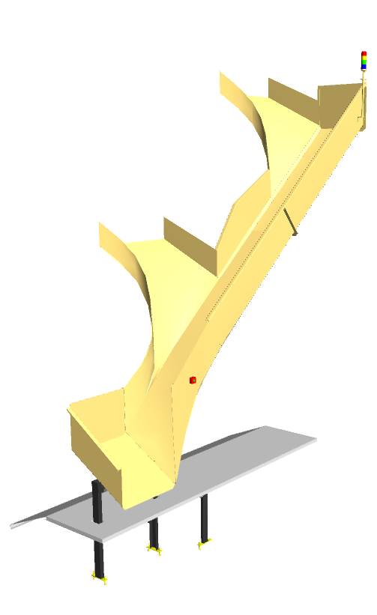
Rejection chute has capacity to accumulate 40 shipments, The sorted shipments will directly deposit into roll cage trolley place below.

Image for representation purpose only

Calculation for Design: We have considered an average shipment size of 300 X 300 X 300 mm while designing the capacity of chutes.
Average shipment size considered for chute volume calculation | L(m) | B(m) | H(m) | Volume (m3)
 | 0.3 | 0.3 | 0.3 | 0.027
Collection type PTL Chute | 5.8 | 0.7 | 0.5 | 2.03

Assuming a 60% occupancy rate, about 45 shipments will readily fit into these chutes.
Each Chute is equipped with below components to ease the operations:
- Chute Full Sensor
- Four Color Tower Light
- Push Button
Chute I/Os | Description
Chute Full Sensor | To alert the system that the chute is full and mark that chute unavailable for further sortation
Four Colour Tower Lamp | To indicate the chute status
Push Button | To Start/Stop Sorting Operations

Rejection Chute (L-Type) (Bespoke Flipkart design to be used)

Rejection Chute is a type of chute used for the smooth descent of materials or objects from an elevated position to a lower level. It utilizes base metal to guide and support the flow of items along the chute & end gate can be closed to collect the shipments within its area.
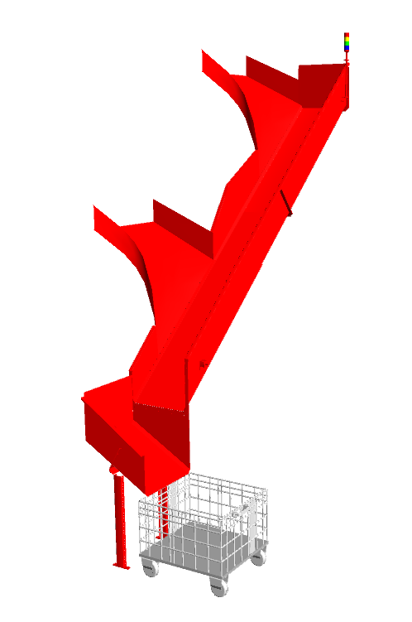
Rejection chute has capacity to accumulate 40 shipments, The sorted shipments will directly deposit into roll cage trolley place below.

Image for representation purpose only

Calculation for Design: We have considered an average shipment size of 300 X 300 X 300 mm while designing the capacity of chutes.
Average shipment size considered for chute volume calculation | L(m) | B(m) | H(m) | Volume (m3)
 | 0.3 | 0.3 | 0.3 | 0.027
Collection type PTL Chute | 5.8 | 0.7 | 0.5 | 2.03

Assuming a 60% occupancy rate, about 40 shipments will readily fit into these chutes.
Each Chute is equipped with below components to ease the operations:
- Chute Full Sensor
- Four Color Tower Light
- Push Button
Chute I/Os | Description
Chute Full Sensor | To alert the system that the chute is full and mark that chute unavailable for further sortation
Four Colour Tower Lamp | To indicate the chute status
Push Button | To Start/Stop Sorting Operations

Bag Take away Conveyor

In both double decker Loop CBS, there is a series of Bag Takeaway Conveyors, spanning a combined length of 521 meters. Following the secondary sorting process, bags are securely fastened and manually placed onto these conveyors, which are positioned below the Loop CBS to cover all chute locations. These conveyors then transport the collected bags back to the lower level.
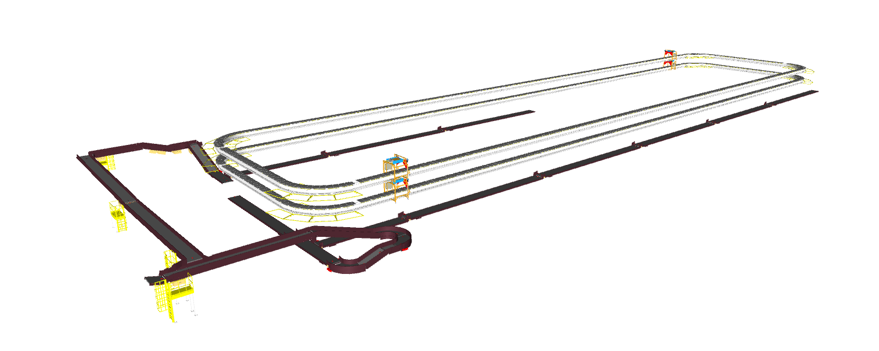

Conveyor BOQ

S.No | Name | EL_1 | EL_2 | Length (m) | Width (mm) | Set
1 | PVC Belt Conveyor | 5800 | 5900 | 20 | 1010 | 1
2 | PVC Belt Conveyor | 5800 | 5900 | 20 | 1010 | 1
3 | PVC Belt Conveyor | 5800 | 5900 | 20 | 1010 | 1
4 | PVC Belt Conveyor | 5800 | 5900 | 20 | 1010 | 1
5 | PVC Belt Conveyor | 5800 | 5900 | 20 | 1010 | 1
6 | PVC Belt Conveyor | 5800 | 5900 | 20 | 1010 | 1
7 | PVC Belt Conveyor | 5800 | 5900 | 20 | 1010 | 1
8 | PVC Belt Conveyor | 5800 | 5900 | 20 | 1010 | 1
9 | PVC Belt Conveyor | 5800 | 5900 | 13 | 1010 | 1
10 | PVC Belt Conveyor | 5738 | 5838 | 5 | 1010 | 1
11 | PVC Belt Conveyor | 5800 | 5900 | 19 | 1010 | 1
12 | PVC Belt Conveyor | 5738 | 5838 | 5 | 1010 | 1
13 | PVC Belt Conveyor | 5838 | 5938 | 8 | 1010 | 1
14 | PVC Belt Conveyor | 5800 | 5900 | 10 | 1010 | 1
15 | PVC Belt Conveyor | 5738 | 5838 | 14 | 1010 | 1
16 | PVC Belt Conveyor | 5800 | 5900 | 10 | 1010 | 1
17 | PVC Belt Conveyor | 5800 | 5900 | 20 | 1010 | 1
18 | PVC Belt Conveyor | 5800 | 5900 | 20 | 1010 | 1
19 | PVC Belt Conveyor | 5800 | 5900 | 20 | 1010 | 1
20 | PVC Belt Conveyor | 5800 | 5900 | 13 | 1010 | 1
21 | PVC Belt Conveyor | 5800 | 5900 | 20 | 1010 | 1
22 | PVC Belt Conveyor | 5800 | 5900 | 20 | 1010 | 1
23 | PVC Belt Conveyor | 5800 | 5900 | 20 | 1010 | 1

Layout View of Bag & Semi-large Sorter
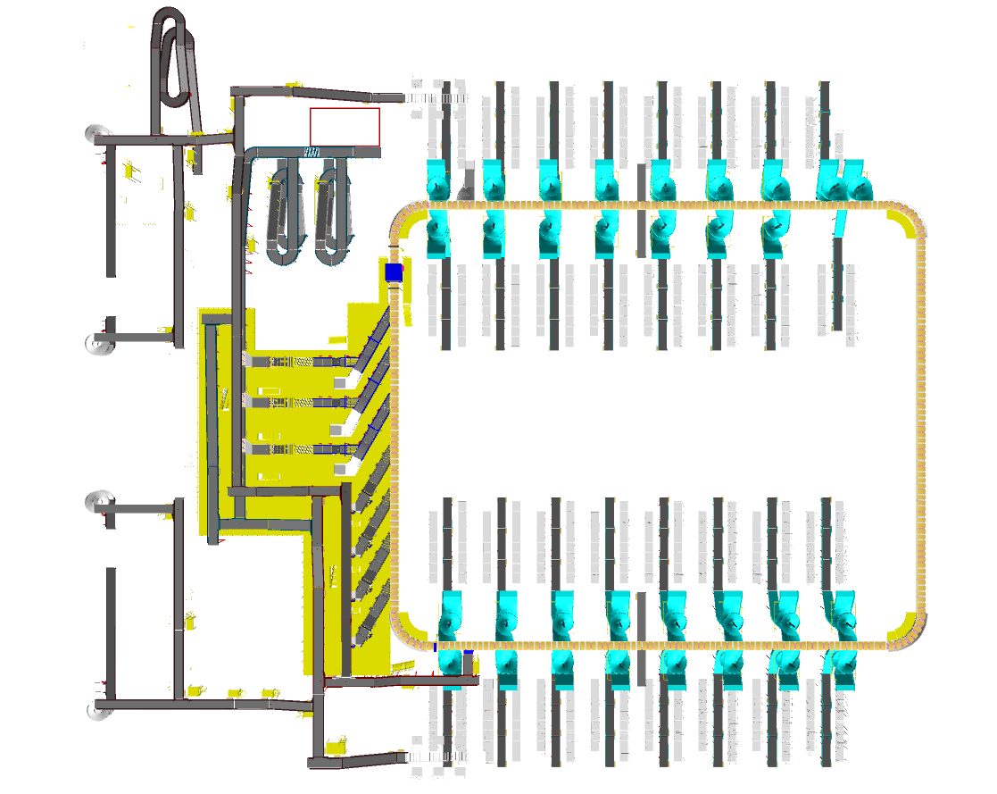
3
4
1

7
2

1

6
5
1

7
8
1
4

Legend
1 – Infeed Powered Spiral (From Shipment sorters)
2 – Infeed Staircase Conveyor (Cross Dock Semi-large shipments)
3 – Infeed Staircase Conveyor (Cross Dock Bags)
4 – Contingency Lines
5 – Induct Lines
6 – Main Loop CBS
7 – Output Spiral Chutes
8 – Refeeding Line

Proposed System Capacity Calculations

Sorter System Capacity
The following table shows the throughput calculation for the sortation system designed based on Flipkart RFP requirements.

SPECIFICATION | VALUE
Sorter Type | Loop CBS
Speed | 2.3 m/s
Pitch | 800 mm
Carrier per hour | 10,350 CPH
Belts per hour | 10,350 BPH
Effective Designed Throughput of 1 loop CBS (A) | 10,350 Shipments per hour
No of Feedlines (Bags + Semi-large) per loop | 7 (4+3) Nos.
Per Feedline Capacity (Bags) | 900 Bags per hour
Total feedline capacity (Bags) per loop | 3,600 Bags per hour
Per Feedline Capacity (Semi-large shipment) | 2400 SL Shipments per hour
Total feedline capacity (Bags) per loop | 7,200 SL Shipments per hour
Total Feedline designed capacity (B) | 10,800 Shipments per hour
System designed throughput | 10,350 Shipments per hour
Designed throughput from One loops | 10,350 Shipments per hour

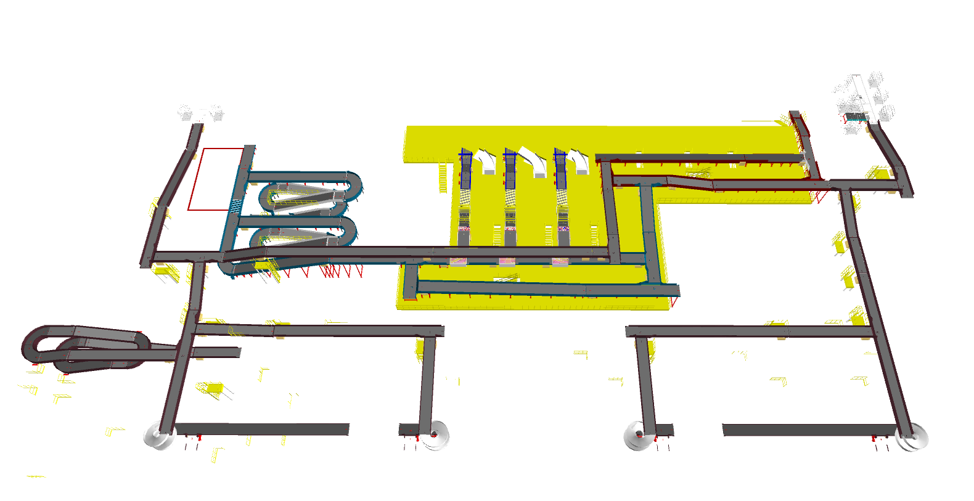
System description

Infeed System
4
4

2
3

1

Legend
- Infeed Staircase Conveyor (Cross Dock Bags)
- Infeed Staircase Conveyor (Cross Dock Semi-large)
- VDS Loop
- Contingency Line

CBS loop is equipped with Infeed conveyor facilitating the movement of SL shipment volume to Loop VDS and in parallel, Two Staircase conveyors for facilitating the movement of Marketplace SL shipment volume to the same VDS loop. Additionally, Bags transported from NL Shipment & Cross Dock Bags are connected to separate VDS loop for further induction.

Infeed System Description
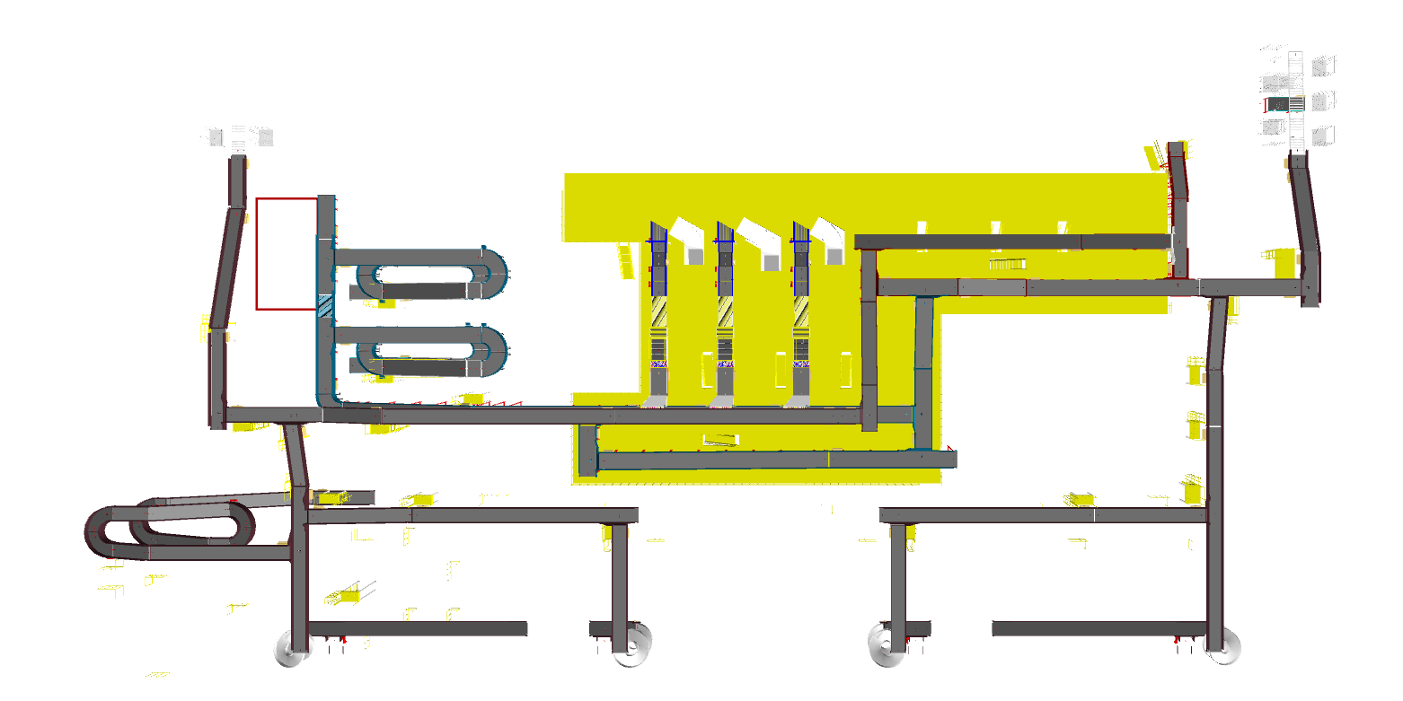
Infeed conveyor system consists of below components:
- Straight PVC Conveyor
- Inclined PVC Conveyor
- Powered Spiral Conveyor
- VDS System

6
5
2
3
1

2
1

1
3

4
4
4
4

Legend
- Straight PVC Conveyors
- Inclined PVC Conveyors
- Staircase conveyors
- Powered Spiral Conveyors
- SWEDI VDS Loop
- Bag VDS Loop

Straight and Inclined Powered Belt Conveyor

Falcon’s Belt Conveyors are modular & robust in design, used for smooth conveying of products over Straight, inclined and declined paths. MS profile is used to build conveyor frame.

The conveyors are supplied with the necessary supports and bolts to fix them to the supporting plane, as well as with the junction elements allowing easy and jam-free passage from one conveyor to the other.
Some Silent Features of Falcon’s Belt conveyor:
- Low Noise
- Maximum uptime.
- Minimal maintenance
- High safety standards.
- Fastest ROI.







Specification | UOM | Remark
Manufacturer Name | Name | Falcon Autotech
Material of Roller | Type | MS Rollers with Zinc Plating
MOC of Belt | Type | PVC
Belt Thickness | mm | 3
Belt Finish | Type | Matt Finish
Belt width | mm | 1200
Belt Joint Type | Type | Vulcanized, Endless Belts
Belt Make/Model No. | Make | FORBO/DERCO
Chassis | mm | MS, 3mm Thick, Powder Coated-75 Microns
Idler Roller Pitch on running side (Top) | mm | 480
Idler Roller Specs | Spec | Dia.50.8, shaft-12 mm, bearing-6301
End Rollers | Spec | Dia 81.2 x 2.85 Thick, 30mm Shaft Dia, & Bearing Size-UCFH206D1, MOC-EN9, Zinc Plated -25 microns
Drive Rollers | Spec | OUTER Dia 178 PIPE Dia 168x5 Thick, 40mm Shaft Dia, & Bearing Size-UCF208D1, MOC(SHAFT)-EN9, NEOPRENE RUBBER COATING
Motor Shaft | MOC | EN9 Shaft material
Conveyor Under guarding | Spec | MOC-MS, 0.8 to 1mm thickness, Steel Stiffeners at every 600mm to avoid the sagging due to self-weight
Load capacity per unit length of Conveyor | kg/m | 50
Type of Guides | Type | Steel guides at 50mm/400mm height basis the position of conveyor on both sides from Conveyor Belt Surface.
Drive Power Rating | kW | Motor Rating depends on Length of the Conveyor
Type of Motor | Type | AC Geared Motor
Ingress Protection | Type | IP 55
Type of Drive System | Type | Direct Shaft Mounted Motor/ Flange Mounted
Type of Drive | Type | Chain drive/Torque Arm type
Gear Motor | make | Sew/Nord
Drive | make | Lenze/Siemens/Omron/Allen Bradly
Insulation Class | Type | Yes
Conveyor Speed | m/s | Variable speed to meet TPH requirements
Type of Mounts | Type | Fixed Heights Legs with Grouting Provisions

Roller Aligner conveyor

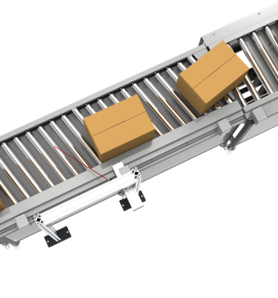

ZTR Curves (Pic for ref.)



Plastic Modular Belt Conveyor

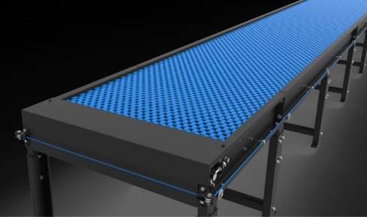
Falcon’s Belt Conveyors are modular & robust in design. MS profile is used to build conveyor frame.
Some Salient Features of Falcon’s Modular Belt conveyor:
- Low Noise
- Maximum uptime.
- Minimal maintenance
- High safety standards.
- Fastest ROI.
Specification | UOM | Remark
Manufacturer Name | Name | Falcon Autotech
Plastic Modular Belt Material | Type | POM with PBT Pins, Pitch-25.4 mm, Pin Dia- 5mm
Plastic modular Belt Make | Make | Movex
Sprocket Size & No. of Sprockets on Drive End & Tail End | Type | 5/146.4 mm
Sprocket material | MOC | POM
Chassis | mm | MS, 3mm Thick, Powder Coated-75 Microns
Wear Strip Material | MOC | UHMW PE1000
Return Roller type | Type | DIA- 50 mm/20303
Return Roller Pitch | mm | 800
Driven Shaft | Type | MOC-EN9 Solid Shaft hardened to BHN 240, Size-60SQ MM, Zinc Plated -25 microns, Bearings-UCF-210D1
Duplex Sprocket | MOC | MS
Duplex Chain | MOC | MS
Conveyor Under guarding | Type | GI SHEET (1MM THICK)
Type of Guides | Type | Steel guides at 50mm/400mm height basis the position of conveyor on both sides from Conveyor Belt Surface.

Conveyor BOQ

S.No | Name | EL_1 | EL_2 | Length (m) | Width (mm) | Set
1 | PVC Belt Conveyor | 10.3 | 8644 | 6 | 1410 | 1
2 | PVC Belt Conveyor | 0 | 8750 | 15 | 1410 | 1
3 | PVC Belt Conveyor | 0 | 0 | 2 | 1410 | 1
4 | PVC Belt Conveyor | 0 | 9250 | 4 | 1410 | 1
5 | PVC Belt Conveyor | 0 | 6300 | 13 | 1410 | 1
6 | PVC Belt Conveyor | 0 | 9250 | 14 | 1410 | 1
7 | PVC Belt Conveyor | 0 | 9000 | 7 | 1410 | 1
8 | PVC Belt Conveyor | 0 | 6050 | 5 | 1410 | 1
9 | PVC Belt Conveyor | 14.6 | 6063 | 13 | 1410 | 1
10 | PVC Belt Conveyor | 0 | 0 | 2 | 1410 | 1
11 | PVC Belt Conveyor | 0 | 8393 | 3 | 1210 | 1
12 | PVC Belt Conveyor | 0 | 6050 | 4 | 1410 | 1
13 | PVC Belt Conveyor | 17.9 | 351 | 5 | 1410 | 1
14 | PVC Belt Conveyor | 17.9 | 1793 | 6 | 1410 | 1
15 | PVC Belt Conveyor | 17.9 | 3592 | 9 | 1410 | 1
16 | PVC Belt Conveyor | 0 | 6300 | 13 | 1210 | 1
17 | PVC Belt Conveyor | 0 | 9673 | 7 | 1410 | 1
18 | PVC Belt Conveyor | 9.6 | 8894 | 6 | 1410 | 1
19 | PVC Belt Conveyor | 15.6 | 8042 | 4 | 1210 | 1
20 | PVC Belt Conveyor | 0 | 6300 | 13 | 1410 | 1
21 | PVC Belt Conveyor | 17.9 | 351 | 5 | 1410 | 1
22 | PVC Belt Conveyor | 17.9 | 1793 | 6 | 1410 | 1
23 | PVC Belt Conveyor | 17.9 | 3592 | 9 | 1410 | 1
24 | PVC Belt Conveyor | 0 | 6300 | 13 | 1210 | 1
25 | PVC Belt Conveyor | 0 | 8500 | 5 | 1410 | 1
26 | PVC Belt Conveyor | 0 | 8450 | 5 | 1210 | 1
27 | PVC Belt Conveyor | -15 | 8399 | 8 | 1410 | 1
28 | PVC Belt Conveyor | 0 | 8200 | 20 | 1210 | 1
29 | PVC Belt Conveyor | 0 | 8450 | 12 | 1210 | 1
30 | PVC Belt Conveyor | 15 | 8349 | 6 | 1210 | 1
31 | PVC Belt Conveyor | 0 | 10900 | 20 | 1210 | 1
32 | PVC Belt Conveyor | 0 | 10900 | 2 | 1210 | 1
33 | PVC Belt Conveyor | -7.6 | 10555 | 7 | 1210 | 1
34 | PVC Belt Conveyor | 0 | 9334 | 9 | 1210 | 1
35 | PVC Belt Conveyor | 0 | 6300 | 5 | 1210 | 1
36 | PVC Belt Conveyor | 17.8 | 5816 | 2 | 1210 | 1
37 | PVC Belt Conveyor | 17.9 | 6500 | 7 | 1210 | 1
38 | PVC Belt Conveyor | 0 | 6966 | 4 | 1210 | 1
39 | PVC Belt Conveyor | 18 | 5916 | 4 | 1210 | 1
40 | PVC Belt Conveyor | 18 | 7490 | 3 | 1210 | 1
41 | PVC Belt Conveyor | 0 | 8450 | 5 | 1210 | 1
42 | PVC Belt Conveyor | 0 | 7589 | 4 | 1210 | 1
43 | PVC Belt Conveyor | 18 | 5766 | 7 | 1210 | 1
44 | PVC Belt Conveyor | 0 | 450 | 6 | 1210 | 1
45 | PVC Belt Conveyor | 18 | 350 | 12 | 1210 | 1
46 | PVC Belt Conveyor | 17.9 | 4043 | 6 | 1210 | 1
47 | PVC Belt Conveyor | 17.9 | 5916 | 6 | 1210 | 1
48 | PVC Belt Conveyor | 0 | 8707 | 11 | 1210 | 1
49 | PVC Belt Conveyor | 0 | 8200 | 1 | 1210 | 1
50 | PVC Belt Conveyor | 14.8 | 7787 | 4 | 1210 | 1
51 | PVC Belt Conveyor | 0 | 7773 | 3 | 1210 | 1
52 | PVC Belt Conveyor | 0 | 5900 | 2 | 1210 | 1
53 | PVC Belt Conveyor | 0 | 4051 | 1 | 1210 | 1
54 | PVC Belt Conveyor | 18 | 7490 | 3 | 1210 | 1
55 | PVC Belt Conveyor | 18 | 5766 | 7 | 1210 | 1
56 | PVC Belt Conveyor | 0 | 7589 | 4 | 1210 | 1
57 | PVC Belt Conveyor | 18 | 6867 | 4 | 1210 | 1
58 | PVC Belt Conveyor | 0 | 6484 | 1 | 1210 | 1
59 | PVC Belt Conveyor | -15 | 9232 | 11 | 1210 | 1
60 | PVC Belt Conveyor | 2.1 | 8087 | 18 | 1210 | 1
61 | PVC Belt Conveyor | 0 | 10650 | 4 | 1210 | 1
62 | PVC Belt Conveyor | 0 | 10900 | 19 | 1210 | 1
63 | PVC Belt Conveyor | 15 | 9482 | 6 | 1210 | 1
64 | PVC Belt Conveyor | 0 | 9584 | 8 | 1210 | 1
65 | PVC Belt Conveyor | 0 | 8200 | 20 | 1210 | 1
66 | PVC Belt Conveyor | 0 | 8200 | 20 | 1210 | 1
67 | PVC Belt Conveyor | 0 | 6300 | 1 | 1410 | 1
68 | PVC Belt Conveyor | 5.6 | 7840 | 12 | 1210 | 1
69 | PVC Belt Conveyor | 0 | 7950 | 11 | 1210 | 1
70 | PVC Belt Conveyor | 0 | 8750 | 9 | 1410 | 1
71 | PVC Belt Conveyor | 0 | 6300 | 1 | 1410 | 1
72 | PVC Belt Conveyor | 0 | 3576 | 1 | 1410 | 1
73 | PVC Belt Conveyor | 0 | 1801 | 1 | 1410 | 1
74 | PVC Belt Conveyor | 0 | 450 | 6 | 1410 | 1
75 | PVC Belt Conveyor | 0 | 6300 | 1 | 1410 | 1
76 | PVC Belt Conveyor | 0 | 3576 | 1 | 1410 | 1
77 | PVC Belt Conveyor | 0 | 1801 | 1 | 1410 | 1
78 | PVC Belt Conveyor | 0 | 8143 | 11 | 1210 | 1
79 | PVC Belt Conveyor | 0 | 6050 | 7 | 1410 | 1
80 | PVC Belt Conveyor | 0 | 8750 | 11 | 1410 | 1
81 | PVC Belt Conveyor | 0 | 9500 | 4 | 1410 | 1
82 | PVC Belt Conveyor | 2.9 | 8753 | 20 | 1410 | 1
83 | PVC Belt Conveyor | 0 | 9250 | 4 | 1410 | 1
84 | PVC Belt Conveyor | 0 | 0 | 2 | 1410 | 1
85 | PVC Belt Conveyor | 0 | 9250 | 9 | 1410 | 1
86 | PVC Belt Conveyor | 0 | 9500 | 4 | 1210 | 1
87 | PVC Belt Conveyor | 0 | 450 | 6 | 1410 | 1
88 | PVC Belt Conveyor | 0 | 9000 | 7 | 1210 | 1
89 | Modular Conveyor | 0 | 9250 | 20 | 1238 | 1
90 | Singilator with centre aligning | NA | NA | 0 | NA | 1
91 | Singilator with centre aligning | NA | NA | 0 | NA | 1
92 | Belt Turn (1410mm_90°) | NA | 6600 | 0 | NA | 1
93 | Belt Turn (1410mm_180°) | NA | 6600 | 0 | NA | 1
94 | Belt Turn (1410mm_180°) | NA | 6600 | 0 | NA | 1
95 | Belt Turn (1410mm_180°) | NA | 6600 | 0 | NA | 1
96 | Gravity Roller Conveyor | NA | 6300 | 9 | 1200 | 1
97 | Belt Turn (1200mm_90_deg) | NA | 6484 | 0 | NA | 1
98 | Belt Turn (1200mm_180_deg) | NA | 4051 | 0 | NA | 1
99 | Belt Turn (1200mm_180_deg) | NA | 7773 | 0 | NA | 1
100 | Belt Turn (1200mm_180_deg) | NA | 5900 | 0 | NA | 1
101 | Belt Turn (1200mm_90_deg) | NA | 5816 | 0 | NA | 1
102 | Belt Turn (1200mm_90_deg) | NA | 6484 | 0 | NA | 1
103 | Gravity Roller Conveyor | NA | 6300 | 9 | 1200 | 1
104 | Belt Turn (1410mm_180°) | NA | 6600 | 0 | NA | 1
105 | Belt Turn (1410mm_180°) | NA | 6600 | 0 | NA | 1
106 | Belt Turn (1410mm_180°) | NA | 6600 | 0 | NA | 1
107 | Modular Conveyor | 0 | 9250 | 8 | 1238 | 1
108 | Aligning Conveyor | NA | 6050 | 0 | NA | 1
109 | Singilator with centre aligning | NA | NA | 0 | NA | 1

Induction to Bag & Semi-large Sorter

The main purpose of the feedlines is to transport the Semi-large shipments & Bag from the infeed points to the sorter by means of Singulator, straight and curved belt conveyors, 30° merging conveyors and 30° induction lines. The flow of shipments on the belt conveyors is controlled by sensors in such a way that a gap is ensured between the shipments.
Weighing Scales installed on the feedlines will capture the weight of each shipment and will perform weight control to detect out-of-spectrum shipments.
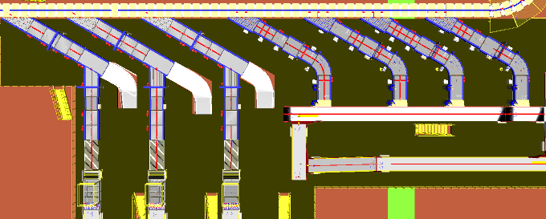
The system's design ensures that the maximum capacity of each feed, considered as the sum of the flows from the connected inductions, is always less than the planned induction capacity of 2400 for Semi-Large shipments/hour and 900 bags/hour.

Induction Zone

Automatic Feedlines for Semi-large Shipment
Each Loop CBS has a total 3 Automatic Feedlines for Semi-Large Shipment with Designed IPP of 2400 PPH.

1. Each Feedline has 13 Conveyor Modules-

  - Singulator- 1 Nos.
  - Aligning Conveyor- 1 Nos.
  - Weighing Conveyor- 1 Nos.
  - Receiving Conveyor- 1 Nos.
  - Spacing Conveyor- 4 Nos.
  - Buffer conveyor- 3 Nos.
  - Angle Merge- 2 Nos.
  - Oversize/Overweight Chute- 1 Nos

- Sensors are placed on the Induct Lines to determine the exact position and dimensions (Length and Width) of the Shipment on the conveyor and prepare the Cross-Belt Cell for receiving the shipment with high precision.

- Over the feedline, shipments are evenly spaced and smoothly transferred to the main Loop.

Swivel Wheel Divert
Swivel Wheel Diverter (SWEDI) is a non-impact sortation module for linear sortation lines, ideal for medium volume sort centres. SWEDI's modular design allows it to save space while also allowing for future expansion of sorting point
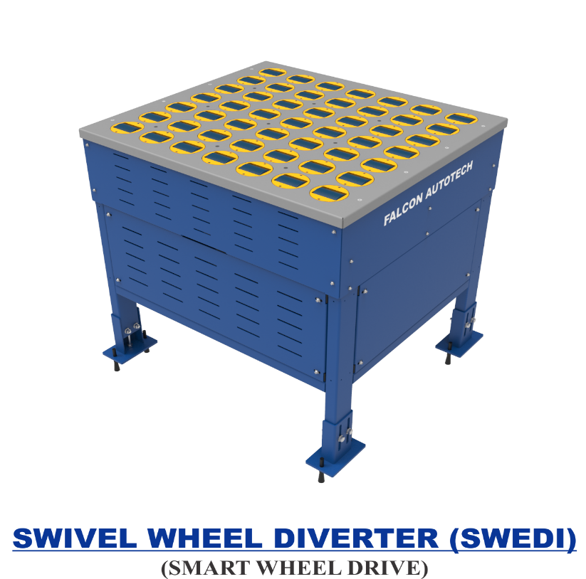

Technical specifications of SWEDI Unit
Items | Make
SWEDI Unit’s Dimensions | 1400 mm (L) x 1000 mm (W)
Load Capacity | 35 KG
Throughput | 2400 PPH
Conveying Drive Unit | 48V, 50 Watt DC powered smart roller
Diverting Drive Unit | Servo Motor; 220V, 50HZ, 750W, Single Phase
Conveying Speed | Up to 120 m/min
Diverting Angle | 90 Degrees at double sides
Frame Material | MS Powder Coated Steel Frame
Stand Support | MS Powder Coated Steel Frame
PLC | Siemens
Servo Motor | Delta
Noise Level | <75 Db when measured from 1 m in a silent warehouse.

Singulator
To maintain singulated flow for semi-large parcels, Singulators are provided at Automatic Induct Lines. Each Singulator is a combination of three conveyor set.
- Divergence Module
- Separation Module
- Roller Section
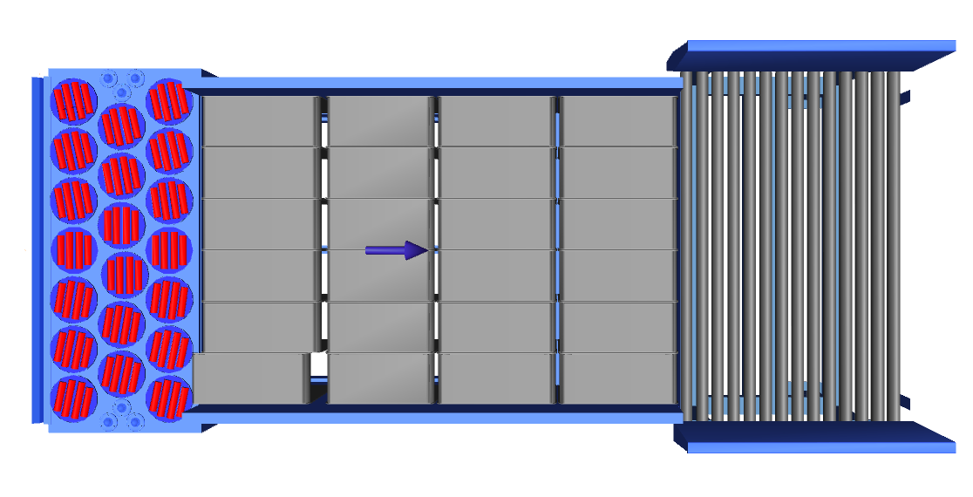
2
3
1

Aligning Conveyors
An Aligning conveyor is a type of conveyor system used to align the shipments to a particular side of the conveyor.

This Conveyors required to maintain the product alignment on the line.

Buffer Conveyors
A buffer conveyor, also known as a buffering conveyor or accumulation conveyor, is a type of conveyor system used to temporarily store or hold items in a controlled manner. Its primary purpose is to manage the flow of items between different stages of a production or handling process when there is a mismatch in the speeds or capacities of the upstream and downstream equipment.
This Conveyors required to maintain the Throughput of Line.





Weighing Conveyor
A weighing conveyor, also known as a weigh belt conveyor, is a type of conveyor system specifically designed to measure the weight of materials as they move along the conveyor belt. It combines the functions of conveying and weighing into a single integrated process.
Weighing Conveyors equipped with high precision Load Cells to capture the weight of Shipments.

Make- Bizerba/ Mettler Toledo

Receiving Conveyor
A Receiving conveyor is a type of conveyor system used to receive & Release the products for induction onto CBS. It serves as the connection point at turn point of entry where products are collected and conveyed to subsequent stages of the process.






Intelligent Merge Conveyor
An intelligent merge conveyor is a type of conveyor system that incorporates advanced automation and control technologies to intelligently merge multiple conveyor lines or streams of materials into a single unified flow. It optimizes the merging process by dynamically adjusting the speed and position of items to ensure a smooth and efficient merge.
In the proposed solution this is 30° triangular high-speed conveyor used for inducting shipment/boxes directly on to the sorter. The Belts are Strip Belts for smooth shipment movement.


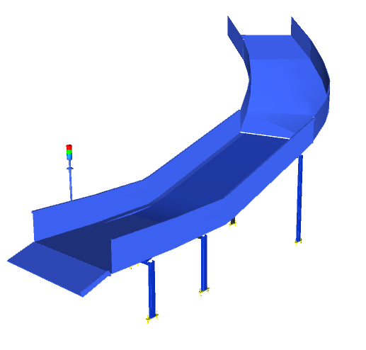
Irregular Collection Chute

Semi-Automatic Feedlines for Bags
Each Loop CBS has a total 4 Semi-Automatic Feedlines for bags with Designed IPP of 900 PPH

1. Each Feedline has Four Conveyor Modules-

  - Scanning Conveyor- 1 Nos.
  - Weighing Conveyor- 1 Nos.
  - Buffer conveyor- 2 Nos.
  - Intelligent Merge- 1 Nos.

- Sensors are placed on the Induct Lines to determine the exact position and dimensions (Length and Width) of the Shipment on the conveyor and prepare the Cross-Belt Cell for receiving the shipment with high precision.

- Over the feedline, shipments are evenly spaced and smoothly transferred to the main Loop.

Buffer Conveyors
A buffer conveyor, also known as a buffering conveyor or accumulation conveyor, is a type of conveyor system used to temporarily store or hold items in a controlled manner. Its primary purpose is to manage the flow of items between different stages of a production or handling process when there is a mismatch in the speeds or capacities of the upstream and downstream equipment.
This Conveyors required to maintain the Throughput of Line.





Weighing Conveyor
A weighing conveyor, also known as a weigh belt conveyor, is a type of conveyor system specifically designed to measure the weight of materials as they move along the conveyor belt. It combines the functions of conveying and weighing into a single integrated process.

Weighing Conveyors equipped with high precision Load Cells to capture the weight of Shipments.
Make- Bizerba/ Mettler Toledo

Scanning Conveyor
A Scanning conveyor is a type of conveyor system used to Pause, Scan & Release the bags for induction onto CBS. It serves as the Static scanning of product where products are paused for a while and conveyed to subsequent stages of the process after scanning



Intelligent Merge Conveyor
An intelligent merge conveyor is a type of conveyor system that incorporates advanced automation and control technologies to intelligently merge multiple conveyor lines or streams of materials into a single unified flow. It optimizes the merging process by dynamically adjusting the speed and position of items to ensure a smooth and efficient merge.
In the proposed solution this is 30° triangular high-speed conveyor used for inducting shipment/boxes directly on to the sorter. The Belts are Strip Belts for smooth shipment movement.


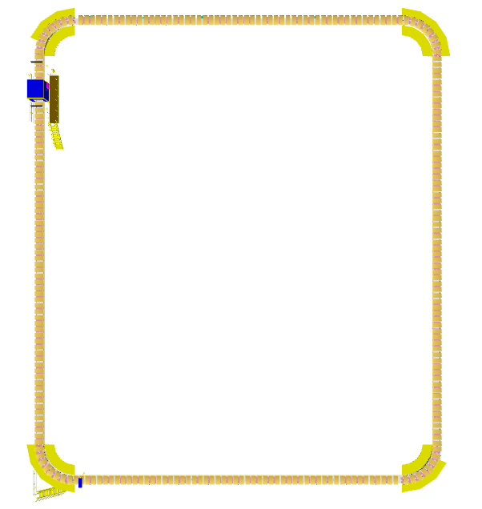

Induct Zone

- The proposed Single Deck CBS Sorter will be installed on ground level. The Sorter runs at 3500 mm from ground level.

- We have provided loop with Single Belt Carriers with 800 mm pitch and Belt Size of 600 x 1200mm.

- One loop CBS has a total length of 265 m & 331 number of carriers.

- As SL Shipments passes through the Barcode Scanning Tunnel on the Loop, their barcodes are scanned, Bags are scanned manually at inducts, After the scanning chutes are assigned & once the shipment reaches the respective chute, the carrier carrying the shipment for the chute will actuate and drop the shipment in the assigned chute.

Sorting Output

Spiral Chutes
A spiral chute is a type of chute used for the smooth descent of materials or objects from an elevated position to a lower level with compact footprint. It utilizes base metal to guide and support the flow of items along the chute length & drops the bags or Semi-large shipment onto Belt conveyor that further follows the roll cage trolley.
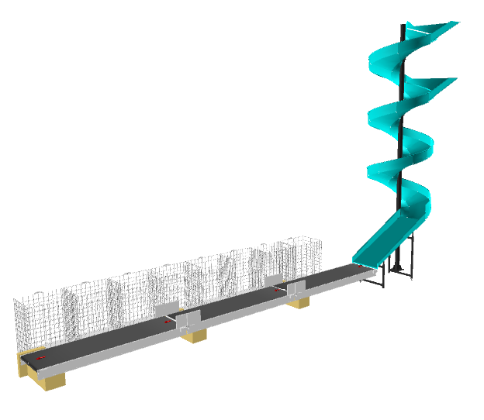
Each Spiral chute is further linked to 8 roll cage trolley via modular conveyor line ( roll cage trolley is In FK scope).

Each Chute is equipped with below components to ease the operations:
- Chute Full Sensor
- Four Color Tower Light
- Push Button
Chute I/Os | Description
Chute Full Sensor | To alert the system that the chute is full and mark that chute unavailable for further sortation
Four Colour Tower Lamp | To indicate the chute status
Push Button | To Start/Stop Sorting Operations

Rejection Chute

Rejection Chute is a type of chute used for the smooth descent of materials or objects from an elevated position to a lower level. It utilizes base metal to guide and support the flow of items along the chute & transfer the Shipment/Bags to Powered belt conveyor

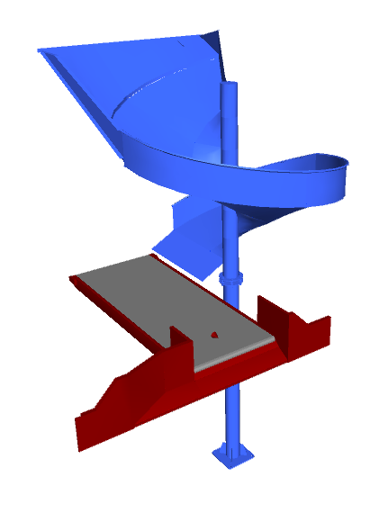

Each Chute is equipped with below components to ease the operations:
- Chute Full Sensor
- Four Color Tower Light
- Push Button
Chute I/Os | Description
Chute Full Sensor | To alert the system that the chute is full and mark that chute unavailable for further sortation
Four Colour Tower Lamp | To indicate the chute status
Push Button | To Start/Stop Sorting Operations

Conveyor BOQ

S.No | Name | EL_1 | EL_2 | Length (m) | Width (mm) | Set
1 | Modular Conveyor | 1002 | 1002 | 5 | 1238 | 1
2 | Modular Conveyor | 1002 | 1002 | 5 | 1238 | 1
3 | Modular Conveyor | 1002 | 1002 | 5 | 1238 | 1
4 | Modular Conveyor | 1002 | 1002 | 5 | 1238 | 1
5 | Modular Conveyor | 1002 | 1002 | 5 | 1238 | 1
6 | Modular Conveyor | 1002 | 1002 | 5 | 1238 | 1
7 | Modular Conveyor | 1002 | 1002 | 5 | 1238 | 1
8 | Modular Conveyor | 1002 | 1002 | 5 | 1238 | 1
9 | Modular Conveyor | 1002 | 1002 | 5 | 1238 | 1
10 | Modular Conveyor | 1002 | 1002 | 5 | 1238 | 1
11 | Modular Conveyor | 1002 | 1002 | 5 | 1238 | 1
12 | Modular Conveyor | 1002 | 1002 | 5 | 1238 | 1
13 | Modular Conveyor | 1002 | 1002 | 5 | 1238 | 1
14 | Modular Conveyor | 1002 | 1002 | 5 | 1238 | 1
15 | Modular Conveyor | 1002 | 1002 | 5 | 1238 | 1
16 | Modular Conveyor | 1002 | 1002 | 5 | 1238 | 1
17 | Modular Conveyor | 1002 | 1002 | 5 | 1238 | 1
18 | Modular Conveyor | 1002 | 1002 | 5 | 1238 | 1
19 | Modular Conveyor | 1002 | 1002 | 5 | 1238 | 1
20 | Modular Conveyor | 1002 | 1002 | 5 | 1238 | 1
21 | Modular Conveyor | 1002 | 1002 | 5 | 1238 | 1
22 | Modular Conveyor | 1002 | 1002 | 5 | 1238 | 1
23 | Modular Conveyor | 1002 | 1002 | 5 | 1238 | 1
24 | Modular Conveyor | 1002 | 1002 | 5 | 1238 | 1
25 | Modular Conveyor | 1002 | 1002 | 5 | 1238 | 1
26 | Modular Conveyor | 1002 | 1002 | 5 | 1238 | 1
27 | Modular Conveyor | 1002 | 1002 | 5 | 1238 | 1
28 | Modular Conveyor | 1002 | 1002 | 5 | 1238 | 1
29 | Modular Conveyor | 1002 | 1002 | 5 | 1238 | 1
30 | Modular Conveyor | 1002 | 1002 | 5 | 1238 | 1
31 | Modular Conveyor | 1002 | 1002 | 5 | 1238 | 1
32 | Modular Conveyor | 1002 | 1002 | 5 | 1238 | 1
33 | Modular Conveyor | 1002 | 1002 | 5 | 1238 | 1
34 | Modular Conveyor | 1002 | 1002 | 5 | 1238 | 1
35 | Modular Conveyor | 1002 | 1002 | 5 | 1238 | 1
36 | Modular Conveyor | 1002 | 1002 | 5 | 1238 | 1
37 | Modular Conveyor | 1002 | 1002 | 5 | 1238 | 1
38 | Modular Conveyor | 1002 | 1002 | 5 | 1238 | 1
39 | Modular Conveyor | 1002 | 1002 | 5 | 1238 | 1
40 | Modular Conveyor | 1002 | 1002 | 5 | 1238 | 1
41 | Modular Conveyor | 1002 | 1002 | 5 | 1238 | 1
42 | Modular Conveyor | 1002 | 1002 | 5 | 1238 | 1
43 | Modular Conveyor | 1002 | 1002 | 5 | 1238 | 1
44 | Modular Conveyor | 1002 | 1002 | 5 | 1238 | 1
45 | Modular Conveyor | 1002 | 1002 | 5 | 1238 | 1
46 | Modular Conveyor | 1002 | 1002 | 5 | 1238 | 1
47 | Modular Conveyor | 1002 | 1002 | 5 | 1238 | 1
48 | Modular Conveyor | 1002 | 1002 | 5 | 1238 | 1
49 | Modular Conveyor | 1002 | 1002 | 5 | 1238 | 1
50 | Modular Conveyor | 1002 | 1002 | 5 | 1238 | 1
51 | Modular Conveyor | 1002 | 1002 | 5 | 1238 | 1
52 | Modular Conveyor | 1002 | 1002 | 5 | 1238 | 1
53 | Modular Conveyor | 1002 | 1002 | 5 | 1238 | 1
54 | Modular Conveyor | 1002 | 1002 | 5 | 1238 | 1
55 | Modular Conveyor | 1002 | 1002 | 5 | 1238 | 1
56 | Modular Conveyor | 1002 | 1002 | 5 | 1238 | 1
57 | Modular Conveyor | 1002 | 1002 | 5 | 1238 | 1
58 | Modular Conveyor | 1002 | 1002 | 5 | 1238 | 1
59 | Modular Conveyor | 1002 | 1002 | 5 | 1238 | 1
60 | Modular Conveyor | 1002 | 1002 | 5 | 1238 | 1
61 | Modular Conveyor | 1002 | 1002 | 5 | 1238 | 1
62 | Modular Conveyor | 1002 | 1002 | 5 | 1238 | 1
63 | Modular Conveyor | 1002 | 1002 | 5 | 1238 | 1
64 | Modular Conveyor | 1002 | 1002 | 5 | 1238 | 1
65 | Modular Conveyor | 1002 | 1002 | 5 | 1238 | 1
66 | Modular Conveyor | 1002 | 1002 | 5 | 1238 | 1
67 | Modular Conveyor | 1002 | 1002 | 5 | 1238 | 1
68 | Modular Conveyor | 1002 | 1002 | 5 | 1238 | 1
69 | Modular Conveyor | 1002 | 1002 | 5 | 1238 | 1
70 | Modular Conveyor | 1002 | 1002 | 5 | 1238 | 1
71 | Modular Conveyor | 1002 | 1002 | 5 | 1238 | 1
72 | Modular Conveyor | 1002 | 1002 | 5 | 1238 | 1
73 | Modular Conveyor | 1002 | 1002 | 5 | 1238 | 1
74 | Modular Conveyor | 1002 | 1002 | 5 | 1238 | 1
75 | Modular Conveyor | 1002 | 1002 | 5 | 1238 | 1
76 | Modular Conveyor | 1002 | 1002 | 5 | 1238 | 1
77 | Modular Conveyor | 1002 | 1002 | 5 | 1238 | 1
78 | Modular Conveyor | 1002 | 1002 | 5 | 1238 | 1
79 | Modular Conveyor | 1002 | 1002 | 5 | 1238 | 1
80 | Modular Conveyor | 1002 | 1002 | 5 | 1238 | 1
81 | Modular Conveyor | 1002 | 1002 | 5 | 1238 | 1
82 | Modular Conveyor | 1002 | 1002 | 5 | 1238 | 1
83 | Modular Conveyor | 1002 | 1002 | 5 | 1238 | 1
84 | Modular Conveyor | 1002 | 1002 | 5 | 1238 | 1
85 | Modular Conveyor | 1002 | 1002 | 5 | 1238 | 1
86 | Modular Conveyor | 1002 | 1002 | 5 | 1238 | 1
87 | Modular Conveyor | 1002 | 1002 | 5 | 1238 | 1
88 | Modular Conveyor | 1002 | 1002 | 5 | 1238 | 1
89 | Modular Conveyor | 1002 | 1002 | 5 | 1238 | 1
90 | Modular Conveyor | 1002 | 1002 | 5 | 1238 | 1
91 | Modular Conveyor | 1002 | 1002 | 5 | 1238 | 1
92 | Modular Conveyor | 1002 | 1002 | 5 | 1238 | 1
93 | Modular Conveyor | 1002 | 1002 | 5 | 1238 | 1
94 | Modular Conveyor | 1002 | 1002 | 5 | 1238 | 1
95 | Modular Conveyor | 1002 | 1002 | 5 | 1238 | 1
96 | Modular Conveyor | 1002 | 1002 | 5 | 1238 | 1

Description of Components of Equipment

Elements of the sorting system
- Cross Belt Sorter
- Scanning & Sensing on Sorter
- Conveyor System
- Steel Works- Mezzanine & Staircases

Cross Belt Sorter -

Cross Belt Sorter is capable of sorting extremely high volume of versatile products in a gentle manner.
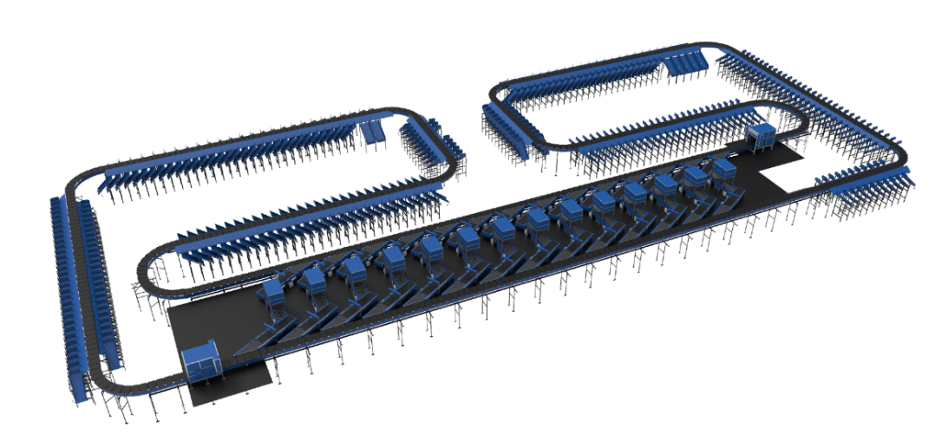
Falcon’s Cross belt sorter is powered by high efficiency linear motors and is based on 100% non-touch actuation technology leading throughput capabilities with extremely low noise levels.
Falcon’s Cross belt sorter is modular in design. It can be easily extendable as per future requirements

CBS Carrier

Falcon’s CBS offers one of the highest Belt widths to Carrier Pitch Ratio in the market today. This additional belt width makes the system capable of handling larger product sizes without compromising on throughput. This also means reduced “dead area” between Carrier belts which drastically reduces the amount of “inbetweeners “and non-sortable shipment recirculation.

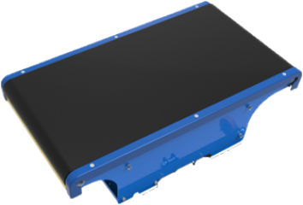

Servo Roller

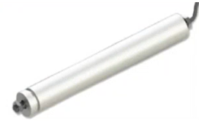
High Powered DC Drive Servo Roller are used to actuate the carrier belts, thereby eliminating the need for complicated drive transfer mechanism, and simplifying the system installation and maintenance.

Chassis

Falcon Autotech’s Cross Belt Carrier Chassis is made up of lightweight Aluminum which makes them light yet sturdy. This reduced weight leads to substantial “Power Savings” over a considerable period of usage.

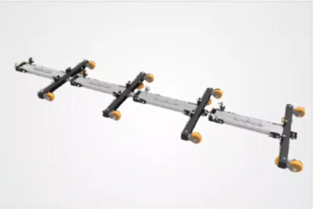

Carrier Wheels

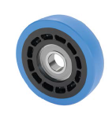
To enhance the reliability of CBS, we will use Faigle make Wheels in Non-Large CBS. Same wheels are used in Falcon XL CBS, where pay load capacity of each carrier is 40 kg as compared to Non-Large CBS, where pay load capacity is 10 kg per carrier.

Specs./ Make | Existing Make | Faigle
Wheel Dia | 75 mm | 100 mm
Revolutions | X | 1.33X
Load bearing capacity | 150 Kg | 175 Kg

Friction Wheel Drive
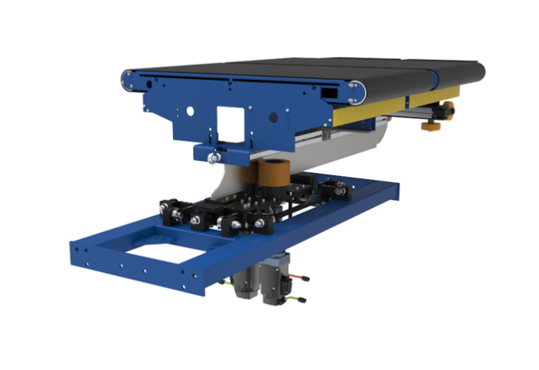
Extremely High Energy Efficient FWD that can be configured at variable speeds depending upon the operational requirements giving you the maximum flexibility when needed. Using servo motors to power friction wheels, FWD makes it better in terms of controlled speed, acceleration & deceleration

Non-contact based Linear motor drive
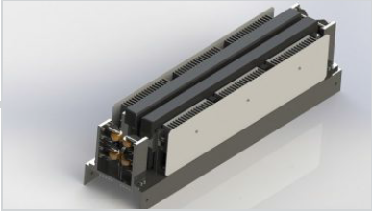
Extremely High Energy Efficient Linear Induction Motors that can be configured at variable speeds depending upon the operational requirements giving you the maximum flexibility when needed.

Power Transmission
Power transmission to Carriers over sliding contacts that require low maintenance and offer high levels of reliability.
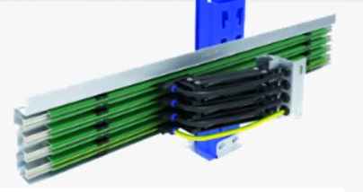

Data Transmission

R-Coax Cable
The R-Coax cable is used for data distribution in the sorter. This is a leaky wave cable, that runs throughout the sorter length transmitting the data. There is one antenna present in the super master carriage, which keeps on receiving the signal from this cable while on the move, wirelessly.
Leaky wave cable position
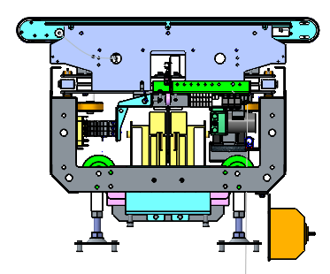
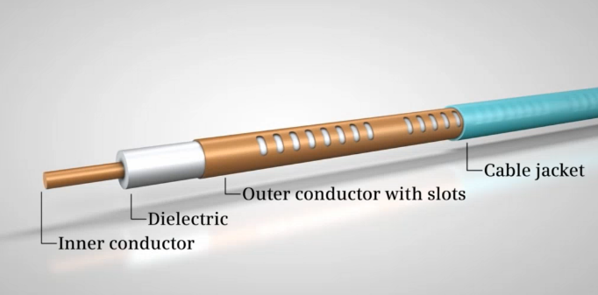

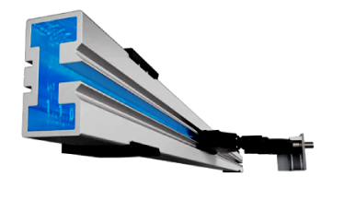
Microwave Data Transmission (Optional)
Microwave Data Transmission system, to achieve interference free communication between Loop and Main PLC at high data rates. The Wireless network is enclosed inside an aluminum profile (slotted microwave guide) such that there is no interference to the sorter-loop communication. This aluminum enclosure isolates Sorter’s communication network from the stray Wi-fi signals of the environment

Carriers positioning System.
Positioning system determines the exact location of each carrier in the loop at any given point in time. There is a plastic tape strip of barcodes (QR Codes) that is running along the sorter loop, which is continuously scanned by scanners placed on a Carrier (Master Carrier)
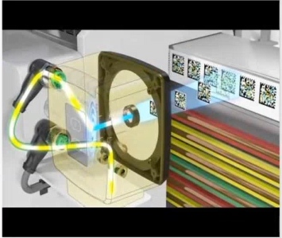

Technical specifications of Sorter (Shipment Sorter)

Items | Make
Sorter Carrier Type | Loop CBS
Sorter Speed in m/s | Up to 2.1 m/s
Sorter Loop Length (Upper Deck) | ~254 m
Sorter Loop Length (Lower Deck) | ~254 m
Sorter Actuation Technology | Electric
Chutes
Direct Bagging chute | 60
Secondary Chutes | 60
VDS Chutes | 24
Irregular chutes | 24
Irregular chutes (02) | 4
Rejection Chutes | 4
DBO chutes | 4
Height of Sorter | ~5500 mm / 3500 mm
Carrier Design
Carrier Motor Make | Falcon
Carrier Pitch - mm | 1175
No. of Carriers | 434 Nos.
Drives
Motor/Drive type | LIM
Power Consumption | Will be specified during DAP
Feedlines | 24 Nos
Power and Data Transmission
Power Transmission | Over Continuous Bus Bar
Empty Carrier Detection System (Camera Based) | 04 Nos
Maintenance Speed of the Sorter- Jog Mode | 0.8 m/s
Area Requirement (L x B) | Refer Layout

Technical specifications of Sorter (SL & Bag sorter)

Items | Make
Sorter Carrier Type | Loop CBS
Sorter Speed in m/s | Up to 2.3 m/s
Sorter Loop Length | ~224 m
Sorter Actuation Technology | Electric
Chutes
Spiral Chute | 32
Sliding Plate | 4
Overweight Chute | 3
Height of Sorter | 3500 mm
Carrier Design
Carrier Motor Make | Falcon
Carrier Pitch - mm | 800
No. of Carriers | 280 Nos.
Drives
Motor/Drive type | LIM
Power Consumption | Will be specified during DAP
Feedlines | 7 Nos
Power and Data Transmission
Power Transmission | Over Continuous Bus Bar
Empty Carrier Detection System (Camera Based) | 01 Nos
Maintenance Speed of the Sorter- Jog Mode | 0.8 m/s
Area Requirement (L x B) | Refer Layout

Scanning & Sensing on Main Sorter Loop

Automatic Barcode Scanning & Dimensioning System
Top Sided Barcode Scanner to scan shipment 1D codes and 2D codes. The Scanner is also capable of Archiving Shipment Images in Real time. As per FLIPKART requirements, Scanning is in FLIPKART scope.
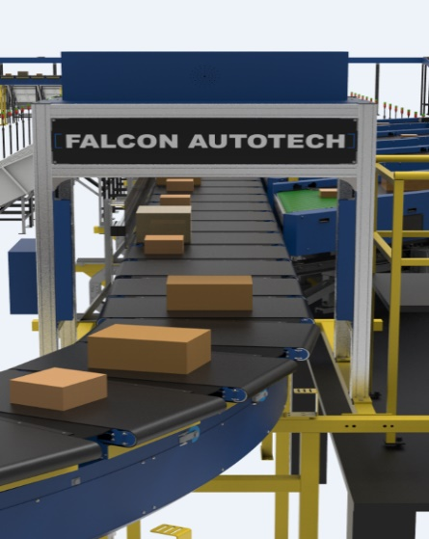
Falcon needs to supply Volume Measurement System. VMS 4200 quoted as option for Dimensioning of Shipments.

6 Side-Automatic Barcode Scanning & Dimensioning System (SL Shipment)
Five-Sided Barcode Scanner present on CBS loop & 1 bottom side scanner on feedlines for SL shipments to scan 1D codes and 2D codes. The Scanner is also capable of Archiving Shipment Images in Real time. As per FLIPKART requirements, Scanning is in FLIPKART scope.
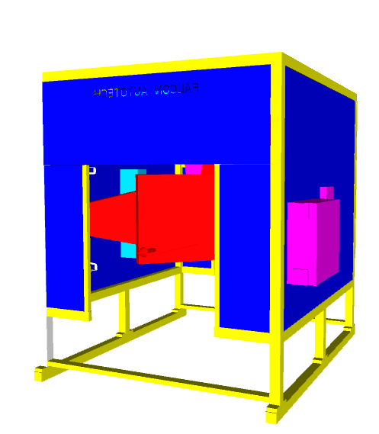
Falcon needs to supply Volume Measurement System. VMS 4200 quoted for Dimensioning of Shipments.

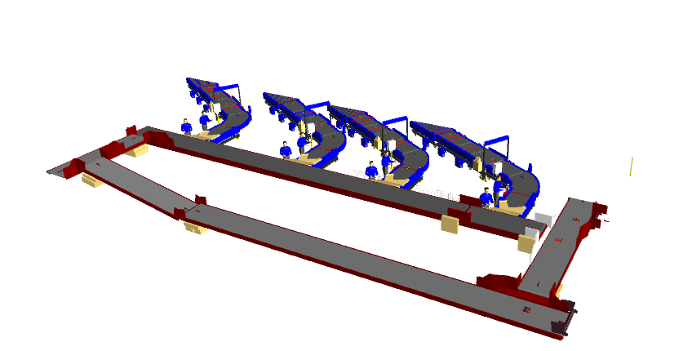
Manual Scanning for Bags
Handled scanners are present at each bag inducts to scan Bags after pulled by operators from dump loop.

Shipment Positioning System.
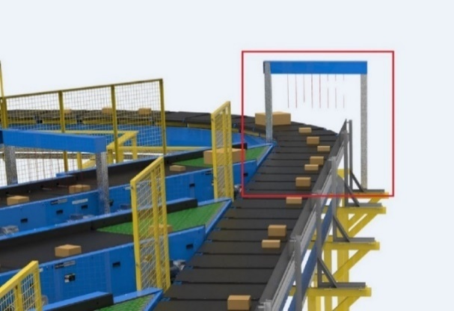
Falcon Cross Belt Sorter is equipped with Multiple shipment positioning Scan Tunnels. A tunnel comprises of a series of high Precision Laser Scanners that detect the absolute position of the Shipment on the Cross-Belt Carrier and prepares the Carrier for discharging the product accurately into the chute (virtual centring) and physically bring the product to the centre of cross belt carrier (Physical centring).

Empty Carrier Detection System
This system detects the empty carriers on the sorter and prepares the Feedlines to load the shipments on the empty carriers. (Camera based)
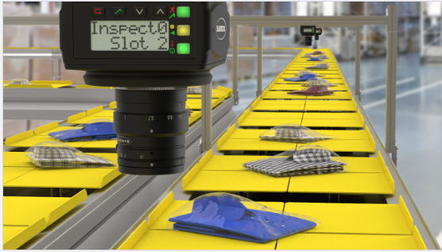

Steel Works – Mezzanine, Maintenance Platforms & Staircases-

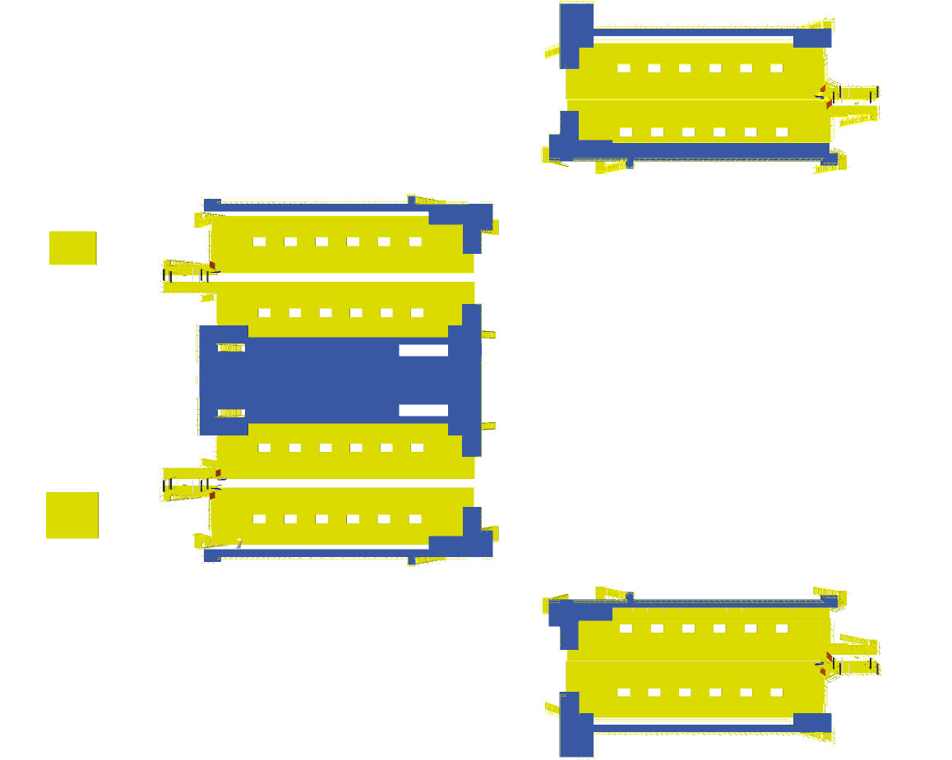
Mezzanine (Non-large Shipment Sorter)

Induct Mezzanine
VDS Mezzanine

- Total Mezzanine Area: 2971 Sq. Metres
- Motor Maintenance Platform: 7 Nos ~ 28 Sq. Meters
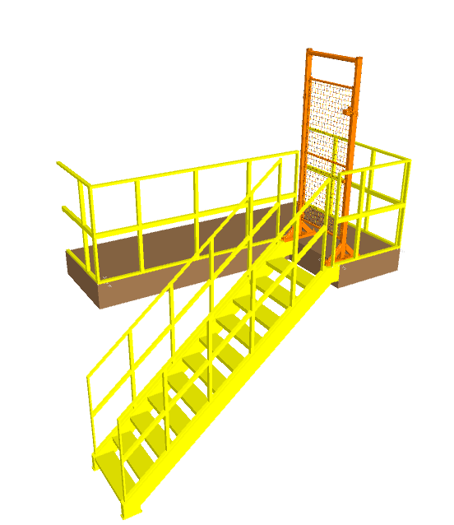
- No of Stairs: 36 Nos
- Monkey Ladder: 131 Nos

Maintenance Platform & Staircase

Maintenance platform with lockable gate

129 Nos ~ 516 Sq. Meter
2 Nos ~ 37.43 Sq. Meter
Safety gate at ICR & Panel: 28 Nos

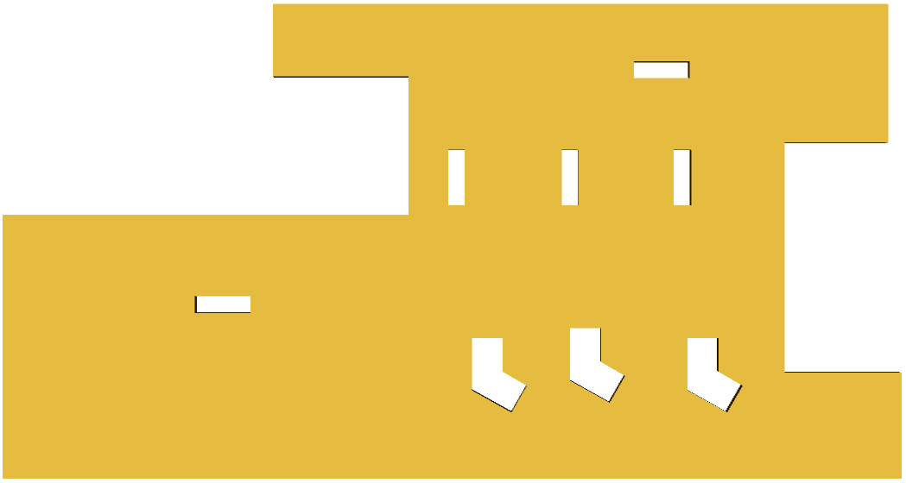
Mezzanine (SL & Bag Sorter)

Induct Mezzanine

Plan view of Mezzanine

- Total Mezzanine Area: 1028 Sq. Metres
- Clear height below Mezzanine: 2400 mm
- No of Stairs: 11 Nos

Maintenance Platform & Staircase
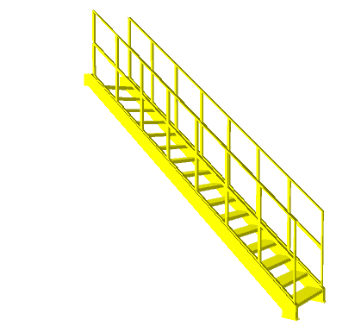
- 4 Sq. Meter: 7 Nos
- Safety gate: 6 Nos
- Monkey ladder: 7 Nos



System layout & Stagging Area Description
Output chute
Induct Zone
Induct Zone
Output chute


Plan View
Output chute
Induct Zone
Induct Zone
Output chute
Output chute
Induct Zone
Output chute

P+1
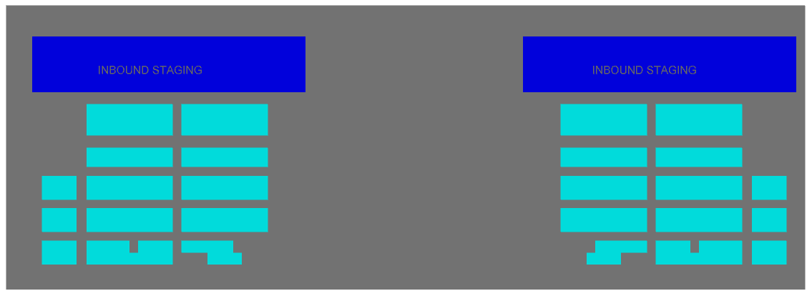

P0

System is marked with different type of Staging areas.
Inbound Staging Area – A total area of 6,834 Sq. Meter is dedicated for Inbound staging of Bags & Shipments.
Outbound Stagging Area – A total area of 9636 Sq. Meter is dedicated for Outbound bag & Shipment Stagging.
Note – The dedicated Areas are considered basis the specification shared by Flipkart.

Dock Calculation
Inbound Docks
Inbound Docks
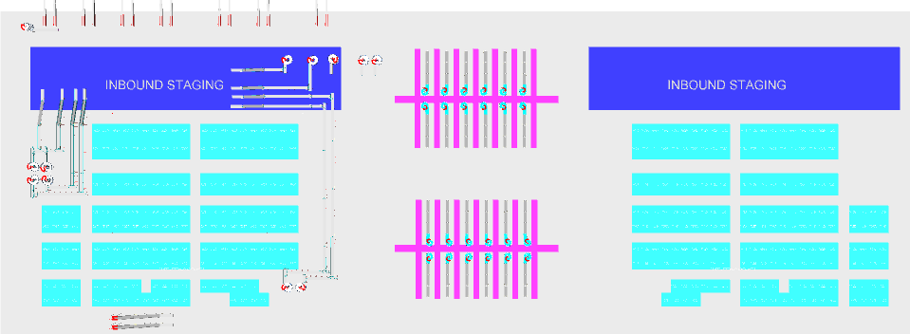

Outbound Docks

Inbound Network cluster  as per RFQ | % volume | Truck /cap | Volume /hr | No of trucks | Truck TAT | Truck filling rate /hr | No of truck position | No of docks
Local | 31% | 90 | 4574 | 51 | 42 | 128 | 36 | 18
Trans | 41% | 120 | 6050 | 50 | 52 | 137 | 44 | 44
Zonal | 7% | 600 | 1033 | 2 | 63 | 571 | 2 | 2
National | 22% | 600 | 3246 | 5 | 63 | 571 | 6 | 6
Total Number of Inbound Docks |  |  |  |  |  |  |  | 69

Outbound Network cluster  as per RFQ | % volume | Truck /cap | Volume /hr | No of trucks | Truck TAT | Truck filling rate /hr | No of truck position | No of docks
Local | 31% | 90 | 2745 | 30 | 60 | 90 | 30 | 15
Trans | 41% | 120 | 3630 | 30 | 75 | 96 | 38 | 38
Zonal | 7% | 600 | 620 | 1 | 90 | 400 | 2 | 2
National | 22% | 600 | 1948 | 3 | 90 | 400 | 5 | 5
Total Number of Outbound Docks |  |  |  |  |  |  |  | 59
The tabular data represent the total number of Inbound & Outbound dock = 128 Docks

Proposed System Technical Details (Shipment Sorter)

Mechanical equipment

Pos. | Qty. | Description | Value
1 | 1 | Infeed System  - Powered Belt Conveyors  - Tilted gate Belt Conveyor  - 90 deg turns  - 180 deg turns  - Gravity roller conveyor  - Telescopic Belt Conveyor  - Tilted VDS gates  - VDS Chutes | ~1396 metres (193 Modules)  ~ 192 metres (04 Modules)  02 Nos  32 Nos  ~58 metres (35 Modules)  14 Nos  48 Nos  48 Nos
2 | 48 | Feedlines  Consists of  - Receiving Conveyor  - Weighing Conveyor  - Buffer Conveyor  - Intelligent merge | 1 Set  1 Set  1 Set  1 Set
3 | 1 | Irregular Shipment Handling  - Powered Belt Conveyors  - Irregular chutes  - Irregular chutes (02) | ~152 metres (17 Modules)  48 Nos  08 Nos
4 | 2 | Sorter  1 Loop Cross Belt Sorter  - Sorter Height  - Sorter Length  - Sorter Speed  - Sorter Drive  - Carrier Pitch  Including:  - Standard Sorter Supports  - Empty Carrier Detection System  - Product Centring System  - Dimension Scanning System  - E-Stops  - Hooters  - Fencing | 3500mm/5500mm  ~254 m(Deck 1), 254 m(Deck2)  ~2.1 m/s  Linear Motor  1175 mm
5 | 2 | Sorter Outputs  - Secondary chutes  - Direct bagging chutes  - Bag holding assembly  - Rejection chutes  - DBO  - Transfer Plate  - Bag holding assembly table | 60 Nos  60 Nos  60 Nos  04 Nos  04 Nos  ~256 m  ~229 Sqm
6 | 1 | Bag Takeaway Conveyor  - Powered Belt Conveyors | ~669 metres (59 Modules)
7 | 1 | Steel Works  - Operator and VDS Platform  - ICR Maintenance platform  - Stairs  - Stairs Platform  - Motors maintenance platform  - Safety gate  - Monkey ladder | ~2971 SQM  ~84 SQM  36 Nos  02 Nos  129 Nos  28 Nos  131 Nos

Electrical Equipment

Electricals
1 | 1 | Consists of  Main Power Distribution panel  Main Control Panel  Feedline Control Panels  Sorter Drive Panels  Network Switches  Field Cabling | Included

Control System

Components
1 | 1 | Consists of  Siemen’s PLC based Control System with SCADA  Industrial Switch | 1 Nos.  As per requirement

Proposed System Technical Details (SL & Bag Sorter)

Mechanical equipment

Pos. | Qty. | Description | Value
1 | 1 | Infeed System  - Powered Belt Conveyors  - Modular Belt Conveyor  - 180 deg turns  - 90 deg turns  - Aligning conveyor  - Sigulators  - Overweight Chutes  - XL Sliding Chute | ~282 metres (42 Modules)  ~22 metres (2 Modules)  06 Nos  01 Nos  01 Nos  03 Nos  03 Nos  04 Nos
2 | 1 | Feedlines  SL Feedline Consists of (3 Nos)  - Receiving Conveyor  - Weighing Conveyor  - Angle Merge  - Short Buffer  - Spacing Conveyor  Bag Feedline Consists of (4 Nos)  - Loading Conveyor  - Weighing Conveyor  - Angle Merge  - Short Buffer | 1 Set  1 Set  2 Set  3 Set  4 Set  1 Set  1 Set  1 Set  2 Set
3 | 1 | Sorter  1 Loop Cross Belt Sorter  - Sorter Height  - Sorter Length  - Sorter Speed  - Sorter Drive  - Carrier Pitch  Including:  - Standard Sorter Supports  - Empty Carrier Detection System  - Product Centring System  - Dimension Scanning System  - E-Stops  - Hooters  - Fencing | 3500mm/5500mm  ~236 m(Deck 1)  ~2.3 m/s  Linear Motor  800 mm
4 | 1 | Sorter Outputs  - Spiral Chutes  - Exceptional handling  - DBO chute | 32 Nos  01 Nos  01 Nos
5 | 1 | Bag Conveyor (followed by spiral chute)  - Modular Belt Conveyors | ~443 metres (96 Modules)
6 | 1 | Steel Works  - Operator Platform  - Stairs  - Motors maintenance platform  - Safety gate  - Monkey ladder | ~1012 SQM  11 Nos  07 Nos  06 Nos  07 Nos

Electrical Equipment

Electricals
1 | 1 | Consists of  Main Power Distribution panel  Main Control Panel  Feedline Control Panels  Sorter Drive Panels  Network Switches  Field Cabling | Included

Control System

Components
1 | 1 | Consists of  Siemen’s PLC based Control System with SCADA  Industrial Switch | 1 Nos.  As per requirement

Electrical System
Main power supply will supply Falcon’s PDP (Power Distribution Panels) electrical cabinets.
PDP cabinets supply the entire system via secondary cabinets:
- Main Control Cabinet
- Induct Control Panels
- Remote Cabinets for Sorter I/O
- Scanner Control cabinets

Reference Picture of Power Distribution Panel
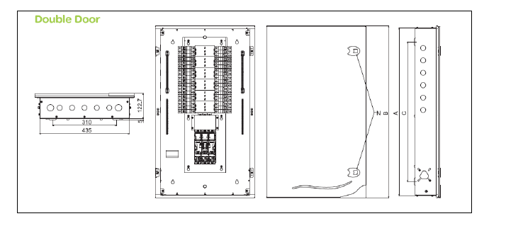

Main Control Panel (Reference)

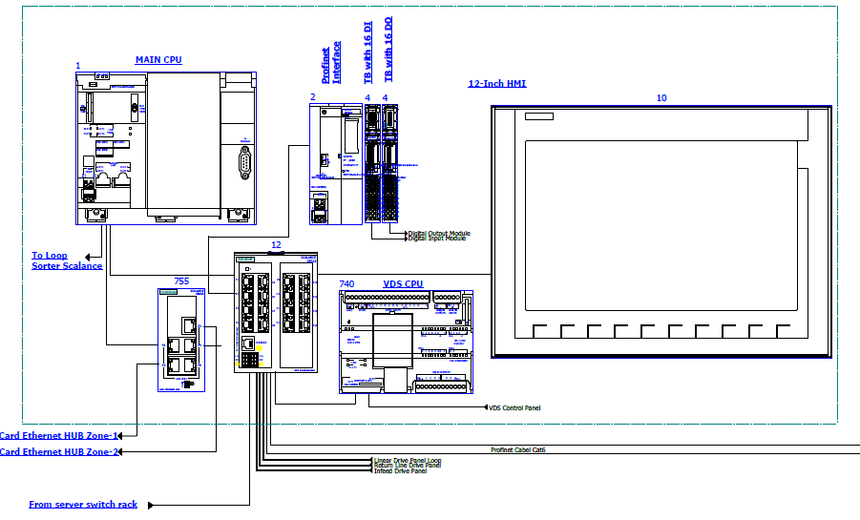

Induct Stations Control Panel (Reference)

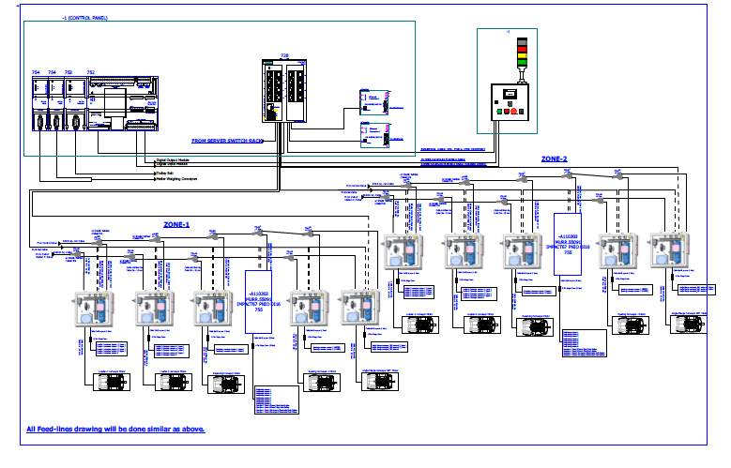

Engines
Three-phase alternating current motors (Induction) will be used through a frequency converter.
The engines will be coupled with a converter to improve consumption and reduce the carbon footprint.
All motors will have appropriate IP ratings

Sensors
The sensors will be supplied, standardized by type, with connector, with a cable length suitable for easy extraction, suitably protected from possible impacts.

Control command
The proposed solution is based on SIEMENS Programmable Logic Controller technology (PLC) platform. The entire system will be logically divided into Zones (Sorter/ Feed Line/ Loop), each managed by a PLC. The planned primary communication protocol is going to be ProfiNet.

Conveyor interface
The frequency converter of each conveyor allows the acquisition of the signals of the sensors/actuators/GIOs associated with it (e.g. conveyor end detection photocells, blockage detection photocells). Each frequency converter will be connected in series by means of the ProfiNet field bus

Controls Architecture (Ref.)

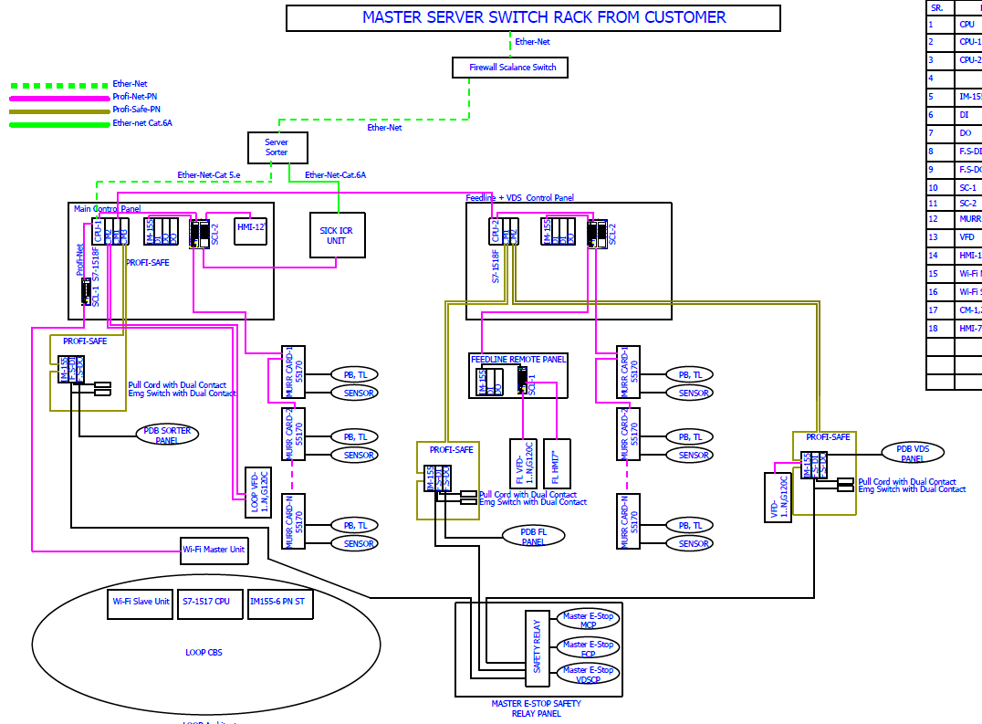

Redundant Control Architecture for Double deck System (Optional)
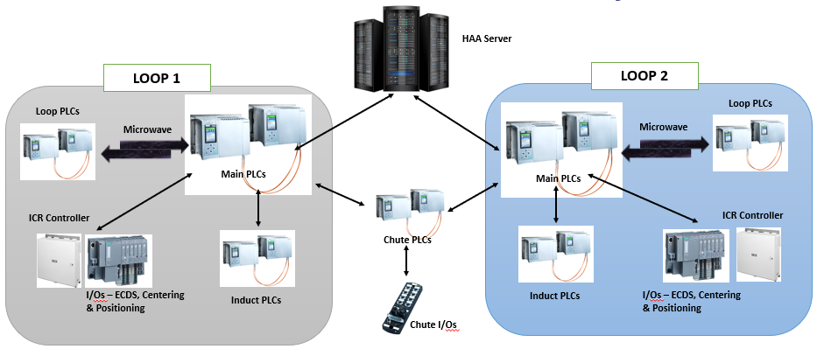

IT Architecture (Ref.)
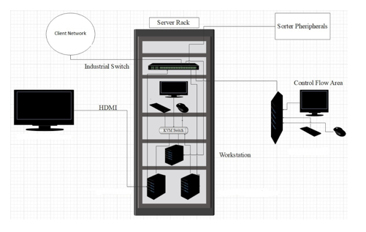

HAA Server (In Flipkart Scope)

S.no | Description | Qty
20Core Config with 128 GB RAM in T440 and 64 GB RAM in T40
1 | Synology_storage_DS723+ 2.6 GHz AMD Ryzen R1600 Dual-Core, 2 x Gigabit Ethernet Ports, | 2
 | 2GB ECC DDR4 RAM, 2 x 3.5/2.5" Bays | 2 x M.2 2280 Slots E10G22-T1-Mini 10GbE RJ-45 network upgrade module for compact Synology servers
2 | Dell Tower Model T440 -PowerEdge T440 Xeon Gold 6148 2.4GHz/20C/27.5MB/150 W 16 DIMMS 4 x32GB RDIMM Up to 8 3.5"" Hot Plug Hard Drives Tower Configuration 2 x 1.2TB 10K RPM SAS 12Gbps 512n 2.5in | 2
 | Hot-plug Hard Drive PERC H750 Adapter Full Height 8GB Cache Dual Hot-plug PS495W iDRAC9Enterprise 3YR ProSupport Next Business Day Onsite/Dual Port Lan
3 | Dell PowerEdge T40 Intel Xeon E-2224G Processor 3.5GHz 8M Cache,4C/4T,Turbo,71W,TPM, 4*16 GB RAM (4 DIMM), 2x1TB SATA 3.5" 7.2k rpm HDD (3 Bay), 1Gbe LOM ,DVD Writer, Onboard RAID 01, Inbuilt PSU Standard (Max 1), 3 | 1
 | Year Onsite NBD,480 GB SSD,1 Gbe Dual Lan Card Extra
4 | Windows Server 2019 | 3
5 | Monitor | 1
6 | KVM Switch | 1
7 | Mouse | 1
8 | Keyboard | 1
9 | Lan Cable | 10
10 | Power Cable | 8
11 | VGA Cable | 1
12 | 42 AC Server Rack | 1
13 | Netgear 24 Port Giga Switch | 2
14 | 2 TB SSD Micron | 4
15 | DP to VGA Convertor Cadyce Brand | 1

Falcon’s WCS CONTROLIT

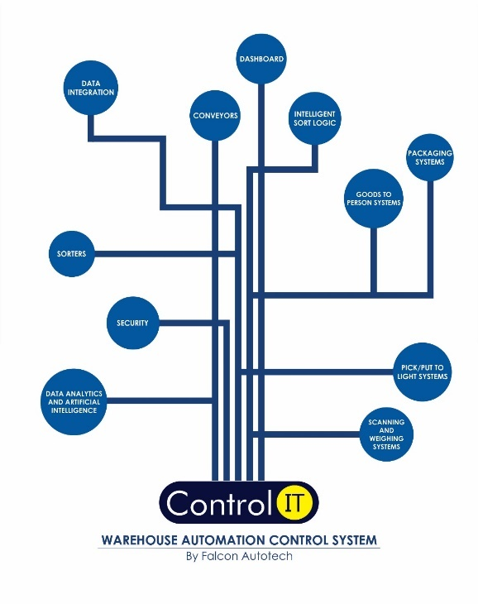

Key Values

Supported Protocols

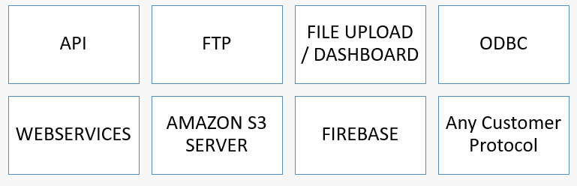

Falcon’s Visual Inspection System (SCADA)

SCADA stands for Supervisory Control and Data Acquisition. It is a system of hardware and software components that allows for remote monitoring, control, and data acquisition of industrial processes or facilities

The Visualization system provided by FALCON (or SCADA) allows the monitoring and control of the different systems delivered for the Flipkart Riyadh Hub. This SCADA system receives from each monitored sub-system all information on their operating status in real time.
At the system monitoring level, the functions performed are:
- Field data acquisition.
- Animated visualization of equipment.
- Representation of the operating mode of the system (nominal, contingency, etc.).
- Alarm management.
- Alarm history management.
- Diagnostic help.
- Failure detection.
- Equipment control.
- Statistics on equipment operation.
- Historical Statistical Report.
- Recording and archiving.
- Safety operator interface.

FIELD DATA ACQUISITION

The field data acquisition function is performed by the SCADA system connected to the sorters' PLCs.
The communication with the PLCs is done using equipped CPU cards that are able to manage the communication with the PLC on the Industrial Ethernet network, without overloading the server.
The acquisition of signals from external systems is carried out via the PLC, using dry contacts.

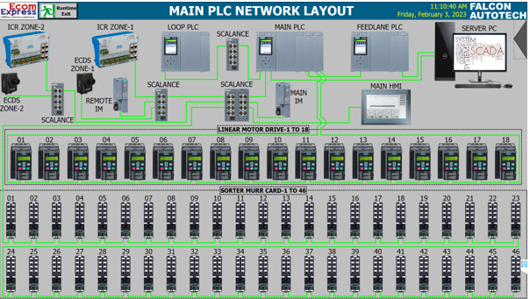

ANIMATED SYSTEM VISUALIZATION

The animated view represents the dynamic graphical user interface that allows real-time monitoring of the controlled systems and the execution of their control procedures.
The various states of the digital signals are displayed on the screen by graphic symbols. All views are web based with responsive capabilities when required so that various devices can be used to display status and information on PC. The types of information that can be displayed on each type of device will be discussed during the design phase of the project.
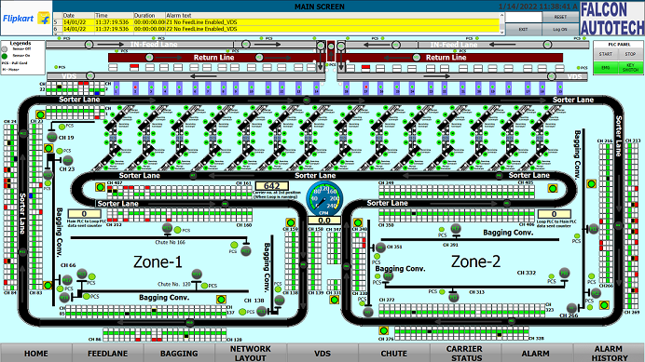

Example of a synoptic view
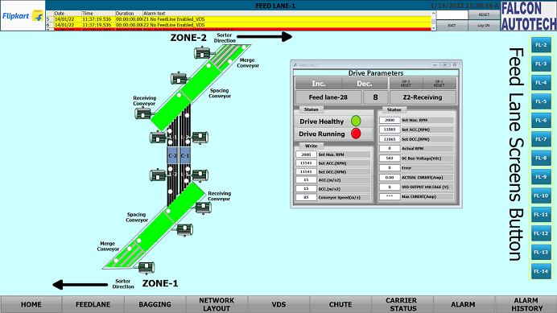

ALARM MANAGEMENT
The alarm pages display a series of information to identify the nature of the alarm or event, the elements involved and the time.
The alarm management includes:
        - The Alarm name.
        - The date on which the above-mentioned alarm was activated.
        - The moment the alarm goes off.
        - The date on which the alarm is activated again.
        - The moment the alarm is activated again.
        - The sub-system that activated the alarm.
        - The area where the alarm was triggered.
        - The name of the beacon that activated the alarm.
        - The alarm state.
        - The alarm value.
        - A complete alarm description.
The historic data of each alarm is stored in the SCADA database. This type of fault detected includes:
          - Sensors.
          - Drive Fault.
          - Lack of monitored equipment.
          - Etc.

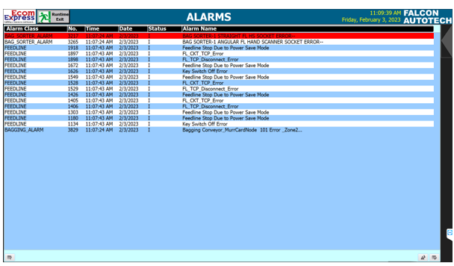
Sample Alarm History Screen

Key Components Make

Items | Make
Belts | Forbo/ Derko
Rollers | Falcon
Cross Belt Carriers | Falcon
Friction Wheel Drive | Falcon
Feed Line Motors | Induction Motors – SEW/ Lenze
Volume Scanners (VMS 4200) | SICK
Weighing Scales | Bizerba/ Mettler Toledo
Encoders | SICK
Sensors | Sick/Leuze/ P&F
PLC | Siemens/ Omron
Control Panels | Rittal/ BCH
VFDs | Siemens/Lenze/ AB/ Omron
Cables | LAPP/ Equivalent
Switch Gear | Schenider/Equivalent
Bearings | NTN/SKF/Equivalent
Power Transmission Systems | Vahle
HMIs | Siemens

Principle of Safety

E-Stops
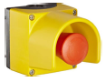

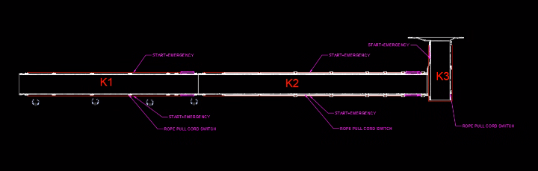
- At Every Conveyor Module – Both sides

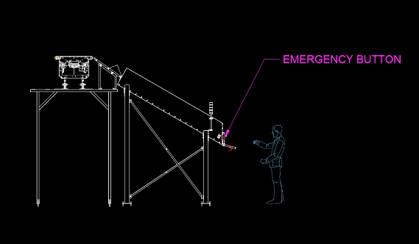
- VDS Chutes

Pull Cords Switch-
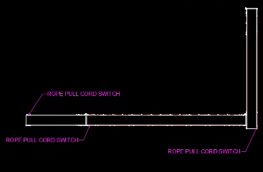
Required for Infeed & Takeout Conveyors

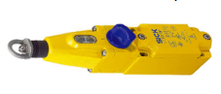

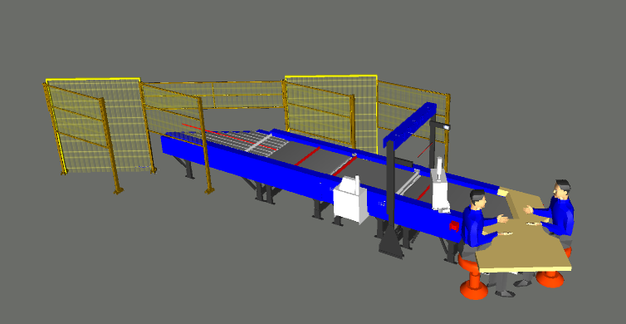

Fencing

- Between Inducts

- Between Inducts and Sorter

Additional Scope-

        - Key management System at Inducts with Fortress
        - FRLS Cables- LAPP/ Polycab/ KEI Make
        - Power Saving Sensors for Conveyors
        - Safety PLC
        - Safety Net between Chutes.
        - Energy Meters & surge arresters
        - Safety Gate at ICRs

Program Organisation

Program/ Project Schedule

S.No. | Activity | Timeline
1 | Receipt of PO | Week 0
2 | Project Kick off | Week 2
3 | DAP Submission | Week 5
4 | DAP Approval | Week 7
5 | Detailed Designing | Week 11
6 | Manufacturing & Procurement | Week 19
7 | Inhouse Assembly | Week 23
8 | Dispatch Start | Week 24

*Above plan is tentative, detailed plan will be shared post order confirmation.

Program & Account Management
At Falcon Autotech, our commitment revolves around fostering optimal engagement and transparency throughout the project management process. To achieve this objective, we propose the implementation of the following approach:
- Establishment of a dedicated Flipkart Business Unit within Falcon Autotech, overseeing project management with assigned spokespersons at each hierarchical level to enhance coordination.
- Implementation of weekly or fortnightly project routines to facilitate meticulous tracking and effective management.
- Adoption of a robust framework for Change Risk and Opportunity Management, coupled with a governance structure to ensure proactive handling of challenges and opportunities.

Flipkart Responsibility

Flipkart Responsibilities During the Assembly and Commissioning Phase

- Provision of the site complex and office area facilities.

- Flipkart to provide HPT/ Forklift for material movement for complete duration.

- The possibility of authorizing access to the site and the execution of the installation work up to 7 days a week and 24 hours a day if deemed necessary and if requested by FALCON.
- Free provision, during the installation phase, of the power supply necessary for the installation activities (estimated at 20 kW).
- Provision, during the commissioning phase, of the power supply necessary for the operation of the shipment sorting system free of charge at the date of FALCON need.
- Provision of the IT system functionality in accordance with the specification at the date of FALCON need.
- The customer is responsible for a safe working environment.
- The customer makes arrangements for the working area(‘s) to be protected against direct weather influences.
- The customer provides adequate lighting, heating, and ventilation to create a normal working environment.
- The cost of temporary storage that may be required (other than in the immediate vicinity of the installation site) is not included in the scope of delivery of this quotation. This also applies to temporary storage that may be required because materials are ready for delivery (in accordance with the schedule) but cannot be delivered due to hold-ups on the customer's side.
- The customer is responsible for the demarcation of aisles and danger zones with floor paint.

Responsibilities of Flipkart During the Tests

- Provision of the test loads and barcode labels required for the tests.
- Provision of personnel required for test activities (loading and unloading operations).
- Provision of the necessary information to sort the shipments correctly.
- Verify with FALCON the quality and conformity of the test loads (labels, cartons).
- Will need to provide the necessary staff to collect information on the tests and to verify and confirm test results with FALCON.

Flipkart Responsibilities During the Training

- Free from their usual work, the employees participate in the training for the duration of the training.
- Provision of a list of participants for each available training course 3 days before the start of the course.

- Provision of a classroom equipped with a whiteboard, video projector, projection screen, and enough space for desks or tables and chairs for the trainer and trained staff.
- Check the prerequisites of the people who have to follow the training, e.g. the qualifications of the technical staff.
- The invitation of staff to attend the training courses will be at the expense of FLIPKART.

Testing, Training, and Support

Acceptance Testing

This section serves to outline the precise criteria and methodology for Falcon to validate that the installed system complies with the operational and performance requirements outlined in this proposal.

Testing necessitates comprehensive assistance from both Falcon and Flipkart Personnel, including:

- Provision of Flipkart material/products for functional testing (Falcon requires a sufficient quantity and a complete range of sizes for thorough testing).
- Accessibility to software components and applications (including accurate data for testing).
- Engagement of Flipkart labour (and equipment if necessary) to facilitate the testing process.
- Ensuring the availability of system equipment throughout the duration of each test.

Acceptance Test Plan

Based on the criteria outlined and mutually agreed upon by Falcon and Flipkart in this proposal, Falcon will formulate the Acceptance Test Plan (ATP). The ATP will define a systematic approach for the execution of the Acceptance Tests specified in this section. Furthermore, the ATP serves as the instrument employed by Falcon to achieve formal acceptance and obtain sign-off from Flipkart.

Falcon will furnish the ATP to Flipkart before the initiation of any tests. The ATP will encompass the following elements:

- Test prerequisites
- Daily plan/schedule
- Personnel responsibilities
- Computer data and test loads required
- Specific test procedures
- Anticipated test results

Minor / Major Faults

Falcon will classify any encountered faults during testing into either Minor or Major categories, as outlined below:

- Minor Faults are characterized as issues affecting a confined area or a single component with no repercussions on the overall test. These faults will be included in the System Snaglist and will not impede the ongoing testing process.

- Major Faults are defined as issues with a significant impact, leading to the inability to showcase the functionality in question. Addressing Major Faults may necessitate restarting the test.

Specific Procedure

- Falcon staff will oversee the upkeep and dissemination of the System Snaglist during Acceptance Testing.
- Upon the resolution of each issue, Flipkart will validate the correction and endorse the resolution on the System Snaglist.
Note: Validation can be conducted independently of Falcon personnel presence and should be documented through the designated signature of Flipkart on the System Snaglist.

Included Acceptance Tests
The following Acceptance Tests are part of the Final Acceptance Testing:
- Physical Acceptance Testing.
- Functional Acceptance Testing.
- System throughput Testing (as specified).

Physical Acceptance Testing

Test Definition
The Physical Test involves a walkthrough of the System, attended by both Falcon and Flipkart personnel. They will verify that the physical equipment is complete and installed according to the final drawings and specifications, typically documented by area or subsystem.

Specific Practice
- Physical Testing is conducted continuously and concurrently with installation.
- Physical Testing may extend into the commissioning and integration periods and should be completed before other Acceptance Testing.
- Physical Testing is considered complete after all System walkthroughs and the resolution of items recorded in the System Snaglist.

Functional Acceptance Testing

Test Definition
Functional Testing follows the completion of Falcon engineering commissioning activities. It verifies the proper function of the System according to the requirements in this Proposal and the detailed specifications developed during the Project.

Note: This testing does not repeat each test conducted during the Commissioning phase of the Project.

Both Falcon and Flipkart personnel will attend and verify that the System functions as described in this Proposal. Defects requiring correction will be logged into the System Snaglist.

Functional Testing typically includes:
- Operation/equipment interface, safety mechanisms, and interaction testing.
- Electrical/control functions such as normal start/stop, flow control, and emergency stopping.
- Controller and computer system interfaces (uploads, downloads, and interlock signals).

Specific Practice
Functional Testing is considered complete after the successful conclusion of all Functional Tests and the resolution of items recorded in the System Snaglist.

Throughput Testing

Test Definition
To demonstrate System's ability to meet the system throughput in the final Material Flow Throughput section of this Proposal, Falcon proposes to conduct Mechanical System Throughput Testing for each area defined in the ATP before beneficial use of the system.

Measurement
System Throughput Testing is completed by Falcon under non-production/controlled conditions, after the completion of related commissioning activities. Defects requiring correction are logged into the System Snaglist.

Tests verify that system throughputs are achieved for the areas specified in the ATP.

Specific Practice
System Throughput Testing is considered complete after the successful conclusion of all System Throughput Tests.

Final Acceptance Criteria
Final Acceptance is declared complete when:
- Physical Acceptance Testing, Functional Acceptance Testing, and System Throughput Testing are all complete.
- All items in the System Snaglist are resolved.
- As-built documentation is submitted.

Acceptance Test Letter
After successful completion of Acceptance Testing, Falcon will provide Flipkart a letter addressing the following:
- The System has been installed and accepted by Flipkart.
- Note: Acceptance may be conditional on the remedy of agreed-upon System Snaglist items with established completion dates.
- Confirmation of the commencement of the warranty period.
- The final payment amount required and the designated due date.
Note: Falcon has approached the testing for this project based on Falcon standard testing practices.

Training

Training for the recently installed material handling system at Flipkart's facility is an integral part of the implementation process. Falcon employs a business-linked learning approach in the design, development, delivery, and evaluation of its training programs.
Falcon adheres to a well-defined process tailored to create learning content specific to Flipkart's installation and application of their systems.

Operations Training

System Operations Training is provided to offer participants an understanding of their area from an operational perspective. Falcon targets critical operations in the assigned functional area, covering flow control, system operation, and control devices. Discussions also emphasize the impact of individual and area performance on upstream and downstream workers.

Maintenance Training

The Maintenance Training curriculum encompasses mechanical, electrical, and controls aspects of the installed system. Topics include safety, system construction and installation, system operation, maintenance and repair procedures, and technical documentation.
Falcon recommends assigning personnel responsible for system maintenance to work with the installation and commissioning crews during their final weeks on-site. Formal training courses for maintenance personnel will be conducted before system startup, featuring classroom lectures, audio-visual presentations, and hands-on demonstrations with the installed system. Site tours will be organized to highlight common operational issues affecting system uptime.

Information System Training

Information System training covers the computer hardware and software aspects of the Automated Material Handling System. Software Application Engineering topics include system administration, data storage, computer system operation, and other computer-related tasks.

Life Cycle Services

Falcon can provide as an option the following Life Cycle services:
• Preventive maintenance.
• Corrective maintenance.
• Hotline service.
- On Site Support
• Supply and management of spare parts.

Preventive Maintenance

A preventive maintenance package refers to planned maintenance activities and services designed to prevent equipment, machinery, or systems from breaking down or deteriorating over time. Preventive maintenance aims to identify and address potential issues before they lead to costly breakdowns or disruptions in operations.

Corrective Maintenance

Corrective maintenance, also known as corrective maintenance, is a type of maintenance activity that focuses on addressing and repairing equipment or system failures, defects, or malfunctions when they occur. Unlike preventive maintenance, which aims to prevent breakdowns through scheduled inspections and maintenance tasks, Corrective maintenance is reactive and comes into play when a problem has already arisen.

Hotline Support

The hotline service access is available 24 X 7
The main function is to dispatch the call to the proper qualified engineer for immediate answer. If the Falcon qualified engineer is not available, the call is transferred to a back-up qualified engineer and finally an answering machine. In the last case, the FLIPKART personnel shall be contacted within the time frame described in the service level.
The Falcon qualified engineer will support FLIPKART maintenance personnel by using a remote access (via VPN) to the equipment/systems.

On Site Support

To adhere to the committed System uptime, dedicated On site team will be available at Site covering all shifts. Team comprises of Supervisor in general shift and 1 Electrical & 1 Mechanical technician in each Shift.

Supply and Management of Spare Parts

This paragraph describes the principles and procedures that will be implemented between Falcon and FLIPKART, with regard to the spare parts management policy.
• Spare parts orders.
• On completion of the DAP, when the configuration will be finalized a final and detailed list, which will be extended to include all spare and wear parts, will be presented to FLIPKART.
• The exact number of spare parts will be determined with FLIPKART, according to its stock strategy on the basis of the list of recommended spare parts.

Commercial Terms

Price Sheet
Non-Large Shipment Sorter
S. No | Component | Set | Price (INR)
1 | Double Deck Loop CBS System | 4 | ₹ 38,35,10,511
2 | Conveyor Automation | 1 | ₹ 27,55,66,453
3 | Output Chutes | 4 | ₹ 6,43,11,719
4 | Steel Works | 1 | ₹ 7,69,46,934
5 | Revit and BIM Collaborate Pro (2 Years) | 2 | ₹ 26,23,090
6 | Spiral Conveyors | 1 | ₹ 3,04,78,490
7 | Toolkit | 4 | ₹ 3,19,200
8 | Software Packages | 1 | ₹ 30,50,000
9 | Installation & Commissioning | 1 | ₹ 3,32,45,332
10 | Packaging & forwarding | 1 | ₹ 1,24,67,000
11 | Project Management | 1 | ₹ 1,75,97,913
12 | Improvement Points | 1 | ₹ 89,30,760
Grand Total (INR) |  |  | ₹ 90,90,47,401

Additional cost for Data Transmission Upgrade
S. No. | Upgrade to Microwave Data Transmission System | Price (INR)
1 | Microwave Data Transmission System for Two Double Decks | 1.4 Cr

S. No. | Upgrade to Redundant Control System | COST IMPACT (INR)
1 | Redundant Controls in both Loops of Two Double Decks | 1.2 Cr
2 | Redundant Chute Controls in Two Double Decks | 18 Lacs
Additional cost for Redundant Control System

Semi-Large and Bag Sorter
S. No | Component | Set | Price (INR)
1 | Double Deck Loop CBS System | 4 | ₹ 38,35,10,511
2 | Conveyor Automation | 1 | ₹ 27,55,66,453
3 | Output Chutes | 4 | ₹ 6,43,11,719
4 | Steel Works | 1 | ₹ 7,69,46,934
5 | Revit and BIM Collaborate Pro (2 Years) | 2 | ₹ 26,23,090
6 | Spiral Conveyors | 1 | ₹ 3,04,78,490
7 | Toolkit | 4 | ₹ 3,19,200
8 | Software Packages | 1 | ₹ 30,50,000
9 | Installation & Commissioning | 1 | ₹ 3,32,45,332
10 | Packaging & forwarding | 1 | ₹ 1,24,67,000
11 | Project Management | 1 | ₹ 1,75,97,913
12 | Improvement Points | 1 | ₹ 89,30,760
Grand Total (INR) |  |  | ₹ 90,90,47,401

Additional cost for Data Transmission Upgrade
S. No. | Upgrade to Microwave Data Transmission System | Price (INR)
1 | Microwave Data Transmission System for Semi-Large/Bag Sorter | 38 Lacs

S. No. | Upgrade to Redundant Control System | COST IMPACT (INR)
1 | Redundant Controls in a Semi-Large/ Bag Sorter | 30 Lacs
Additional cost for Redundant Control System

*Note: Upgraded Sorter wheels (Faigle make) will be provided complementary with this system.

The Total Price is to be understood.
- Freight - Excluded
- Taxes as applicable
- Packing and Forwarding - Included
- Price is valid for 60 days from the date of proposal.
*Material Unloading & Laydown area is in customer scope

Payment Terms

Payment Percentage | Stage
20% | Advance along with PO against ABG
50% + taxes | Material received at Site
20% + 50% 0f I&C | Against erection
10% + 50% 0f I&C | Acceptance and complete handover against PBG

Warranty Period
Falcon’s offered System comes with a standard warranty of 1 year (Starts from the date of beneficiary use).
The warranty covers the following support:
- 24 X 7 Telephonic, Email and Remote Service Support when required.
- Regular Software updates and Bug Fixes.
- Supply of Mechanical and Electrical components in case of failure (excluding damages as mentioned in the Exclusion Clause)
The warranty does not apply to the replacement or repair of:
- Normal wear and tear.
- Consumables.
- Faulty articles continued:
  - Failure to comply with the manufacturer's recommendations (logistics documentation, Technical Information Note, retrofit document) and the rules of the trade.
  - Negligence or abnormal use of equipment.
  - Anomalies produced by an environment of use, storage or transport that does not comply with the specifications or recommendations of Falcon: packaging, temperature, hygrometry, sector, insulation, etc.
  - A defect due to a cause external to the supplies and services of Falcon.
- Equipment other than that supplied by Falcon.
- Items that can be repaired exclusively by Falcon that have been repaired or attempted repairs other than those carried out by Falcon.
- Items that fail due to normal wear and tear of one or more of its components or whose tamper-evident seals (varnish, strip, etc.) have been broken or whose serial numbers have been removed or modified.
- Items damaged during transport to Falcon due to the use of unsuitable packaging.

Exclusions

The scope of supply includes all parts which are defined in the Supplier’s quotation.

All other parts which are not defined in the Supplier’s quotation do not belong to the Supplier’s scope of supply and are excluded. The following parts are also excluded:

- Server System
- Mobile Carts
- Construction Power
- Steel Works- If not specified
- Collection Trolleys below chutes
- Secondary Sortation
- PC for SCADA.
- Fans at chutes & Inducts.
- Building infrastructure; building structure, doors, fire exits, levelling devices, building extinguisher and fire alarm system, building heating and lighting system.
- Electrical power supply and wiring to the main control cabinets.
- UPS for Controls and Drives
- Network Cabling up to the Main Server Rack
- Intermediate wiring to parts which are to be supplied by the Purchaser/others.
- Emergency/Uninterruptable power supply
- Fire-alarm and fire protection devices.
- Traffic and route markings
- Laydown Area
- Ram protection devices
- Cat walks, bridges, maintenance aisles and platforms
- Assembly tools like forklifts and hoisting machines
- All kind of network incl. Local Area Network (LAN/WLAN), exceeding the scope described in Scope of Supply
- Any Kind of Civil work
- Any adjustment of the Supplier’s scope of supply to local rules and regulations
- X-Ray machines
- Roller cages/ Pallets
- Simulation and 3D animation of the sorter system
- Interface with other equipment not specified in this offer.
- Provision of facilities for the control room (furniture, air conditioning, heating, etc.).
- The supply and installation of fencing around the different corridors.
- Any item specifically indicated as not forming part of the subject matter of the Seller's supply in the offer documentation.
Thank You

